PROJECT STATUS REPORT
To: Jimmy Serugo, Martin Ogang, Edward-President, Winifred Nansubuga
From: Okaka Isaac- Project Manager
Subject: WASH - Project Northern Uganda GG # 1417461
Period Ending: To date
Self Assessment: 01

ACTIVITIES COMPLETED THIS WEEK
Completed Deliverables:
SOFTWARE PROJECT COMPONENT
Tree Planting In Schools
- The meeting with Management of Barlonyo BVTI and surrounding community leaders resolved that the tree seedling for Barlonyo be planted in 1st rain season that starts around April every year.
- Aloi Community and the School management have made decision and commitment to have tree seedlings planted this Month of October 2015. A total of 15 Hector land is already prepared for tree planting both for the community and schools in Aloi.
- In collaboration with the Lower local government of Aloi Sub County, 10 beneficiaries in the community have applied and have been recommended for tree planting. Each member will receive 1,600 seedlings to be planted in one hector land. This means a total of 10 hectors land will be planted with 16,000 trees- Clonal Eucalyptus species in the community.
- The target schools (Aloi SSS and Aloi High Primary School) have applied and have been recommended to plant and manage 5 hector lands. The land is already prepared ready for tree planting.
- The technical service provider tree planting has already been identified, he has inspected the gardens for tree planting in both communities and schools and plan is underway to deliver and plant the trees soon.

Menstrual Hygiene Promotion
- The school Health and Sanitation Clubs were formed in Barlonyo BVTI, Aloi SSS and Aloi Primary School. Each club comprise of 40 members (10 males and 30 female).
- An expert in menstrual hygiene promotion was engaged to implement the training/promotion activity. The training went on well for three days and the training report is still being worked on. Hopefully, follow on action plan will be attached in her report.
- At least 129 persons benefited from the training.
HARDWARE COMPONENT OF THE PROJECT
FLASH TOILET:
- The contractor has successfully completed painting works in both Barlonyo and Aloi
- Tiles are already fitted in the toilet blocks both in Aloi and Barlonyo.

Water Supply
- Tank stand for both Toilets and Main reservoir is now casted, the reservoir tank is also mounted already on a required elevation pending installation
- Solar stand post and basements are already casted pending mounting of panels and other electromechanical works

Biogas System
- Biogas digesting area in Aloi is already fenced with chain link for purpose of security
- In Barlonyo, the External plastering has been done to deal with leakage. The concrete poles have also been delivered to the site for security fencing.

ACTIVITIES IN PROCESS | NEXT ACTION | DUE DATE
Software
- Tree planting in Schools | - Punching holes for tree planting | - 07nd - October 2015
 | - Supply and planting of seedlings | - 8th – 12th October 2015
 | - Training of beneficiaries | - 13th – 24th October 2015
Hard Ware
- Flash Toilet System | Casting of Reservoir tank stand | -
 | Installation of the Tank | -
- Biogas | Fencing of Biogas area in Barlonyo | -
 | Feeding of Biogas digester for testing in both Aloi and Barlonyo
- Solar and Water Supply System | Fencing the water/Solar pump station in Aloi
 | Electromechanical works in Aloi
 | Mounting of reservoir water tank in Barlonyo and fencing the surrounding of the pump station

ACTIVITIES TO BE STARTED NEXT WEEK
SOFTWARE
- Micro Credit Fund
- Production of IEC Materials (T-Shirts, Manuals and Posters)
HARDWARE
- Installation of submersible solar pumps in both Barlonyo and Aloi
- Completion of security fencing work in Barlonyo
- Solar mounting and Electromechanical works in Barlonyo

OTHER ACTIVITIES YET TO BE IMPLEMENTED
SOFTWARE
- Community Led total sanitation
- School led total sanitation
- Training of Hand Washing Ambassadors
- Training of Water Users Committee, Care takers and RCC
- Radio Spots messages on sanitation and Hygiene Promotion
HARDWARE
- Feeding of Biogas Digester
- System testing
- Installation of roof gutter flow network for rain water harvesting technology.

ISSUES FOR IMMEDIATE ATTENTION
- Kitchen Construction must be fastened to allow for gas piping and biogas system testing.

Photos
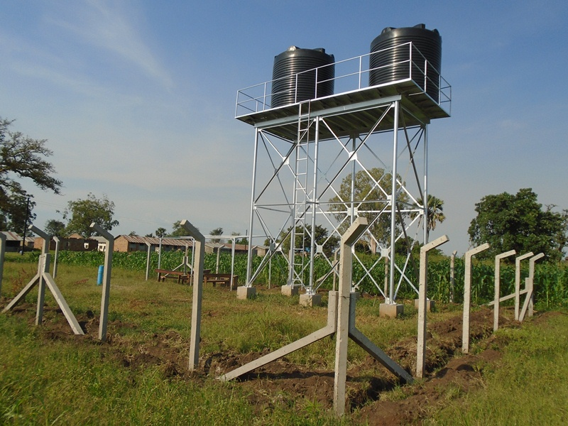
Pump Station bing fenced for purpose of security.

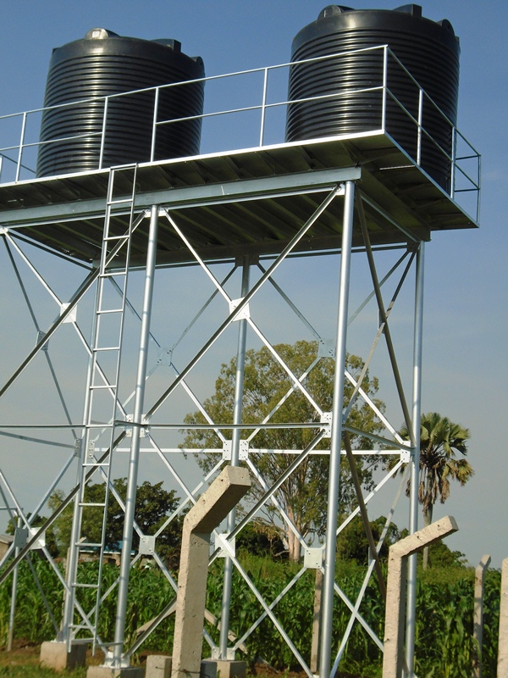
Reservior Tank already mounted in Aloi

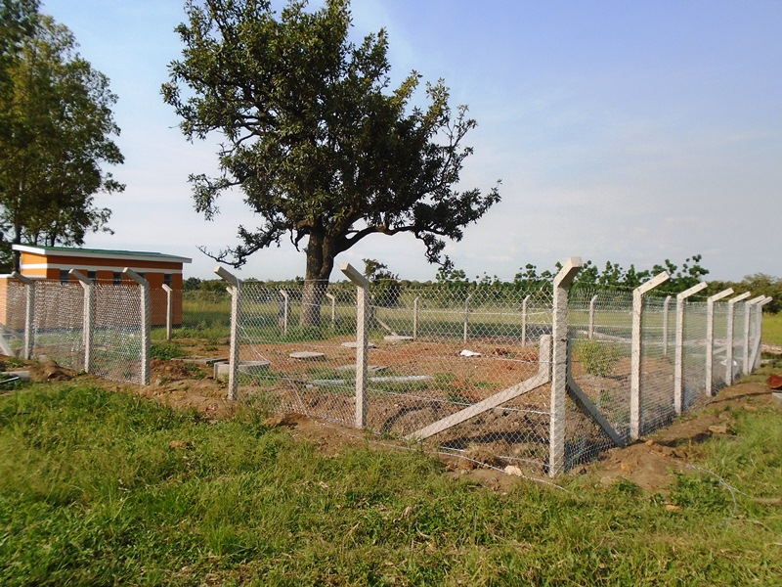
Biogas area already fenced with chain link wires
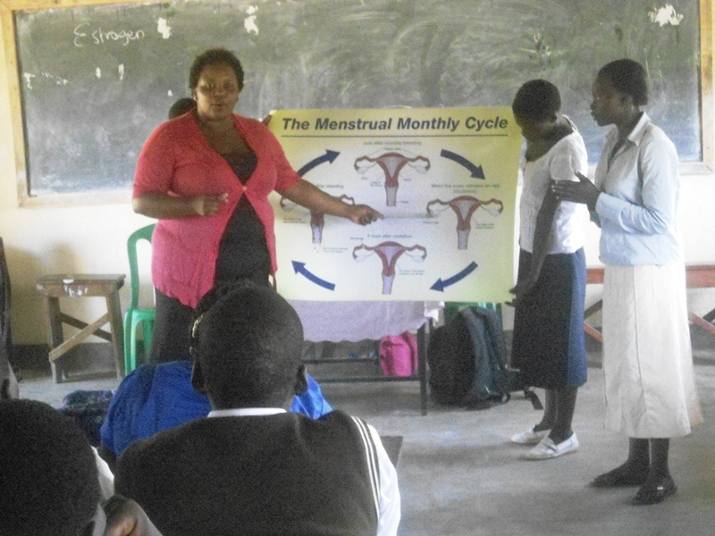
Lydiah (in Red top) facilitation Menstrual Hygiene training in Barlonyo.

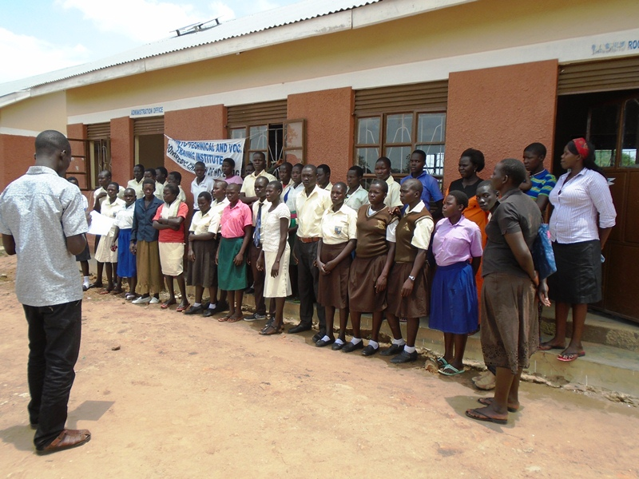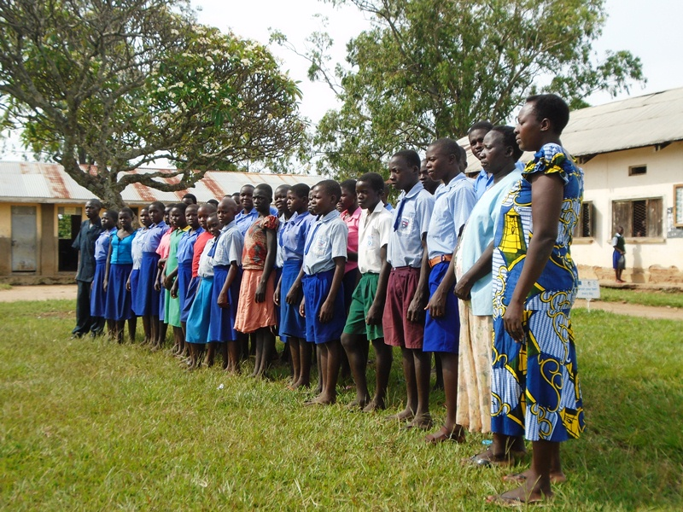
Barlonyo School Health and Sanitation Club Aloi High School Health Club

