November 25, 2014

Rotary Club of Cambridge Preston-Hespeler

Attn: Mike Thomas

Dear Mike

We have received your cheque for a contribution to our Global Grant 1417561.

On behalf of all the members of the Rotary Club of Oakville Trafalgar, our partner Rotary Clubs, and the beneficiaries in northern Uganda, please accept my heartfelt thanks. 6,600 citizens of Barlonyo and Aloi will have access to safe water, sanitary toilets, and hygiene education due to your efforts. In addition, the schools in both the towns will have access to solar generated power for their lights and equipment. Other benefits will be the fuel generated from digesting the waste and access to micro-financing for tree planting.

You have helped us meet our goal and it truly is appreciated.

Thank you again.

Yours in Rotary,

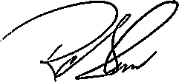

Ron Salem
President

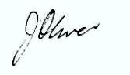
June Oliver
Chair, International Services

