Membership Application

INTRODUCTION
Thanks for considering joining the Rotary Club of Cambridge Sunrise. This package has been prepared to inform potential applicants about:
- our Club (including mission, vision, values and history)
- the expectations of membership
- the nomination process, and
- where to get additional questions answered and the formal application form.
WHO ARE WE - ROTARY CLUB O F CAMBRIDGE SUNRISE
The Rotary Club of Cambridge Sunrise is made up of people with a passion for making a difference in our city and the world. We are leaders who love helping people, and our motto is "service above self". We meet for breakfast on the 1st, 3rd and 5th Friday mornings to socialize, plan service projects, discuss local and international issues and hear interesting guest speakers. In 2021, the Club began using Zoom to offer virtual participation. We contribute over $50,000 each year to local and international projects.
OUR MISSION
We provide service to others, promote integrity, and advance world understanding, goodwill, and peace through our fellowship of business, professional, and community leaders.
OUR CORE VALUES
Our values drive the intent and direction of the organization’s leadership. Our core values are:
FELLOWSHIP AND GLOBAL UNDERSTANDING
We build lifelong relationships.
ETHICS AND INTEGRITY
We honor our commitments
DIVERSITY
We connect diverse perspectives.

VOCATIONAL EXPERTISE, SERVICE, AND LEADERSHIP
We apply our leadership and expertise to solve social issues.

Page 2 of 7

VISION STATEMENT – ROTARY CLUB OF CAMBRIDGE SUNRISE
We are neighbours, friends, and community leaders who come together to create positive, lasting change in Cambridge and around the world.
MISSION STATEMENT O F ROTARY INTERNATIONAL
The mission of Rotary International is to support its member clubs in fulfilling the Object of Rotary by:
- Fostering unity among member clubs
- Strengthening and expanding Rotary around the world
- Communicating worldwide the work of Rotary
- Providing a system of international administration
OUR HISTORY
The Rotary Club of Cambridge Sunrise was founded in 1995. We are actively involved with local and international projects. Our members work diligently to raise money in the community and unselfishly dedicate their time for the betterment of humanity.
We meet on Friday mornings at 7:15 a.m. at the Galt Country Club to enjoy breakfast together, discuss community affairs, network and socialize. We have dynamic and informative guest speakers and on occasion a prominent figure, government official, or interesting personality attends our meetings.
Rotary began in 1905 and is an organization of service clubs known as Rotary Clubs located all over the world. It is a secular organization open to everyone regardless of ethnicity, gender, or political preference. There are 33,000 clubs and over 1.2 million members worldwide. Members typically meet weekly for breakfast, lunch or dinner to socialize and to work on service goals.
The stated purpose of the organization is to bring together business, professional and community leaders to provide humanitarian service, encourage high ethical standards in all vocations, and build goodwill and peace in the world.
Rotary International’s motto is “Service above Self", and its secondary motto is "They profit most who serve best.”

Page 3 of 7
CRITERIA FOR MEMBERSHIP
The Rotary Club of Cambridge Sunrise is looking for people who will help to make the world a better place and who:
- live or work within the vicinity of the club or surrounding area.
- hold (or be retired from) a professional, proprietary, executive, managerial, or community position.
- will ensure dues are paid each quarter; total semi-annual dues are $1200.00 ($1200 x 2 times per year = $2400 total per year). In addition, Club members receive a Club Social Membership to the Galt Country Club, and will be billed directly for any dining fees. They may also use the Club facilities in accordance with the Galt Country Club membership terms and conditions (Visit: www.galtcountryclub.com for details of the Galt Country Club)
- will complete a criminal records check prior to induction into the club (available on a while-you-wait basis at the Waterloo Regional Police Headquarters on Maple Grove Road, Cambridge).
EXPECTATIONS OF MEMBERS
- Be energetic and enthusiastic for the betterment of the community. Consider a commitment of approximately 8-10 hours each month.
- Attend regular meetings (on the 1st, 3rd and 5th Fridays of each month). Attendance at meetings allows members to enjoy fellowship, enrich professional and personal knowledge and meet other business and professional leaders in the community. To enable members to participate during schedule/travelling conflicts, a Zoom option will be available for most meetings.
- Actively partake in at least one committee. Committees are Service Projects, Club Administration, Rotary Foundation, Public Relations and Fundraising.
- Engage in fundraising initiatives. This may include selling raffle tickets, working bingo 23 times per year, participating and assisting in the annual golf tournament, Cambridge Rotary Ribfest (12 hours in total hands-on volunteer commitment on 2nd weekend in August or a financial contribution/sponsorship in lieu), Cambridge Times Rotary Classic, and other fundraisers throughout the year.
- Participate in the “hands-on” projects of the Club.
- Consider becoming a sustaining member. We encourage each member to contribute to The Rotary Foundation (by contributing $100.00 per year – which aligns with the Foundation’s call to action, “Every Rotarian, Every Year,” you are considered a “sustaining member”.

Page 4 of 7

NOMINATION PROCESS FOR MEMBERSHIP
Individuals who wish to have their name considered for nomination are requested to complete and submit an application form to The Rotary Club of Cambridge Sunrise and be prepared to attend an orientation meeting.
QUESTIONS?
For more information about the Rotary Club of Cambridge Sunrise and Rotary International please visit:
Rotary Club of Cambridge Sunrise website: www.rotarycambridge.com
Rotary Club of Cambridge Sunrise Facebook page: https://www.facebook.com/CambridgeRotary/
Rotary District 7080 www.rotary7080.org
Rotary District 7080 Facebook page: https://www.facebook.com/Rotary7080/
Rotary International website: www.rotary.org
Rotary International Facebook page: https://www.facebook.com/rotary/
Galt Country Club www.galtcountryclub.com
Further questions may be directed to any member of the Club, or by e-mailing the Membership Committee Chair through the link on the Club website.

Page 5 of 7

Membership Application Form
Please submit the completed package to The Rotary Club of Cambridge Sunrise.
Before making the decision to apply, please ask yourself:
- Am I able to support the mission and values of Rotary?
- Do I have the time to contribute to be an effective member?
- Can I make a meaningful contribution?
- Can I place Rotary’s interests above my own when making decisions, if required?
- Do I understand the benefits of being a member?
- Do I understand the financial commitment?
Full Name
Address
Home Phone
Mobile Phone
Email
Occupation (or Retiree)
Company Name
Company Address
Phone_____________________________________
Page 6 of 7

Please indicate the following skills areas you believe you can bring to the Rotary Club of Cambridge Sunrise.
SIGNATURE

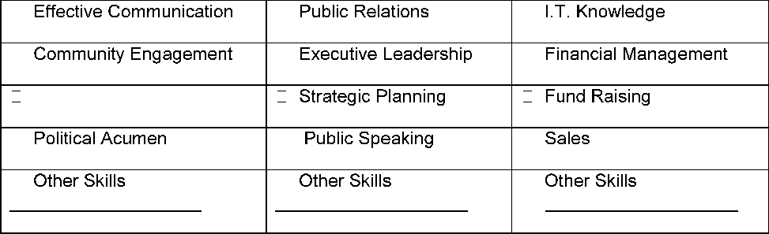
Analytical Decision Making
DATE
Please submit to your sponsor (a current Club member) or send to:
Membership Committee
Rotary Club of Cambridge Sunrise
40 Tamarack Court • Cambridge, ON • N3C 3A8 • Canada
Page 7 of 7
APPENDIX 1
OBJECTS O F ROTARY
The objects of Rotary are to encourage and foster the ideal of service as a basis of worthy enterprise and, in particular, to encourage and foster:
- The development of acquaintance as an opportunity for service;
- High ethical standards in business and professions, the recognition of the worthiness of all useful occupations, and the dignifying of each Rotarian's occupation as an opportunity to serve society;
- The application of the ideal of service in each Rotarian's personal, business, and community life;
- The advancement of international understanding, goodwill, and peace through a world fellowship of business and professional persons united in the ideal of service.
ROTARY FOUR-WAY TEST
These objectives are set against the "Rotary Four-Way Test". It remains the standard for ethics in business management:
Of the things we think, say or do...
- Is it the truth?
- Is it fair to all concerned?
- Will it build good will and better friendships?
- Will it be beneficial to all concerned?

Original 2012-13
Updated: December 2020

