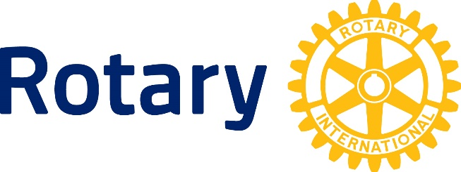

All About Rotary
For new and prospective Rotarians

The Rotary Club of Bolton

Chartered June 26, 1950

Rotary Place, 7 Rotarian Way, P.O. Box 405 Bolton, ON L7E 5T3

2022-23 President: Andrew Morgan
Membership Chair: Don Ogden 416 518 0378

Rotary International District 7080

To find out more about Rotary, check the following web sites: www.boltonrotary.ca www.rotary.org www.rotary7080.org

September 2022

What is Rotary?

Rotary is officially defined in this way:
“Rotary is an organization of business and professional persons united worldwide who provide humanitarian service, encourage high ethical standards in all vocations, and help build goodwill and peace in the world.”

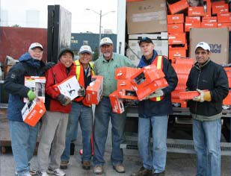
A young lawyer named Paul Harris started Rotary in Chicago in 1905. Feeling lonely in the big city, and missing the fellowship of his small-town upbringing, he invited three young business acquaintances to his office, and explained his idea for a different kind of businessmen’s club. They met regularly, rotating around each member’s place of business – hence the name “Rotary Club.”

Since then, Rotary has grown into an organization of 1.2 million members, in 34,000 clubs, in over 200 countries. It also developed into the world’s first service club, which, because of its size and scope, is able to work in a unique way to help improve the quality of life, and to work for peace and understanding throughout the world.

Geographically, Rotary is managed by Districts. Bolton is one of
50 Rotary clubs in District 7080, defined as south-western Ontario.

Two statements of policy guide Rotarians:

- The Object of Rotary, and
- The Four-Way Test.

The Object of Rotary
The Object of Rotary is to encourage and foster the ideal of service as a basis for worthy enterprise, and, in particular, to encourage and foster:

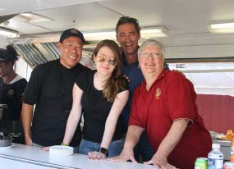
- The development of acquaintance as an opportunity for service.
- High ethical standards in business and professions; the recognition of the worthiness of all useful occupations; and the dignifying by each Rotarian of his occupation as an opportunity to service society.
- The application of the ideal of service by every Rotarian to his/her personal, business and community life.
- The advancement of international understanding, goodwill and peace, through a world fellowship of business and professional people, united in the ideal of service.

“As a Rotarian, I am constantly offered opportunities to serve locally, nationally and internationally. It is a unique experience.”

2 | All About Rotary: An Introduction to the Rotary Club of Bolton

The Four-Way Test
Of the things we think, say or do: | - Is it the TRUTH?  - Is it FAIR to all concerned?  - Will it build GOODWILL and BETTER FRIENDSHIPS?  - Will it be BENEFICIAL to all concerned?
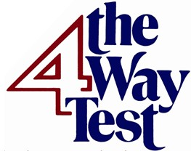 | This is one of the most widely printed and quoted statements of business ethics in the world. Rotarian Herbert J. Taylor created it in 1932, when he was asked to take charge of the Chicago-based Aluminum Company, which was facing bankruptcy. Taylor looked for a way to save the struggling company. He drew up the 24- word code of ethics for all employees to follow in their business and professional lives. The survival of the company was credited to this simple philosophy. The message should be known and followed by all Rotarians.
The Rotary Club of Bolton
Our History  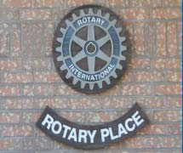  “If Rotary ran the world there would be no war and no poverty.”  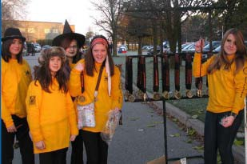 | The Rotary Club of Bolton was sponsored by the Rotary Club of Brampton and was granted its charter by Rotary International on June 12, 1950.  Currently the Club meets every Monday at 6:30pm at Rotary Place, 7 Rotarian Way, Bolton, just behind the “Wellness Centre.”  In 1981 the Rotary Club of Bolton sponsored the Rotary Club of Palgrave.  Both locally and internationally, the Club is very active in supporting charitable organizations, listed below. We built Rotary Place in the mid-1990’s, which is home to the Caledon Seniors.  The building of the Rotary Youth Centre, completed in 2008, we partnered with the Town of Caledon for design and construction. Our Club donated $1.5 Million to the project.  The Club donates academic and athletic scholarships yearly to the local high schools. Bolton Rotary’s special interest in ‘Youth’ has resulted in the Club’s support of the Youth Exchange Program. In addition, the Club has been active in Adventures in Citizenship and was a founding member of Camp Enterprise in Peel Region. We activated an Interact Club at Humberview School and have been supporting the Robotics – Alpha Dogs program for 7 years and recently the feeder students FIRST Lego League.  The Club has supported Rotary International’s “Polio Plus Program” since its inception in 1985.

3 | All About Rotary: An Introduction to the Rotary Club of Bolton

Contributions in
Our most recent International project is a fresh water project in Guatemala, where we are providing fresh water to 45,000 people in the city of Gualan. Bolton Rotary took the lead on this project and raised $120,000 US through the partnership with other clubs in our District 7080.

The Rotary Club of Bolton has a solid history of 69 years of service to the community. The Rotary motto of “Service above self” guides each Rotarian today, as it has over the Club’s history.

Since being chartered, our Club has donated and distributed hundreds of thousands of dollars to projects like these:

our Community and
the World

“Being a Rotarian makes me a true world- citizen.”
- Rotary International Student Exchange
- Adventure in Citizenship – High School Students
- District 7070/7080 Camp Enterprise – High School Students
- Bolton Camp Restoration + Murray Stewart Trail
- Caledon Kids First
- PolioPlus Eradication
- Shoeboxes for Mexican Kids
- Headwaters Health Care
- Bethell Hospice Caledon
- Caledon Community Service
- Caledon Meals on Wheels
- 1st Bolton Scouts
- Humberview Alphadogs Robotics
- Caledon FIRST Lego League
- Girl Guides
- Salvation Army
- Sustaining Member Program
- William Osler Hospital
- Sonop (South Africa) nursing home improvements
- Honduras Fresh Water Project
- Guatemala Fresh Water Project
- Sleeping Children Around The World
- Diabetes Research
- Ukraine Crisis Support and Medical Supplies
- Water First Indigenous Water Operator Certification
- and many others…..

Our Major Fundraisers
All members are expected to participate in some way in our Club’s major fundraising activities. Presently, these comprise:

- Red and Black Charity Dance (February)
- Along the Bunny Trail – family walk (April)
- Charity Golf Tournament (May)
- Haunted Hill Rotary 1kFun Run and 5k Walk/Run (Oct)

What are the Obligations of a Rotarian?

“As I am self-employed and work alone much of the time, my Rotary club gives me a professional group I can interact with. I have learned so much about my community through Rotary.”

A Rotary club has two main functions: to promote fellowship among its members and to provide service to the community and the wider world of Rotary.

When you become a Rotarian, you will be expected to attend meetings regularly, only missing a meeting when it is unavoidable.

Because we meet weekly, members get to know one another very well, learn about other businesses and professions and form strong and close friendships. Also, it helps to get jobs done when members can be counted on to be there.

A Rotary club functions through committees. Everyone is expected to take a share of committee work, and be available to assist in fund-raising and service projects.

4 | All About Rotary: An Introduction to the Rotary Club of Bolton

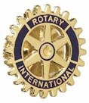 | Rotarians are also expected to carry the ideals of Rotary outside the club into their own fields of work. You can do this by wearing your Rotary pin proudly, by displaying The Four-Way Test in your place of business and by exemplifying its principles in your everyday business dealings.
What happens  at a Rotary meeting?  “When I travel, I am an ambassador of my club, my district and my country and am welcomed in fellowship wherever I go. I can be ‘at home’ with friends anywhere at a Rotary club meeting.”  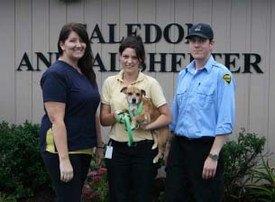 | Every Rotary club has its own character, but there are some  common elements that make Rotarians feel at home at any club worldwide.  Meetings are built around a meal, which for the Rotary Club of Bolton is dinner. The meeting starts at 6:30PM and usually lasts for about an hour and a half. Members and guests start to gather about 15 minutes before the meeting for social talk and fellowship. In Canada, we usually sing our national anthem and recite the 4-way test.  Following the meal, there is usually a guest speaker and time to conduct some club business – giving reports, making plans and solving problems. Committee Chairs will give project updates. Members often bring guests: spouses, prospective members or just people who are interested in the guest speaker.  There may be Rotarians visiting from other clubs in the area, or even from around the world.  The meeting is usually chaired by the President and run by the Sargant-at-Arms whose job it is to handle the physical preparations of the meeting, keep attendance records, manage our 50/50 draw, and then help maintain an orderly, dignified and effective meeting.  Members can pay “happy bucks” for the privilege of giving good news, or bragging about achievements. It is a “fun-raising” time. Good-natured fines may also be doled out during the Sergant- At-Arms Report.  A weekly newsletter called “Rotabolt” highlights meeting agendas, news and events.
What does Rotary cost? | Each Rotarian pays quarterly dues of about $300 to their Rotary Club. Our dues cover all administration expenses of the club as well as dues to District 7080 and Rotary International (RI per capita $34, Council on Legislation $3, Magazine $8, District insurance $22, District Support $39, Training $25, PresidentElectTraining $20). In the Rotary Club of Bolton, each member is responsible for paying for their meal at weekly meetings, currently $20/weekly.  All members are encouraged to become ‘sustaining members’ of the Rotary Foundation by contributing a minimum of US$100 annually ($25 quarterly).

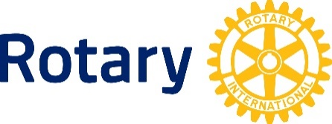 | Our annual Executive Changeover and Awards Dinner, held in June, costs approximately $75 per person.  Additional costs may include such things as the annual District Conference and other Rotary fun and fundraising functions and special club events. These events are optional but members and their spouses are encouraged to attend.  Overall, you should budget approximately $1,200-$1,300 per year, of which $900 are meal costs.
Rotary Programs  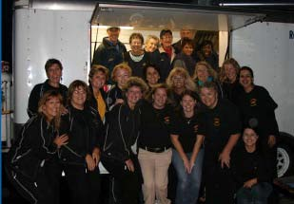 | Youth Exchange  Aimed at Rotary’s objective of promoting world peace and understanding between all peoples, Rotary clubs and districts sponsor more than 8000 students of secondary school age for travel abroad and home-stay (generally) with a Rotarian host- family or families for an academic year. Our own Club has been active in this program since 1975.  Camp Enterprise  A 3-day business camp aimed at teaching the principles of business entrepreneurship and encouraging the development of leadership skills in grade 11 and 12 high school students. Our club has been very active in this program since 1978.  Interact and Rotaract Clubs  Interact, for secondary-school students, and Rotaract, for young adults 18-29, are Rotary-club sponsored service clubs. The clubs carry out at least one local and one international service project each year.  Rotary Youth Leadership Awards (RYLA)  RYLA is a week-long ‘camp’ program comprising seminars, workshops and activities designed to develop and recognize good citizenship and leadership qualities in young people 17-23.
“It is very rewarding to see the excitement on the face of a student chosen for International Youth Exchange, to hear the gratitude of seniors, to know that together we are making a difference in our own community and around the world.”

6 | All About Rotary: An Introduction to the Rotary Club of Bolton

