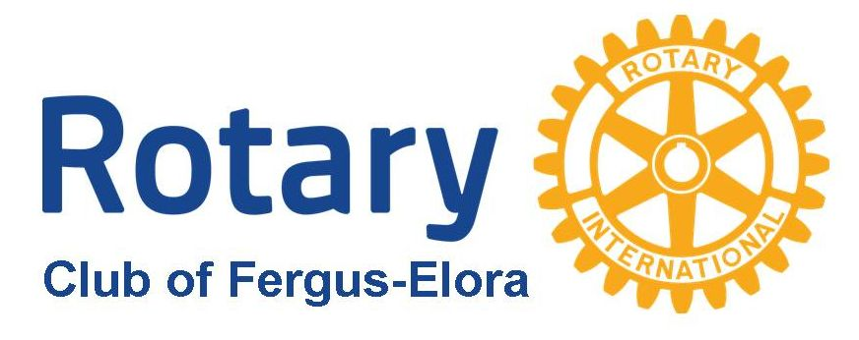
Application for Funding – Deadline Oct 22, 2021 (All applications considered- see last page for focus areas and approval guidelines)
To submit your application for funding please complete this form and email to: bruce.mcleish@gmail.com

Section A: Tell us about your organization

Organization Name:

Charitable Registration Number:

Address:
Telephone Number: Website:

Executive Contact:

Name: Title/Position:
Email: Telephone Number:

Primary Contact for this Proposal (if other than above)

Name: Title/Position:
Email: Telephone Number:

What is your Organization’s Mission and Mandate?
How many Staff and Volunteers do you have?

Full-time Employees: Part-time Employees: Volunteers:
Financial Overview:

Last Year’s Total Gross Annual Revenue: $

Annual Fund-Raising Target: $

.

Section B: Tell us about the Project you would like us to support
Title of the Project:

Why is this project/program needed in our community? (Maximum 100 words)

What do you want to do? (Maximum 100 words)

How will the success of the project/program be measured? (Maximum 100 words)

Number of people affected

Section C: tell us about the cost of this project/program

What is the total cost of this project/program?

$ Capital $ Operating $
Amount of funding requested: Date Needed:

$
Note: For funding requests over $1,000 please attach your most recent financial statements
Have you received funds from the Rotary Club of Fergus-Elora in the past 5 years? If yes, date and amounts.

Do you have other sources of funding secured or pending for this project/program? If yes, what organizations and amounts?

Section D: volunteer opportunities
Rotary is a service organization. Please describe any ongoing volunteer opportunities and/or short-term projects we could help you with.

Section E: promotion - How will you share the news of receiving the funds from the Rotary Club of Fergus-Elora?

Application for Funding – Deadline Oct 22, 2021
Primary Focus Areas for Proposals
(however all applications will be considered)
► Maternal and child health
► Support for the environment
► Basic Education and literacy
► Needs of seniors or youth

Rotary Club of Fergus-Elora - Donations Policy

A) We will give highest priority to funding requests that meet these general guidelines:
- This club usually undertakes projects each year in which we desire to be a major contributor.
- Projects require a specific completion target date. We usually do not get involved in on-going operational funding, but we may consider funding the start-up phase of a new community service with an on-going mandate.
- We prefer projects that will help a large number of persons but will consider large and small projects in which only one person receives direct benefit.
- We focus on projects that are of general benefit to the community, with
particular attention being paid to those who are most disadvantaged in
the community and guidelines as follows:
- How will it benefit our communities
- Number of people affected - Amount of money involved
- We strongly support Rotary sponsored international projects, youth development programs and exchange programs.
- We support projects which have a high probability of completion and subsequent success
- Visibility

B) We give lower priority to requests that meet these guidelines:
- School organized trips for Bands, out of town sporting events etc. We expect most of such funding should come from students raising funds themselves and from parents. This does not preclude the support of disadvantaged individuals.
- As a club we generally do not support funding requests for large Charitable organizations with established fund-raising machinery of their own.

