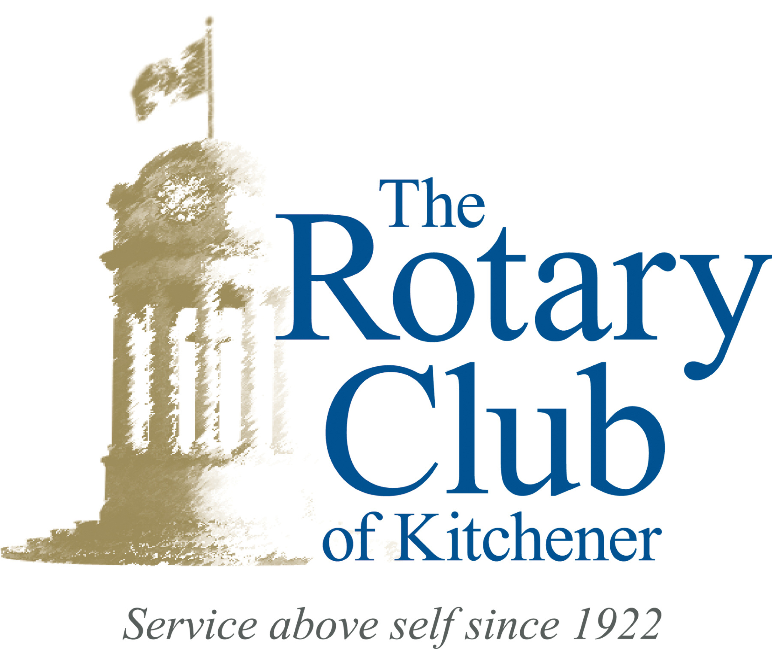
My Own To Do List

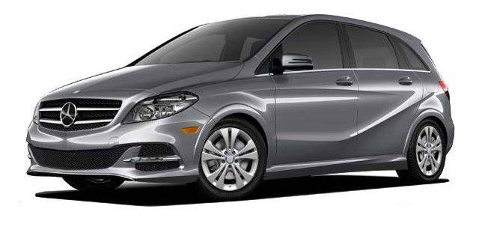
Car Draw
In Vino
Caritas
Online Auction

Community
Service
International
& Peace

Club Vitality
Youth

Have Fun

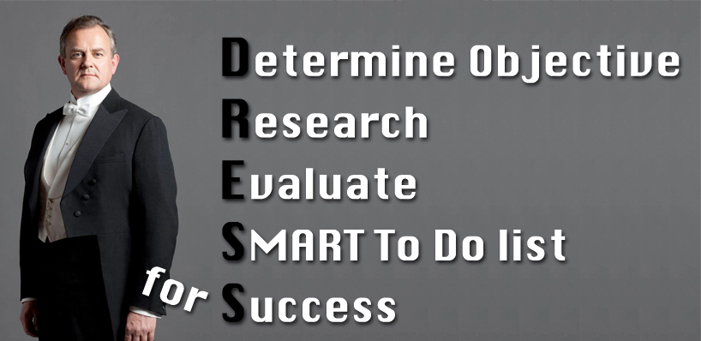
“SMART” To Do Lists
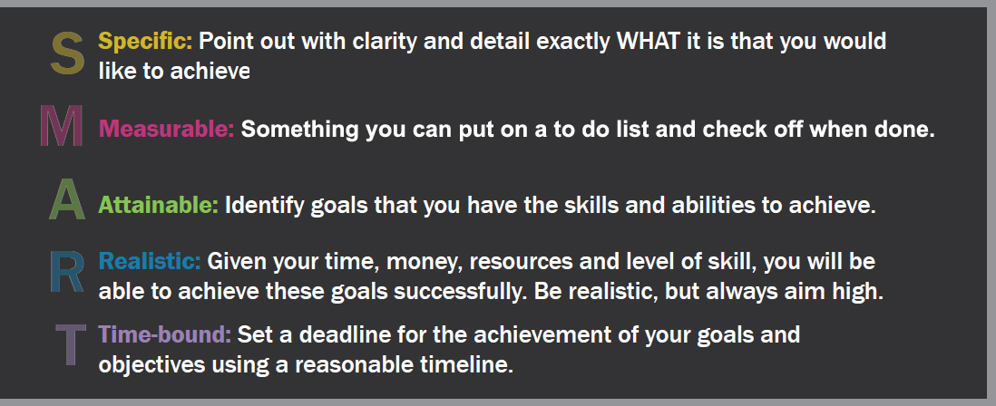

The ideas below are potential To Do Items (Do you have new or different ideas? Share them)
Car Draw  - Raise at least $1,500 in ticket sales  - Find a corporate sponsor (how many?)  - Sell tickets at Market (how many times?)  - Sell tickets at Ribfest, Plowing Match etc.  - Sell tickets on draw night at Rangers game  - Send emails to work, family and friends, then follow up with them  - Attend another club and promote tickets  - Share ads/links on Facebook, Twitter etc.  - Mail out ticket books and return envelopes  - Help with envelope stuffing at Kidsability | Club Vitality / Membership  - Provide ideas and feedback  - Identify causes / projects to support  - Bring a prospective member to a meeting  - Invite a prospective member to join Rotary  - Make all guests feel welcome  - Attend District Conference, District Assembly-Club Leadership Training, Rotary Leadership Institute, District Changeover, International Conference, etc.  - Network at events, e.g. Inspiring Women, International Women’s Day Breakfast, etc.  - Update my profile: ww.rotary.org/myrotary
Online Auction  - Secure online auction items (how many?)  - Find advertisers / sponsors (how many?)  - Advertise with work, family and friends  - Share ads/links on Facebook, Twitter etc.  - Attend another club and promote auction  - Participate in the auction | In Vino Caritas  - Secure silent auction items (how many?)  - Find event sponsor (how many?)  - Attend event and sell tickets (how many?)  - Send emails to work, family and friends  - Share ads/links on Facebook, Twitter etc.  - Attend another club and promote event
International Projects and Peace  - Polio Plus program – Polio cards  - Nogales shoebox program  - Agua Prieta shoebox program  - Rotary African Women's Education  - Financial support to peace scholarships | Youth  - Rotary Civics Youth Forum project  - Help with Camp Enterprise  - Host an exchange student  - Help an exchange student with a ride, etc.  - Consider RYLA and/or Camp Enterprise candidates to propose
Community Service  - Kidsabilty Fun Day  - Forest Hill School snack program  - Dom Cardillo Trail Cleanup  - Rotary Peace Park  - New Year’s Eve event  - House of Friendship yard work  - Earth Day activities | Have Fun  - Sit with different people at meetings  - Invite friends and family to meetings  - Attend a meeting of another club  - Attend December holiday social  - Enjoy special meetings (Halloween, Valentine’s Day, etc.)  - Participate in Dine-a-round  - Participate in Tuesday Evening Alcohol Mixer (TEAM)  - Socialize

