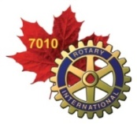 ROTARY DISTRICT 7010 
SERVICE PROJECTS REPORT
September 2016 Volume 9

************************************************************************

September is Basic Education and Literacy Month

Dear fellow Rotarians,
It has come to my attention that with summer almost over and Thanksgiving quickly approaching, that Rotarians are back on their Rotary jobs producing information that needs to be shared before the end of September. Therefore I am circulating this service report, hoping Presidents and other leaders will share it ASAP. I also ask that if anyone has service oriented info to share at could affect others in District 7010, to please send it to me at dawn@straka.ca. The next Report will come out in mid-October, 2016.
Yours in Rotary Service,

Dawn Straka

Rotary District 7010 Service Chair

************************************************************************

 | Collaborating with partners on sustainable service projects  Taken from ROTARY SERVICE
By Rotary Service Connections Staff Working with partners can strengthen club and district service projects by ensuring sustainability, providing access to subject-matter experts, and strengthening local networks. Partnering with local, national, and international organizations can help meet the many needs of communities around the world. Rotary’s service and project partners support Rotarian-led initiatives within the within the avenues of service and areas of focus. All activities take place at the local level at the discretion of individual clubs and districts. Consider partnering with one of a number of potential service partners to create a greater impact in your community and in the world.

Please remember that if you want to apply for a District Grant for your projects the deadline this year is the end of September. If it is a Global Grant that you are interested in (with or without the additional support of the Government of Canada through TRF Canada) that application has no deadline.

************************************************************************

Report of the “Adventure in Understanding”

The third annual “Adventure in Understanding” program was an outstanding success. The crew of 20 youth, 16 to 18 years old, and 4 leaders travelled the 100KM route from Peterborough to Curve Lake First Nation in three voyageur canoes. This year there were six youth from Curve Lake FN, as well as one each from Shubenacadie First Nation (Nova Scotia), Long Point First Nation (Quebec) and North Spirit Lake First Nation (Manitoba).

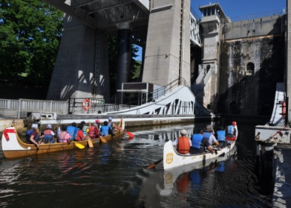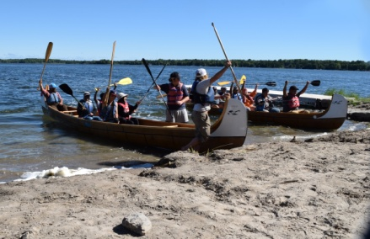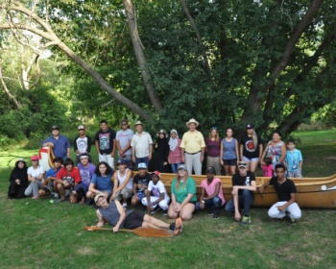

The crew also included eight new Canadian immigrants who arrived within the last year from Kenya, China, Iraq, Syria, and the Philippines. The New Canadian participants are all talking about the trip as a life changing experience. Not only did they learn to paddle and enjoy being on and in the water, they will be attending their ESL classes in the same school as their new First Nations friends from Curve Lake.

The six days, five nights, canoeing/camping experience provided many opportunities for the paddlers to connect with the land and water around them and the rich history of the Anishnabae of Curve Lake First Nation. One of the many highlights noted was the opportunity to hear the youth drumming at the Curve Lake Powwow grounds, while watching the northern lights dancing above the waters! As co-coordinator Glen Caradus remarked, “the best way to get to know your neighbours is to go and say hello”.

Adventure in Understanding is a voyage of individual growth and self-awareness as participants learn and teach, speak and listen, serve and be served. It is a voyage of discovery that will light a spark of awareness that will burn as a strong force in the minds and hearts of these youth as they mature into the leaders of to-morrow.

This program was developed by the Rotary Club of Peterborough Kawartha in co-operation with Curve Lake First Nation, Camp Kawartha, and the Canadian Canoe Museum to provide an opportunity for First Nation and non-native youth to share experiences as they learn and travel up the Trent Severn Waterway. The all-inclusive $300 per person cost is made possible in part this year because of support by the Community Fund for Canada’s 150th, a collaboration between the Community Foundation of Greater Peterborough, Community Foundations of Canada, the Government of Canada, and extraordinary leaders from coast to coast to coast.
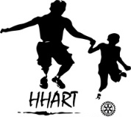
************************************************************************

Haitian Humanitarian Assistance & Relief Team (HHART) News

HHART is the acronym for the Rotary Club of Wasaga Beach’s Haitian Humanitarian Assistance and Relief Team. Planning for the eighth HHART mission has begun. The mission will include medical, dental and community development activities for 7 to 10 days in the first half of May 2017. Exact dates will be announced very soon. The team will focus on servicing 8 small villages occupied by poor and disadvantaged people, primarily of Haitian heritage, near Puerto Plata in the Dominican Republic.

The HHART 8 planning team is currently considering 11 potential projects that could qualify for a district grant. Each project is associated with at least one of Rotary International’s six Areas of Focus or personally safety. Briefly, these projects are:

- Facilitate medical and dental care and clinics for impoverished people (includes purchase of medicine and medical/dental supplies),

- Effect local road improvements (ideally from dirt to concrete) to control water run-off, and improve sanitation and personal cleanliness,

- Install coverings over public meeting places to protect people from blazing sun and torrential rains,

- Repair shoddy wiring in makeshift homes to reduce or eliminate risk of fire and electrocution,

- Install a modern, WI-FI based fire detection and alarm system throughout an entire village to provide early warning of fire and prevent loss of life and minimize property damage,

- Install a community garden and provide training to those who will raise crops in those gardens,

- Installation of small playground equipment to provide recreation opportunities to toddlers,

- Sponsor a music program by providing instruments and training for instructors,

- Install fire-fighting equipment in public areas for use by first responders,

- Provide defibrillation packs in at least three villages for use by first responders, and

- Install solar lighting systems to allow residents to cope with frequent back outs.

HHART leaders are working diligently with local Rotarians in the Dominican Republic to define each project in detail. If your club is looking to sponsor an international service project for $2,000 or less and/or wishes to assist HHART 8 to access matching funds from The Rotary Foundation, please contact the HHART Chief of Operations, Rotarian Steve Wallace, at steve@HHART.info or (705) 444-4012 without delay.

HHART leaders are qualified and experienced at applying for, managing, and reporting on district grant projects. To make the entire sponsorship and district grant process club-friendly, HHART leaders are prepared to help draft district grant applications for submission to the District before the September 30, 2016 deadline. Although hands-on participation in the project as a member of HHART 8 is preferred it is not mandatory because Rotarians on the HHART 8 team have the ability and expertise to oversee and manage project execution and assist with report writing. Visit www.Facebook.com/HHART.info to learn more about previous HHART missions.

************************************************************************

The Rotary School of Cambodia: The Dream Six Months Later

The Rotary School of Cambodia continues to thrive. The two classrooms provide English instruction to approximately 150 children a day. The students range in age from 8 to 13 and learn the basics of oral and written English. The motivation and commitment of the students is inspiring. Many ride their bicycles 4 or 5 kilometers each way for class, often arriving an hour early so they can spend time reading the library books and practicing their English.

The sewing program is also fully operational. Five women from the surrounding villages are learning the skill of tailoring. They are developing the skills necessary to design and manufacture garments with the goal of running their own tailoring shop in their villages and providing a sustainable income for their family. Each woman has been provided with a treadle sewing machine to learn on, and will receive it upon successful completion of the program. Included in the lessons will be learning how to design and create traditional Khmer costumes and clothing. This is a longer term goal but will be a significant asset in developing and marketing their businesses.

There is also a teacher education component of the program. In April, 4 newly graduated teachers from the B.Ed. program at Trent University will travel to Cambodia to work with the teachers to develop instructional materials and resources, learn new teaching strategies and to improve their English.

************************************************************************

Educational Opportunities project in Honduras
The Rotary Club of Peterborough is seeking partners for a global grant in Honduras. The basis of this global grant is sustainable community development by increasing educational opportunities within a region of Honduras, affecting up to 70 teachers, over 600 primary school students, and their families. We aim to enhance the life of villagers by firstly providing general teacher training and student-focused female empowerment courses to increase the efficacy and equality of their primary schools. To extend the educational opportunities to villagers, we are planning interventions in the form of micro-finance, skills training (such as community health-care worker, sustainable agricultural practices, and handicrafts training), in select villages. All of these smaller projects would be provided through partnerships with local Rotary-affiliated agencies and Honduran organizations. The Tegucigalpa Sur Rotary club is eager to help through administration of the projects. The needs assessment will be carried out in October 2016 although much preliminary investigation has been done. Here is a brief description which could change slightly after the needs assessment:

Global Grant details : all in USD – total of $85,000- $90,000 including the following:
$12,000 - $15,000 - Female Empowerment courses to be taught in 60-70 schools for grades 5 and 6 through the Honduran organization Shoulder to Shoulder: http://shouldertoshoulder.org/education/yo-puedo-girls-leadership
This course includes instructions and materials for the entire school year, and incorporates a business project for girls.
$25,000 - vocational courses at girls’ high school including computer repair, hairdressing and beautician, and seamstress. Micro-business training will be a possible follow-up through the Fundacion Unidas Americas, a Rotary-sponsored organization existing in Central America.
$10,000 - primary school teacher training instruction that will be a train-the-trainer format. A teacher training system will be established with the local Honduran school board. Networking and training courses will be set up for the 1 year period of the grant. A Honduran teacher with over 20 years experience in training will lead this project and will train 10-12 teacher volunteers who will then be tasked with training the other 50-60 teachers in the school district. These training courses will be held at least once monthly and focus on student-centred teaching and learning.
$10,000 - furnishing Teacher Training Centre (being built with a $25,000 grant from an outside organization) - furniture to equip the centre for courses – tables, chairs, workstations and equipment like a photocopier and laminator.
$10,000 - vocational training courses for villagers. These courses will be chosen by villagers depending on their needs and provided by agencies in Honduras. Probable courses include sustainable agriculture and handi-crafts. Micro-loans may then be made available.
$10,000 - texts for 200 students following the model of the Guatemala Literacy Project trial with sustainable rental payment by parents planned.
$5000 – computers in 2-3 pilot schools. There are more and more systems being developed constantly to address students who have little or no access to computers and/or the internet. The grant will include a pilot project which, once proven successful, could be used in other parts of Honduras or other countries. Here are some examples of projects being investigated that could be tailored to their needs, often using only a TV and tablets.

Rotarian Marie Press plans a service TRIP TO HONDURAS – FEBRUARY 6-13 OR 6-16, 2017. For further information please contact Marie at mariepress@hotmail.com .

************************************************************************

Travares Gardens Literacy Project

This major international project of the Rotary Club of Peterborough Kawartha continues to seek partners to expand its support and involvement. A team of Rotarians visited Kingston Jamaica in March, spent 5 days at the school and explored all the educational and specifically the literacy needs of their 206 students. While there the Rotarians learned a great deal more about the children, their parents and the community generally. Travares Gardens is a school of grades 1-6 in a community of many single parent families, 70% unemployment, poor nutrition, poverty, with a well assessed population of developmentally delayed children. It is a school with all kinds of potential. Considerable more literacy support beyond our original expectation is needed and will go far to rectify the situation. Our involvement has already had an impact. Since we were there the Ministry of Education has been dealing with some of the physical plant matters. Very recently the principal wrote us about a meeting she had with a senior person in the Jamaican Ministry of Education. “He assured me that the MoE will do all possible to ensure our leaking roof is an occurrence of the past as they have already secured some funding to act promptly. In that discussion, he examined our bathrooms infrastructure which is pretty archaic and promised to install concrete hand wash areas for students as well as to install more modern flushing systems for both boys and girls restrooms.” By holding up this literacy project, in effect we have been change supporters.

Besides our Club’s $5000. contribution we have had financial pledges from the BEL Club and Rotary Clubs in Englehart, Gravenhurst and Penetanguishine which are very much appreciated. Other offers of financial support from Rotary Clubs, in the next couple of weeks, will help Rotary make a tremendous difference for the school and the whole community. For more information or for a speaker at your club, please contact dawn@straka.ca or at 705-295-6375.

************************************************************************

“The best way to find yourself is to lose yourself in the service of others.”
― Mahatma Gandhi

