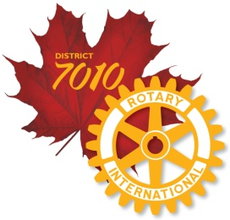
Global Grant Scholarships - An opportunity to Study Abroad
Rotary International Global Grant Scholarships fund graduate-level coursework or research for one to four academic years. It is acknowledged as the world’s largest privately funded international scholarship program. The mission of the scholarship is to advance world understanding, goodwill, and peace through the improvement of health, the support of education, and the alleviation of poverty. This scholarship provides up to $40,000 USD for a year's study.
Applications are being sought for the 2023-24 academic year.
We are looking for applicants -
- Who have completed or will have completed undergraduate studies prior to 2023-24 academic year, and demonstrated academic success.
- Who plan to pursue a career in an area of focus and have a long-term commitment to measurable, sustainable change in that area.
- Who demonstrate a strong commitment to international understanding and peace.
- Who demonstrate “service above self” and a propensity to be an ambassador for Rotary.
- Who plan to study in one of Rotary’s areas of focus:
- Peace and conflict prevention/resolution
- Disease prevention and treatment
- Water and sanitation
- Maternal and child health
- Basic education and literacy
- Economic and community development
Please review the information found at this link District 7010 website > Projects and Programs > Rotary Foundation > Global Grant Scholarship.
North Bay and area applicants can contact: Colin Vickers, Rotary Club of Nipissing at mailto:colin.b.vickers@gmail.com or by calling 705-845-8909. Applications for area candidates will be accepted by Colin Vickers until April 20, 2022.

