Rotary Club of Peterborough Kawartha Adventure in Understanding
Camper Packing List 2020
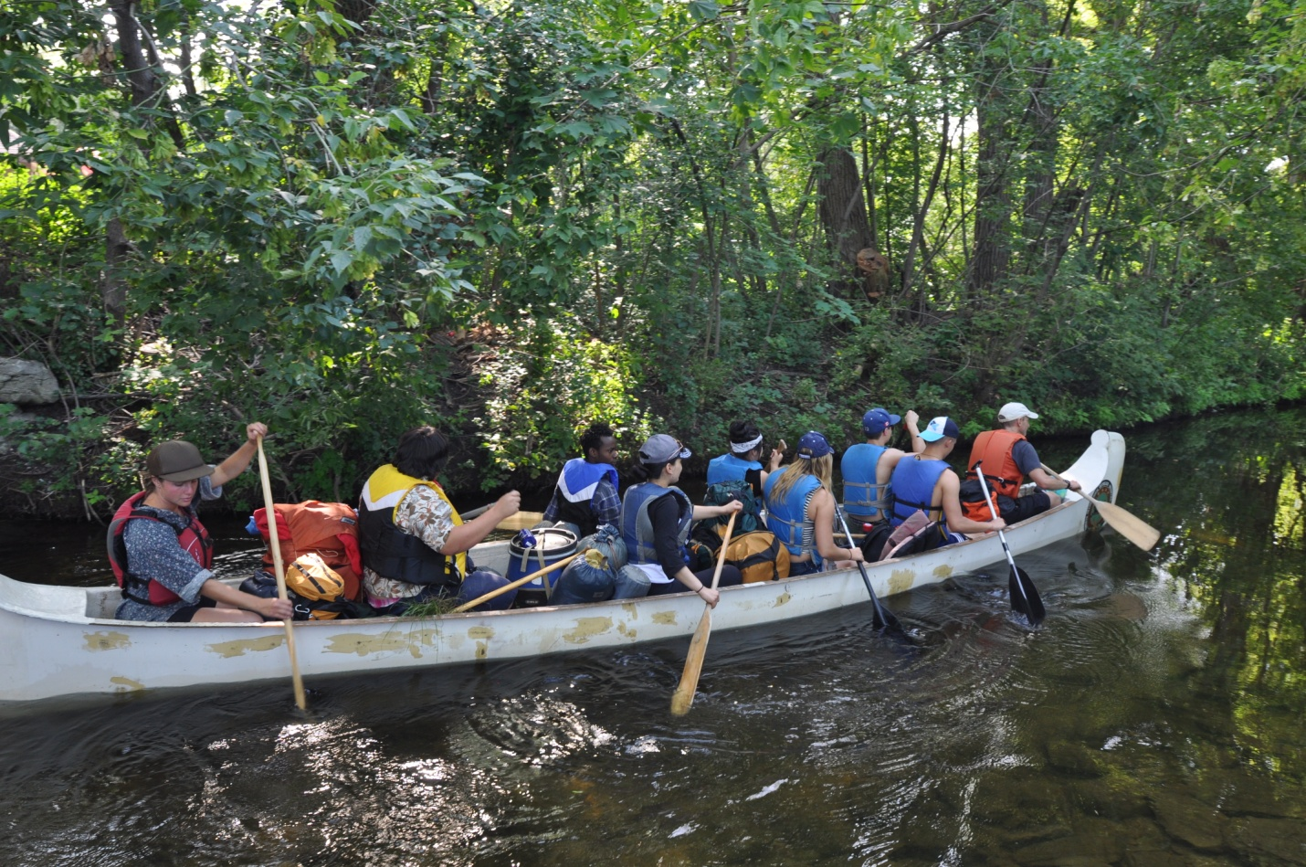
Our canoes are VERY full during the trip. No suitcases or hockey bags PLEASE.
A watertight dry-bag (backpack) large enough to contain the following :
Whistle is REQUIRED ( FOX40 is best, but other pea-less whistles will do)
Hiking or Running shoes (these will be “wet shoes” to be worn while canoeing or hiking)
Crocs are not appropriate as they give no ankle support
Dry shoes to be worn at campsites (crocs, sandals or running shoes are fine)
NO flip-flops

1. 2 t-shirts or sunshirts
2. 1 long sleeve shirt
3. 1 sweater – fleece or wool is preferred
4. 1 pair of pants – fleece, wool, or synthetic preferred
5. 1 pair of shorts
6. 2 or 3 pairs of socks ( should include 1 wool pair)
7. 2 or 3 pairs of underwear
8. Bathing suit and towel
9. Hat
10. Waterbottle ( 750 ml. ideal)
11. Toothbrush
12. Raingear
13. Sun screen
14. Insect repellant
15. Sleeping bag ( the more compact the better)
Synthetic tend to be more compact than down
16. Optional – therm-a-rest or similar inflatable pad – no foam pads
Ground sheets will be provided if requested in advance
17. Optional – journal, pen, flashlight

