
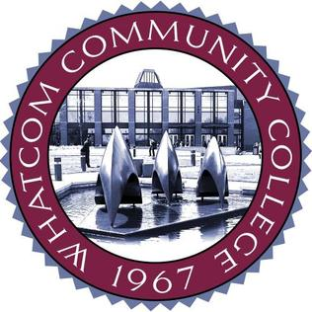

Our Rotary Club of Bellingham meeting location at Whatcom Community College – SYRE STUDENT CENTER
ROOM 107/108

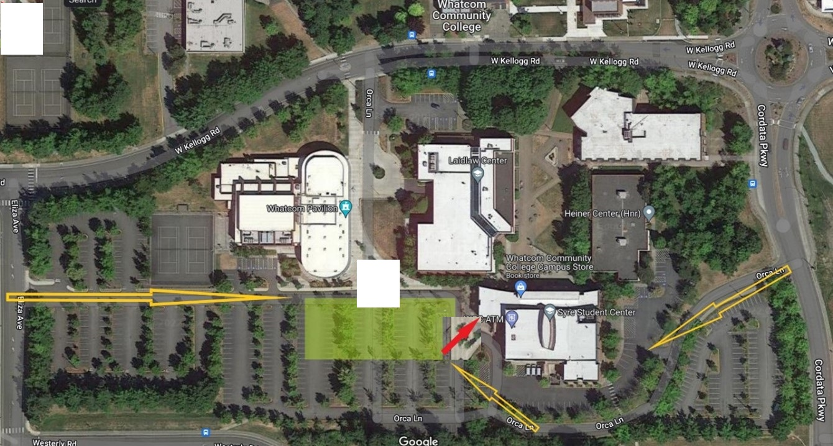

The buildings address is 235 W. Kellogg Rd. But this is not where you park. There is no parking off of Kellogg Road. You must enter parking off either Eliza Ave or Cordata Parkway. You are looking for the YELLOW lot (look on light poles for Y2 or Y3).
Enter from Eliza Ave: the driveway between Kellogg Rd and Westerly Rd has a driveway into the campus, follow that about 200 yards until it slopes down, park in the area between the three buildings.
Enter from Cordata Parkway: Just north of the WTA station and Cruisin Coffee before the round about is Orca Lane, take Orca Lane around the first two buildings until you find a large parking lot between three buildings.
Google maps directions to parking https://goo.gl/maps/Ng1vkLwcFj19vfTV8

