Greetings, xxxx –

Insert schmoozing text here.

I am also writing to you today to tell you a little bit about the Rotary Club of Bellingham and why I am a member. We are always looking for local folks who want to make a difference – both locally and internationally, and when thinking about community members who would make great Rotarians, I immediately thought of you. Here is a little bit about our Club and I would really love the opportunity to chat with you one on one about it:

The Rotary Club of Bellingham was chartered September 17th in 1917 and was the 331st Club to be founded. Today there are 46,000 Rotary Clubs worldwide in over 200 countries.

CLUB VISION STATEMENT
Rotary Club of Bellingham is a diverse group of community leaders who, through bold vision and high aspirations, are committed to making our local and global community a better place and more peaceful place to live. Through fellowship, discovery and partnerships, we are dedicated to engaging and enriching the community and individual members by making a positive impact on the lives we encounter and serve, having fun along the way.

OUR PROJECTS AND LEGACY
Throughout our 100+ years in the Bellingham community, our Club has carried out an impressive number of community and international projects. In fact, there are hundreds of projects we have taken on with millions of dollars contributed over the years. A few of our more-notable projects include the creation of Boulevard Park, Arne Hanna Aquatic Center, development of the Fairhaven Village Green, creation of the Depot Market, development of the Bellingham Food Bank, and Hospice House. In these cases, we worked with local organizations to bring these projects to life as a major contributor.

Take a look at this video which marks Rotary’s 100th anniversary in the community to see the impact we have made:

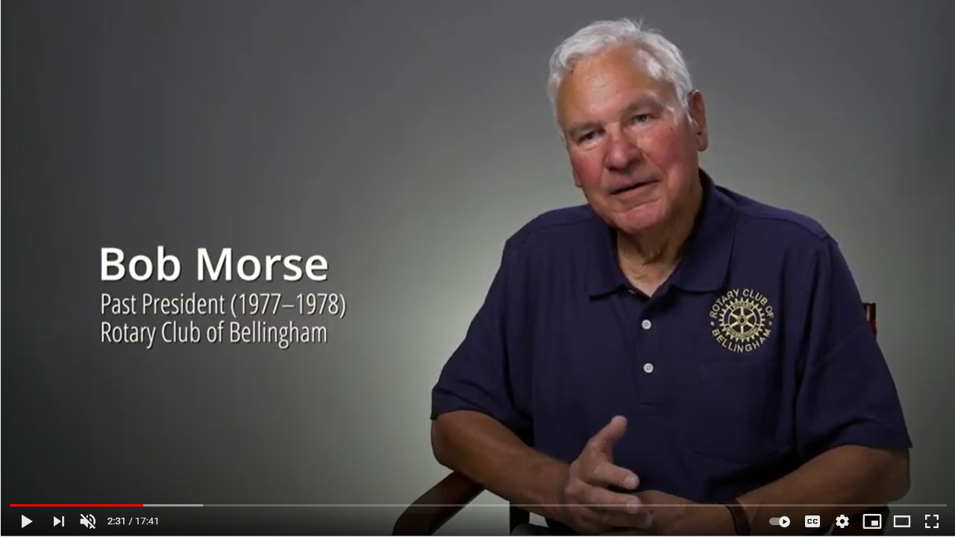
https://youtu.be/ZG48xYJe4YE

Internationally, our Club is involved in not only Rotary International, but we have first-handedly contributed to bringing infrastructure to villages in Honduras, provided water and infrastructure to villages in Africa, and have provided technology and learning systems to schools in Africa. These are a few of the initiatives we have contributed to in recent years.

We also have a strong scholarship program. In fact, in 2022, the Rotary Club Foundation provided $98,000 in scholarships to local worthy students.

This is just the tip of the iceberg! Our Club also participates in service projects, has social events, and weekly meetings with compelling guest speakers that are a wealth of information.

I would really love the opportunity to share a bit more, chat with you about what you are looking for in ways to give back, and see if we are a good fit. What is your availability…

