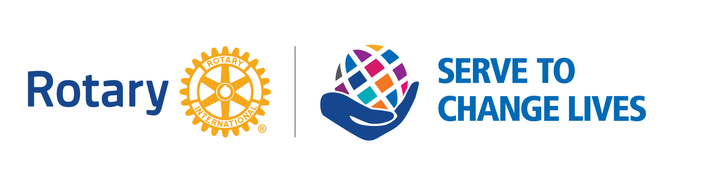

ROTARY CLUB OF FONTHILL

WEEKLY MEETING MINUTES
Wednesday, March 30th, 2022
Hybrid Meeting

- Welcome Guests – Beverley North interested in becoming a Club Member and Guest Speaker April Jeffs, Chair of Niagara Parks Commission

- Land Acknowledgement - Pat

We begin this gathering by acknowledging the land on which we gather is the traditional territory of the Haudenosaunee and Anishinaabe peoples, many of whom continue to live and work here today. This territory is covered by the Upper Canada Treaties and is within the land protected by the Dish with One Spoon Wampum agreement. Today this gathering place is home to many First Nations, Metis and Inuit people and acknowledging reminds us that our great standard of living is directly related to the resources and friendship of Indigenous people.

- Toast: Pat

To the Queen and Canada, To the Office of the President of United States, and To the President of Rotary International

- 4-WAY TEST: Pat
Of the things we think, say, or do
Is it the truth?
Is it fair to all concerned?
Will it build good will and better friendships?
Will it be beneficial to all concerned?

- Invocation: Pat

- Presidents Report, Correspondence and Announcements

- President Ann and her husband Mike borrowed a friend’s trailer to help load and transport collected items destined for Poland from St. John’s Ukrainian Catholic Church to Hamilton Airport. The Church is still asking for cash donations to help cover costs of renting hanger, flights and drivers to Ukraine.
- Crossley Interact has raised over $800 to date for Ukrainian Relief Fund through Rotary International.
- Paul Snack and Dick Goode were attending a meeting with students at EL Crossley this morning to continue Family Funfest planning. The students are proud to report that they have secured $7000 in sponsorship dollars. Way to Go!!!!!
- Home Show is April 8,9 and 10 at MCC. Our Club has booked a table for the weekend, and we are still in need of volunteers to set up and manage. You can register online.
- Outdoor Clean Up is scheduled for April 23. Registration is available online. We are meeting at 10am outside MCC and will start from there. Make sure you have waterproof boots.
- Our Club is still in need of finding a President Elect for 2023-24. It is a rewarding role and there is lots of member support to offer assistance.

- Guest Speaker – April Jeffs, Chair Niagara Parks – introduced by Dave Schulz
April’s presentation https://portal.clubrunner.ca/289/Documents/en-ca/02e26a45-f5ea-4f9e-af00-25a04bc605cc/1/

- Rotary Moment and Happy Loonies - Troy

- Birthdays and Anniversaries

Birthdays: Paul A ( Mar 5); Mel (Mar 19); Jason (Mar20)
Anniversaries: Ann (Mar 12)
Rotary: Ann, Janet, Meg and Pat Duncan

Next Meetings/Events:

April 6th – Guest speaker Mike Lethby from RAFT

April 8,9,10 – Home Show please sign up for sessions

April 13th – Irene Newton – President of Niagara Chapter, Ukrainian Canadian Congress

April 23rd – Earth Day Clean up – please sign up and meet at the MCC at 10 a.m.

April 26th – Joint Hybrid Meeting with Niagara Rotary Clubs – Please sign up via Eventbrite

