Rotary Fun Night
Hosted by Areas 11 and 12 Assistant Governors

When - Tuesday, August 25th
Where - Cheney Stadium (Opponent: Memphis)
Game Time – 7:05 pm
Pre-function – Starting around 5:30ish in parking lot
(We will have beer/wine/water with hotdogs & hamburgers)

Why – To have fun & make clubs stronger. This night brings together, in a social setting, Rotarians and Non-Rotarians to share current projects & ideas….Maybe even plan to work together on a new project.
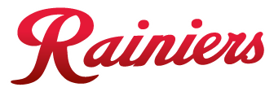

Rotary

and the

Invite friends, co-workers and any non-Rotarians to join us. The more Rotarians, non-Rotarians, friends and family the better.

RSVP – Friday, August 21st The Tickets need to be pre-paid. AG Scott will do so but all RSVPs will be responsible for reimbursing Scott. Payment to be given to President of club.

Ticket Cost - $15.50 (part of this cost pays for the Tailgating expense)

- Reserved Seat ticket (tentatively sitting in section E, 3rd base side)
- Ballpark meal: hot dog, chips and drink (once you are inside the park)
- Group recognition on the video board during the game

