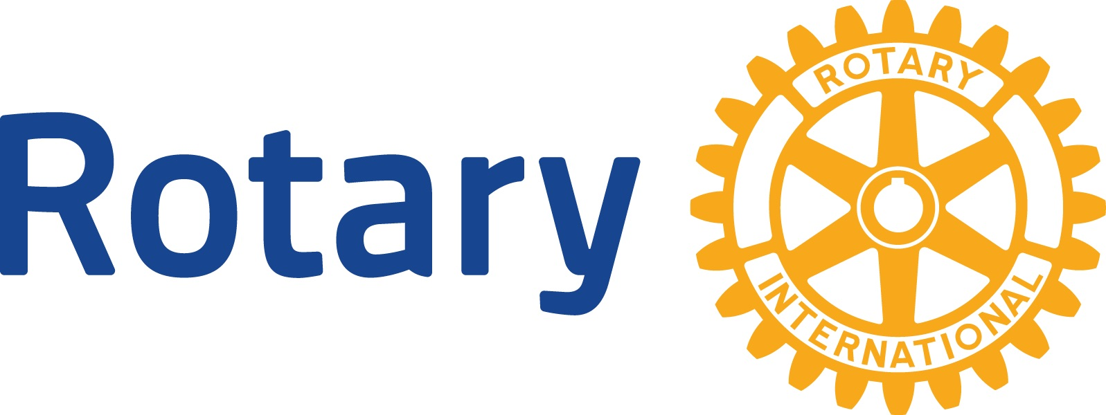
Meeting Speaker Guidelines – for Speakers

- Choose a topic of informational, educational, motivational or entertainment value that will be of general interest to a diverse range of club members.

- Refrain from controversial topics or volatile issues that could arouse anger and division. If you would like to present to the Club about a controversial or volatile issue, please contact the Rotary Board of Directors for direction, via the person who asked you to be a speaker. In such cases, we’ll want to ensure a balanced perspective.

- Refrain from political or religious topics. Rotary International is a non-political and non-religious organization. As a matter of policy, Rotary Clubs do not take positions on public questions, including political or international issues.

- Refrain from product or service sell promotion. Company executives are invited to speak about issues that affect their industry and the community and how they cope with them. Do not use the Rotary podium to promote products or services. Rotary speakers should refrain from dispensing individual financial advice.

- Avoid asking for funding. Requests for funding should only be presented during a meeting if the request has been formally approved, in advance, by the Board.

