Rotary Club of Camrose Daybreak
EyeOpener March 30, 2021 – Ultrasound Supply and Training in Africa

March is Water, Sanitation and Hygiene Month
April is Maternal and Child Health Month

Odell opened the meeting with a video of O Canada for 13 members, guests Dr Duffy and associate Lanice Jones, and Sahakarini members Barbara Frank and Laurie Barr

John offered Food for Thought on our dependence on just-in-time (JIT) supply and how it can be interrupted. Developed in 1970s car manufacturing plants, JIT has become standard practice for many businesses – Superstore, Walmart, etc. The Suez Canal 6-day blockage will result in delays and increased expense in delivery of goods to many destinations. Our east coast will see greater impact than us with late fuel deliveries to Irving in New Brunswick, etc. Some manufacturers and businesses are now hedging supply with a just-in-case level of stock to meet surprise demand or delivery interruptions.

Carol will offer Food for Thought next week

Happy Bucks

- Todd Hirsch gave a common sense economic presentation at noon club meeting
- 3 generations skiing at Norquay
- Aquasize at the swimming pool
- Physio program has knee working well, just have home exercises now
- Odell achieved the Paul Harris plus 3 award, congratulations

Announcements

- From this week’s Connections newsletter:
  - Youth Services Night to Network, Thursday, April 8 7:00-8:30 pm
  - Spring Leadership Assembly, Saturday, April 17 9:00 am-12:20 pm
  - Cyber Security, Sunday, April 18 5:00pm
  - District 5360 Conference-Navigate a New World, Saturday, May 1
  - Raffles at rafflebox.ca, some ending soon
- Rotary masks are available, let me know if you want one

Presentation – Ultrasound Supply and Training in Tanzania, Dr Deidre Duffy

Dr. Deirdre Duffy is a medical doctor and pilot currently living at Dried Meat Lake and working in the Red Deer Hospital Emergency department. She has been travelling to South America and Africa on medical flying missions. It was on one of these missions in Tanzania where her passion in sharing ultrasound technology really bloomed. After flying 5 plane crash victims to the Arusha Medical Center, she realized the medical team needed assistance. Seeing an old bedside ultrasound machine, held together with duct tape, she used it to diagnose some of the injuries. She established a relationship with the missionary doctor there, Dr Wendy Williams. Two years later in 2016 Dr Duffy was on a Flying Doctors mission in Nairobi. With a loaner ultrasound machine, she thought of training in Arusha which she did later in 2017. Further requests led to training in Nairobi and Dar es Salaam.

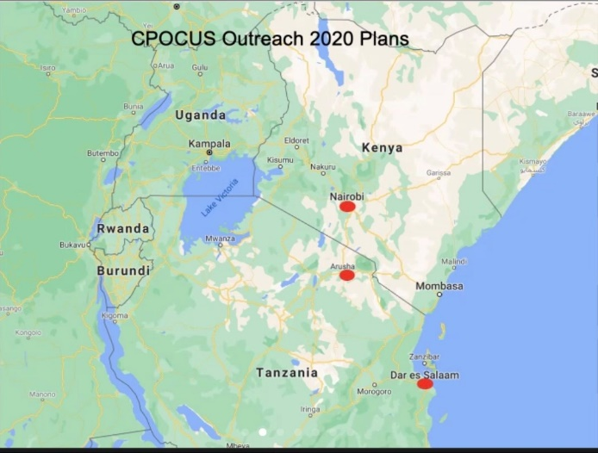

Dr Duffy presented a video on the history of bedside ultrasound in Canada. Ultrasound technology was introduced here in the 1980s and has developed to the point where we have access to ultrasound in every emergency department. But Africa is where we were 20 years ago – only available in major hospitals, operated by radiologists. Obstetricians have long used ultrasound, but now it is used to examine lungs, heart and other internals as well as to diagnose many other problems. A portable ultrasound machine can save many lives through early detection of problems and save money by limiting evacuation to major centres.

The Canadian protocol for bedside ultrasound is one of the highest standards in the world. The EDE (Emergency Department Echo) Course is internationally recognized. Canadians who need to attend this course can do it in Africa and then finish off with a holiday. Many Canadian medical specialists like to attend working holidays.

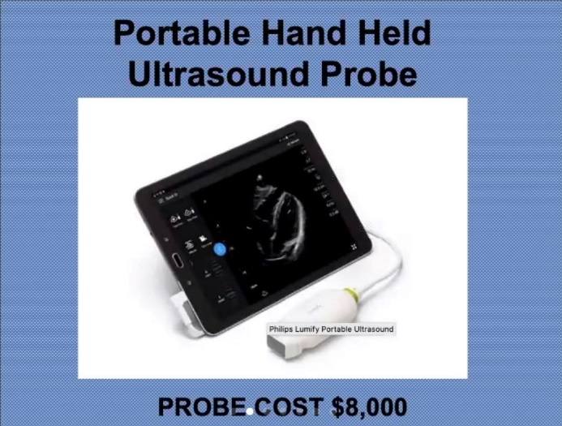

Her plan is to provide equipment and establish a sustainable shared training model where travelling Canadians attending the course will pay the standard C$5,000 course fee. A new ultrasound machine can be bought from the fees of two attendees, allowing the program to expand. Locals attending the course, at a local market rate, will take the training and with additional coaching become instructors, continuing the flow and increasing the number of instructors. As the network grows a broader population is reached.

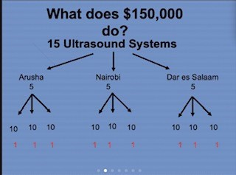

What they need help with, is funding the initial cost of $150,000 Canadian dollars. This will enable the purchase of 15 ultrasound units – 5 in each community to have a 2:1 student to machine ratio in each class of 10.

Here are the links where you can learn more.
https://edecourse.com/
https://cpocus.ca/
Home - Dr. Wendy Willmore (drwillmoremissionary.com) Tanzania/ Kenya PoCUS project : EDE Blog

Reminders

Tuesday April 6 7:00 am Club Meeting – Hesje Observatory, Dr Glynnis Hood
Tuesday April 13 7:00 am Club Meeting – COVID Effect on Alberta Tourism, Maven Boddy
Tuesday April 13 8:00 am Board Meeting

Rob led us in the Four Way Test to close the meeting

Morris Henderson
57.322.2555

ROTARY JOINS LEADERS | ROTARIANS SHARE IDEAS | ROTARIANS TAKE ACTION

