Rotary Club of Camrose Daybreak
EyeOpener May 10, 2021 Being a Canadian Diplomat

May is Youth Service Month

Ted opened the joint meeting with The Tenors rendition of O Canada

Happy Bucks
- Enjoying the weather, nice rain on the weekend
- Celebrated daughter’s 55th birthday
- Bidding is underway on BP Pizza for a Year, Tilly’s Pizza and the Oilers hoodie from Sports Excellence
- 400 stops on census route, some roads in poor condition
- Elk Island Park visit with grand-daughters
Presentation – Being a Canadian Diplomat, Richard Bruneau

Richard was a typical Camrose youth – school at Chester Ronning, Charlie Killam, the Comp and Augustana, work at Vinet King grocery. Change came after Ditmar Mundel, during his fourth year at Augustana, got him to participate in the Rural Development Exchange Program in Mexico. Learning about the complexities of development work and issues of social justice fostered his desire to improve people’s lives. Upon graduating, Richard worked with Canada World Youth in Bolivia, Uruguay, Guatemala and Western Canada.

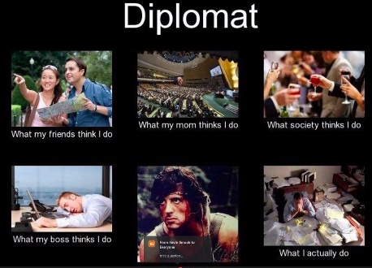
While seeking a Master’s degree at Carleton University Richard applied to the Canadian Foreign Service – a process that takes upwards of one year of interviews, reviews and scrutiny. The Service is looking for candidates of various backgrounds, international work experiences, multiple language competency. In 2006 as Canada was increasing its presence in Afghanistan, Richard was placed as a diplomat with the Afghanistan Task Force in Ottawa for orientation and to learn French and subsequently posted to Kabul. There he was tasked with research and logistics in the bilateral negotiations between the Afghan government, Taliban and other parties.

In 2008 Richard undertook working with the UN in New York and Geneva on the Arms Trade Treaty. Treaty negotiations take a long time to come to resolution. Agreement on chemicals took about 15 years, arms trade 5 to 6 years. Changes in governments, world opinion, personalities all play a part in the extended negotiations.

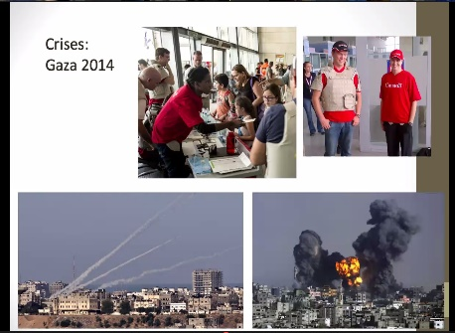
Two years of Arabic language training led to a posting as Counsellor for Canadian-Palestinian political relations in the West Bank and Gaza. Living in Jerusalem saw him dealing with the peace process, human rights and trade. The 2014 Gaza crisis led to assisting Israeli evacuations to Jordan. (are those pictures from this week?) This event left a bitter taste for Canada’s support of Israel and Richard left the Foreign Service to move with his wife to her family farm and learn the cow-calf business.

Richard and his brother-in-law now also operate the Fox and Fable bookstore and games café.

Bidding Winners
- BP Pizza for a Year – Shirley, Cliff and Lou share the pizza
- Tilly’s Pizza certificate – Ron
- Oilers Hoodie - Odell
Alan closed the meeting with the Four Way Test

Morris
587.322.2555

ROTARY JOINS LEADERS | ROTARIANS SHARE IDEAS | ROTARIANS TAKE ACTION

