Rotary Club of Camrose Daybreak
EyeOpener May 18, 2021 Purple Martins in Camrose

May is Youth Service Month

Happy Birthday to Larry this week, Happy Anniversary to Alan next week

Odell opened the meeting with a multi-lingual rendition of O Canada, Glen Hvenegaard and 11 members in attendance

An impromptu Food for Thought suggestion from Odell is to check out the Hive Mind article on how the International Bee Rotary Fellowship is helping to save the bees, page 22-23 in the May issue of the Rotary magazine.

Jackie recommends the bubble tea offered at a variety of outlets in Camrose as Food for Thought. Bubble tea originated in Taiwan and is tea with or without milk, flavoured with fruits such as strawberry or peach as well as a variety of other tempting flavours. The bubbles are actually tapioca pearls which can make some combinations smoothie like. A shortage of tapioca is concerning for the industry. Servings are priced comparable to Starbucks coffees.

Dean will offer Food for Thought next week.

Happy Bucks

- Yard cleanup help from Lisa, Celia, Kim, Lou and Morris appreciated by Carol
- Rain shower was welcomed along with a bullfinch landing in the yard
- Enjoyed time at the County Nature Conservation Centre, great spot to relax, see birds, fish
- Celebrated Norwegian Constitution Day (Syttende Mai, May 17th)

Presentation – Purple Martins in Camrose, Glen Hvenegaard

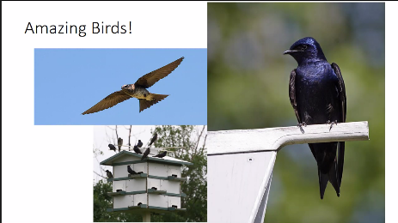
Purple martins are small, 60 gram or so, colonial birds that nest in provided condo nests in the east Rocky Mountains, Pacific coast and eastern US. Pairs of birds arrive here, to nest close to a previous nesting, in late April, early May only to leave late June to fly to Brazil for our winter. They are aerial insectivores aiding in controlling the mosquito and other insect numbers. The birds are docile when their nests, the multi-unit houses you see on poles around the community, are being checked for invaders such as house sparrows that will enter nests and kill birds and damage eggs. The birds seem to enjoy human interaction and do not resist handling.

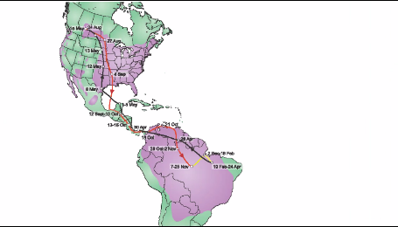
Concern over diminishing numbers has led to a variety of research into the migratory and community habits of the birds. Local enthusiasts have recovered 23 birds they banded and have used light loggers to track the migration. The lightweight light-logger is mounted on the bird and will record the sunrise and sunset time. When the bird is captured upon return to Camrose, the data can be retrieved and analyzed to trace the migration path. The typical migration is a 22,300 km round-trip. One trace shows a journey of 3 weeks to Central America for a one month stay in the area followed by another 3 weeks flying to Brazil. Four months is spent in a variety of places in Brazil before a speedy 3-week trip back to Camrose.

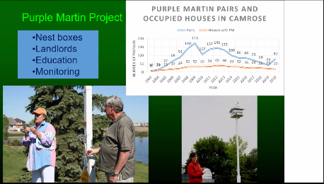
The Purple Martin Festival is an opportunity to learn more about the birds, share ideas and partake in field trips for hands-on experience. Unfortunately, the next festival will be in June 2022, but watch for events in June this year. Consider being a landlord, Glen, Dan Olafson and others are eager to help you get started enjoying the friendly purple martins.

Patterns or pre-built nesting condos are available for purchase. A concrete encased pile with a 16’ 4x4 post and winch assembly complete the structure. An open area where you can observe the birds and provide periodic inspections is desirable for placement.

Announcements

- Save the Date – Foundation Fundraiser Friday June 18, 7 pm Beer and Cider Tasting
- Flags will not be distributed for the May long weekend due to the health restrictions. If restrictions allow, flags will be distributed for July, August and September holidays
- Club dues for 2021-2022 remain at $250, payable in $125 instalments July 1 and January 1

Reminders

- Tuesday May 25, 7:00 am Club Meeting – Chronic Wasting Disease, John Pattison-Williams
- Tuesday June 1, 7:00 am Club Meeting – Battle River Research Group Carbon Project

Rob closed the meeting with the Four Way Test

Morris
587.322.2555

ROTARY JOINS LEADERS | ROTARIANS SHARE IDEAS | ROTARIANS TAKE ACTION

