Rotary Club of Camrose Daybreak
EyeOpener May 25, 2021 Chronic Wasting Disease

May is Youth Service Month
June is Fellowship Month

Odell opened the meeting with a KW Glee Club rendition of O Canada for 12 members and guest John Pattison-Williams present.

Dean offered Food for Thought on the teamwork, resiliency and tenacity that carried the Winnipeg Jets over the Edmonton Oilers. Winnipeg entered the playoffs as underdogs – 2-7 record against Oilers, losing streak, injuries. Edmonton has the two league scoring leaders and were on a roll. Winnipeg won the first 2 games in Edmonton – close games, could have gone either way, we’re not out of it was Edmonton’s story. Down 3-1 on McDavid, Draisaitl scoring with 9 minutes left in the third period of game 3, Winnipeg was undeterred. They believed, they pushed, they won in overtime. Game 4 pressure was all on Edmonton, Winnipeg stayed with their game and won in the 3rd overtime to sweep the Oilers. Winnipeg believed in themselves, never quit, played a team game and ignored the odds. That attitude and hard work paid off.

Rob will offer Food for Thought next week.

Happy Bucks

- House sold, move to Ontario in July
- This rain made its way east through Hardisty as far as Saskatchewan, first rain of the year
- Dismayed with Texas about to legalize open carry without a license

Presentation – Chronic Wasting Disease in Cervid (Deer), John Pattison-Williams
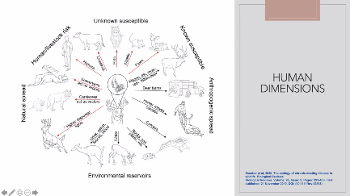
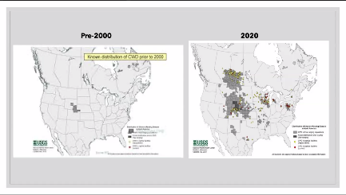
Chronic wasting disease is a disease of the brain in deer, elk, caribou similar in effect and in the same family as BSE in cattle. Research is underway to examine the transmission and spread of the disease.
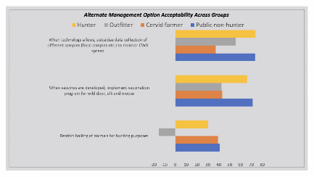
Much like our current pandemic there are many views and opinions on how to approach, deal with and manage the disease. Round tables, focus groups and discussions with veterinarians, outfitters, hunters, elk farms, citizens at large and politicians have not led to consensus and in fact, at times have led to acrimonious outcomes.

The disease is fatal to the animal, who when weakened may fall to predators. Older males are the prime target and are incapacitated in 3 to 5 years. There is work underway for vaccines to assist commercial operators, but research is lacking on the origin of the disease, whether wild or incapture herds are most affected, whether there is a high or low spread.

Announcements

- RI Virtual Convention June 12 to 16, riconvention.org to register and view schedule of speakers, keynotes, breakouts and events
- Save the date – Virtual Beer and Cider Tasting, June 18, 7:00 pm
- Check the raffles on rafflebox.ca for Rotary and areas of interest to you – lots of groups looking for your support

Reminders

- Tuesday June 1, 7:00 am Club Meeting – Battle River Research Group Carbon Project, Khalil Ahmed
- Tuesday June 8, 7:00 am Club Meeting – We Are Rotary
- Tuesday June 8, 8:00 am Board Meeting

Rob closed the meeting with the Four Way Test

Morris
587.322.2555

ROTARY JOINS LEADERS | ROTARIANS SHARE IDEAS | ROTARIANS TAKE ACTION

