Rotary Club of Camrose Daybreak
EyeOpener June 1, 2021 Battle River Research Group

June is Fellowship Month

Odell opened the meeting with an Aboriginal rendition of O Canada for guest Khalil Ahmed and 14 members present

Destiny and Rob have birthdays later this month, Dean and Odell have wedding anniversaries

Rob noted the changes the weather has brought in the last couple of weeks as Food for Thought. Snowflakes, rain and cool temperatures seemed to be setting a trend for a cool, wet spring but the sun came out and it warmed up. An explosion in plant growth launched the renewal spring offers. Potatoes, corn, lettuce and garlic are sprouted; cows and calves were anxiously anticipating their release to pasture and quickly headed for the grassy pastures when the gates were opened. This activity brings you pause to ‘wonder’ how is the soil so productive? How can this garden provide for so many? Investment in research by groups such as the one we hear from today, the Battle River Research Group, continue to lead the progress and innovation needed in agriculture as government steps back.

John will offer Food for Thought next week.

Happy Bucks

- Chance conversation with neighbour in Canmore, member of Canmore Rotary Club. Have 109 members, were meeting Tuesday 8:00 am at golf course with nice buffet
- January cruise cancelled (makes 4 cancelled)
- Haircut on the schedule with restrictions eased
- Provided flagpole, etc to Police Service for Pride recognition, Pride Day moved to June 15
- Houston RI convention information is available at riconvention.org, early bird registration open
- Planted replacements for the frozen tomato plants
- YouTube video predicts climate change will make Russia a food powerhouse – same for Canada?
- Chris has children’s books to share with other Little Free Library stewards
- New food truck added to fleet in Camrose on former Catholic Church property downtown

Presentation – Battle River Research Group, Khalil Ahmed

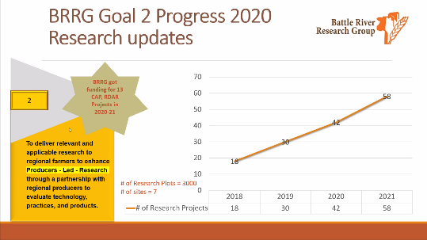
Established in 1988, the Battle River Research group is a farmer-led not-for-profit organization performing a variety of agriculture, primarily grains, related experiments to determine best practices. Based out of Forestburg their work focusses on the five counties of Paintearth, Stettler, Camrose, Beaver and Flagstaff. Many projects include collaboration with universities and colleges such as Lethbridge, the UofA and Lakeland. Recently on-farm partnerships have been formed to further research. With the federal and provincial governments reducing or eliminating budgets and research stations the group has been spurred to more actively pursue partnerships and grants. Their work over the last 30 years has garnered a reputation of thorough and effective research, appropriate experiments and trials and widespread support from farmers, producers and government. They have been able to fund the staffing and expertise to perform effective research.

Announcements

- Rotary Virtual Convention June 12 to 16 – information and registration at riconvention.org
- Camrose Creek Disc Golf Course baskets are in, tee boxes and signs to come
- Polio Watch – YTD only 1 case in each of Pakistan and Afghanistan

Reminders

- Tuesday June 8, 7:00 am Club Meeting – We Are Rotary
- Tuesday June 8, 8:00 am Board Meeting
- Tuesday June 15, 7:00 am Club Meeting – ‘Where Credit is Due’, Namaste Direct documentary

Rob closed the meeting with the Four Way Test

Morris
587.322.2555

ROTARY JOINS LEADERS | ROTARIANS SHARE IDEAS | ROTARIANS TAKE ACTION

