Rotary Club of Camrose Daybreak
EyeOpener July 14, 2020 Social Distancing

Alan and Rob led O Canada for 9 members outside at Grand Drive Park to open the meeting

Announcements

- Our flag program along with St Albert’s were featured in the current issue of the District Connections newsletter. Alan’s flag picture was included.
- Recordings of General and Breakout sessions from the Rotary 2020 Virtual Convention are available at riconvention.org. July breakouts are also available there.
- Centra Cam is looking for donations of T-shirts to be made into rags for a client of theirs. If you have old T-shirts to donate you can drop them off at the Centra Cam main building by the airport or call me and I will pick them up.
- The Certified Training building is for sale. Although a sale is not imminent, we need to start considering alternatives for meetings, storage and activities. Space at Le Chateau and the Rotary Youth Centre were immediate suggestions. Keep your thinking caps on.

Happy Bucks

- Garden fresh salad fixings
- Caution as a case in Camrose and 3 in County
- Happy to be in Camrose and not with daughter in Texas, having record breaking case numbers
- Enjoyed time with daughter’s family, grandchildren in Regina Beach
- 40th wedding anniversary
- Annual fishing getaway
- Off to Vernon
- Only ¼ inch of water in cabin basement

Disc Golf

We had an opportunity to see a disc golf basket, try some throws in the wind and talk about pursuing a disc golf course in Camrose.

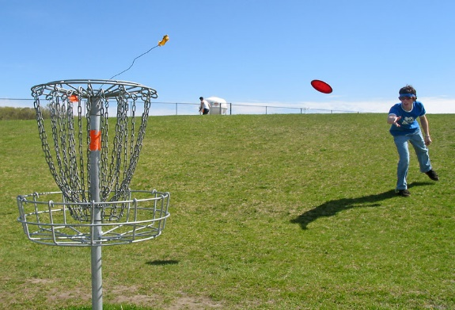
This picture will give an idea of what the golf basket (hole) looks like. You want to get the disc (frisbee) into the basket.
This Photo by Unknown Author is licensed under CC BY-SA

A variety of discs are available for drives (long throws, mid-range and chips (shorter throws) and putting (close throws). Discs range from professional versions to usual playground styles to promotional giveaways.

Courses are developed by having additional baskets. Courses can be professionally designed and feel similar to a regular golf course or merely nade to fit a given area.

Conversation about places for a course in Camrose ranged from a 9 or 18 hole course in Jubilee or Rotary Four Seasons Park to having smaller 3 hole courses in community parks such as Duggan Park, Victoria Park, Century Meadows Park, etc. Would having a number of community courses help build interest in developing a tourist draw course? Would the city be on side? Will the appeal to all ages be a strong selling point? Where would players get discs? This and many other questions were tossed around, talked about and fueled the interest.

Obviously we have a lot of discussion and work to do before there is a dosc golf course in Camrose but there was interest to pursue the investigation. People that were unaware of what disc golf is were pleased to see and try the sport.

Next Meeting – Tuesday Jily 21, 7:00am, Odell will send Zoom invite

District Governor Jim Ferguson Zoom Visit
Board Meeting - Monday, July 27, 7:00 PM. Send Morris pictures of service projects and Rotary sights you want to share with the District Governor
Club Meeting – Tuesday, July 28, 7:00 AM

Rob and Alan led members in the 4 Way Test to close the meeting

Morris
587.322.2555

