Edmonton Downtown Club Roasted Oilers’ President to Raise $60,000

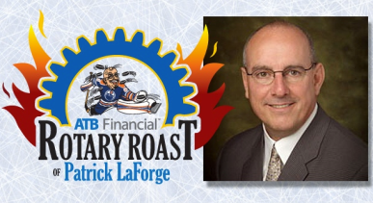
On February 13, the Edmonton Downtown Club treated an energized crowd of 450 guests with a spectacular evening of hockey themed live entertainment – the ATB Financial Rotary Roast of Patrick LaForge.

The ice surface of the Rexall Place was transformed into a comedy club. Patrick LaForge, Edmonton Oilers President and a long time member of the Club, was put in the defense zone, taking stiff yet comedic shots from eight high-profile Edmontonians: Allan Wachowich, Bryan Hall, Garry Meyer, Jason Strudwick, Jim Jerome, Jim Matheson, Len Rhodes and the Mystery Roaster Ruth Kelly. However, with his quick wit, Patrick defended himself “against these evil attackers” and had the final laugh. The Edmonton Oiler Octane Dance Team was also there to entertain, mingle and sell 50/50 tickets. The Club raised more than $60,000, exceeding its fundraising goal of $50,000.

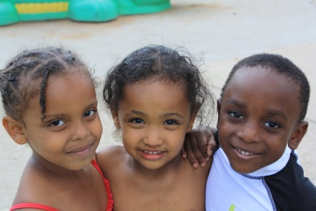
All proceeds from the evening go towards the renovation of the Boys and Girls Clubs Big Brothers and Sisters McCauley Club. This inaugural Rotary Roast event proved to be incredibly successful in other ways as well. In addition to the financial success, the event generated more than $100,000 of media sponsorship including CTV, Edmonton Journal, and 630 CHED. The event has helped to increase the public awareness of the good work Rotarians do in our community. Because of the remarkable success the Rotary Roast event has produced, we are already planning for the next Roast event and we sincerely hope to see you there.

