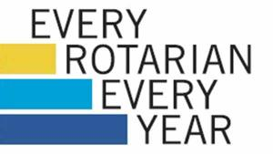 |  | 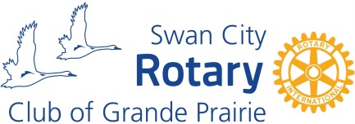

Rotary Foundation Donation Form

Where This Money Goes
The money is held by Rotary International in the Annual Fund and invested for 3 years. Return on investment is used to assist in RI operations so they can continue to do manage the great work of all Rotary Clubs around the world. The funds are split 50-50 between the World Fund (Rotary International Grants) and District Designated Funds (District 5370 Grants – our district). Rotary clubs can apply for grant funding for humanitarian projects in areas such as health, education and the alleviation of poverty. Examples include disease prevention, clean water, literacy, peace and the eradication of Polio.

Swan City Rotary has accessed these funds in the past for our projects in Mexico, Ethiopia, Chile and Cambodia. In the last 3 years we have received district grants for our Highway to Mexico, Philip J. Currie Dino Museum Tours and Friendship Centre projects.

Sign Up Today
Rotary International’s target for contributions is $100US per year per Rotarian. $100US is approximately $35 CDN per quarter. Donors who contribute an accumulated $1000US will be recognized as a Paul Harris Fellow. Each multiple of $1000US is also recognized. Donors who contribute over $10,000 will be recognized as a Major Donor. Your donation truly changes the lives of people in this community and all over the world.

Thank you for your generosity!

Donor’s Name: |  |  | Date:

I would like to donate to the Rotary Foundation via the following method (choose one):
- I hereby authorize the Swan City Rotary Club to add a donation to the Rotary Foundation on my regular quarterly billings in the amount of $ ___________ / quarter.
- I hereby authorize the Swan City Rotary Club to process a one-time donation to the credit card below in the amount of $ ____________.
- Please find a one-time donation in the form of a cheque / cash / e-transfer in the amount of $ ____________.

Card Number: |  |  |  | Expiry:
 | (Write “On File” if credit card is currently on file)
Cardholder’s Signature:

The Rotary Foundation of Canada will provide tax receipts on a quarterly basis.

