PO Box 3062

**There’s no place like home …**

**to start your career**

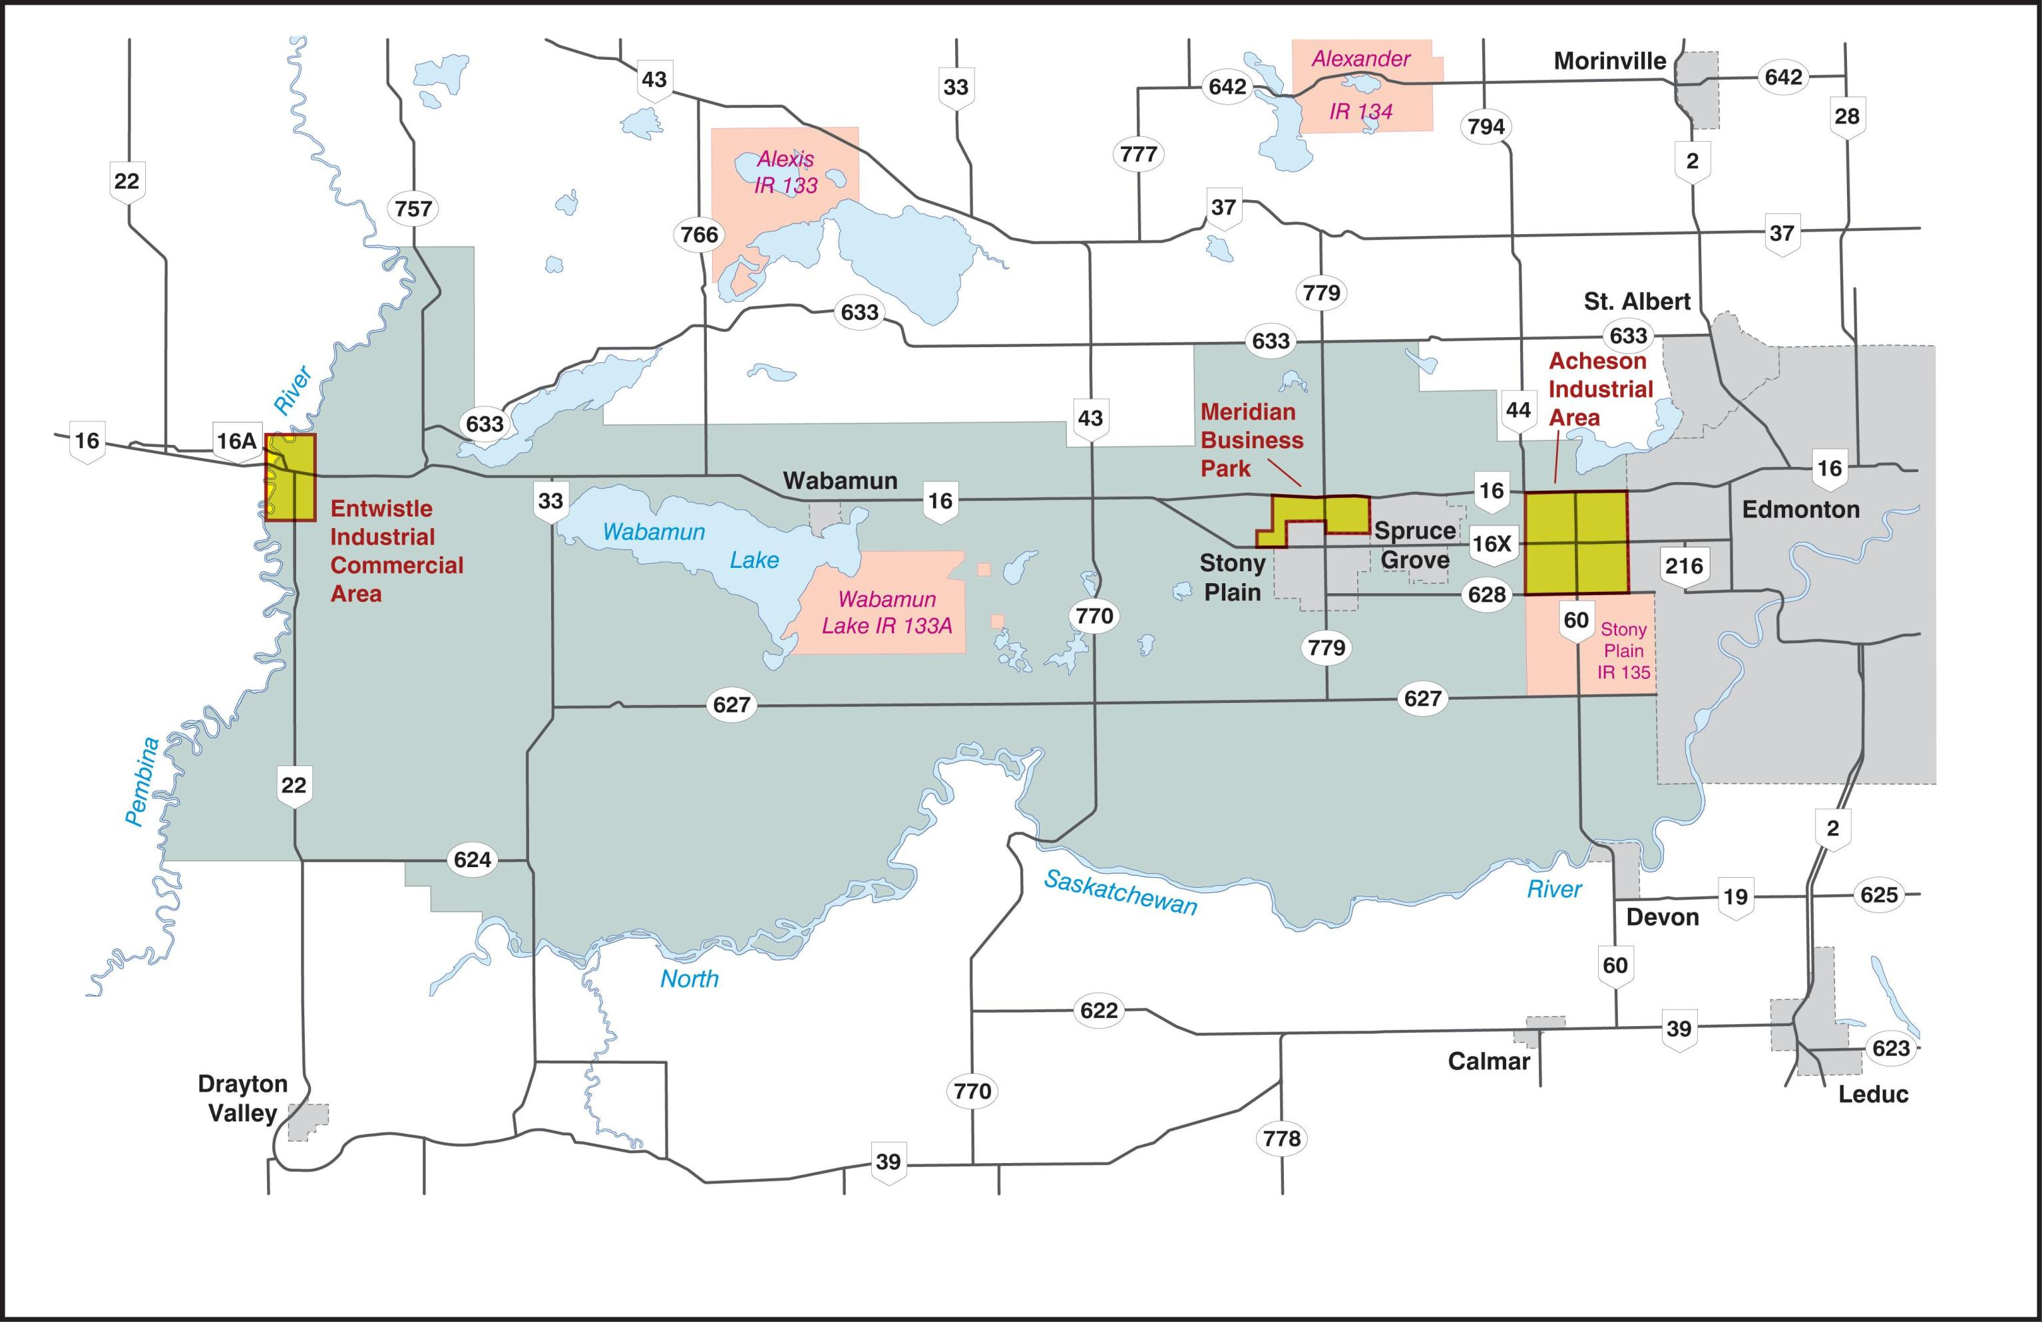

Spruce Grove, AB T7X 2A5

**You are Invited!**

Save the Date: Tuesday, March 22, 2016

Please join the Rotary Club of Spruce Grove and our local High School Students as a participant in our first Vocational Day from 6:30 pm to 9:30 pm at the Horizon Stage, Spruce Grove Composite High School (SGCHS).

This event is designed to bring together local businesses with local students looking to plan their continuing education with the potential to work for your company.

Students will be looking for local career employment as well as summer and part time employment, with the focus of staying in the community where they have friends and family.

You have two opportunities to participate: rent a table in the foyer of SGCHS and/or make a four minute (maximum) on-stage presentation on Horizon Stage as part of this event (see attached form).

“One important key to success is self-confidence. An important key to self-confidence is preparation.” – Arthur Ashe

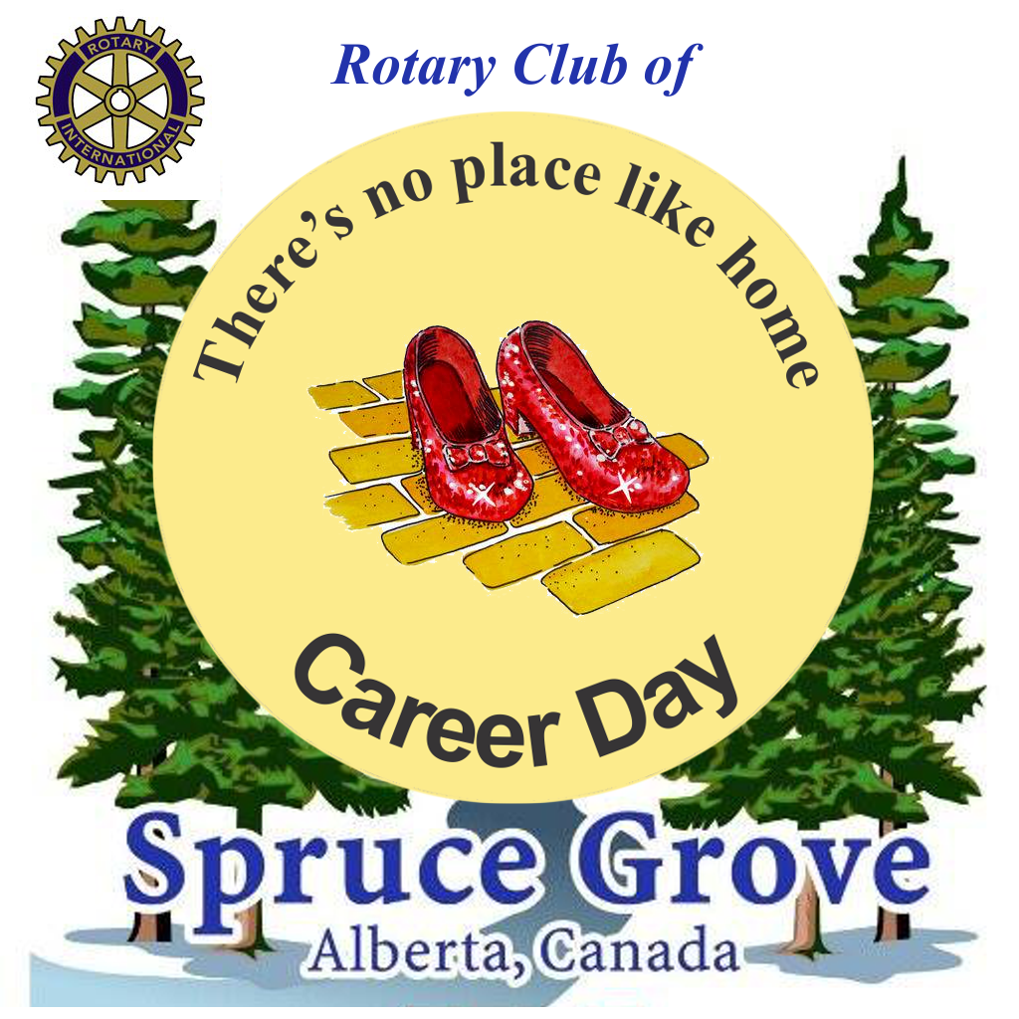

Sincerely yours,

Spruce Grove Rotary

**Dianne Brown, Chair, ph. 780-963-4605 logcabinpottery@gmail.com**