PO Box 3062
Spruce Grove, AB T7X 2A5

Vocational Day 2016
Company Name:
Address:
Phone: Cell:
Email Address:
Company Contact:
Signature:
We agree to take part in the Rotary Vocational Day Event.
Tuesday, March 22, 2016, 6:30 pm to 9:30 pm, Horizon Stage, Spruce Grove Composite High School
The participation costs are: Table $50.00
Add the five minute (maximum) stage presentation for an additional $100.00
Total:
Paid by: Cash / Cheque(s)
prior to the event, supplying all details at the time.
There’s no place like home …
to start your career
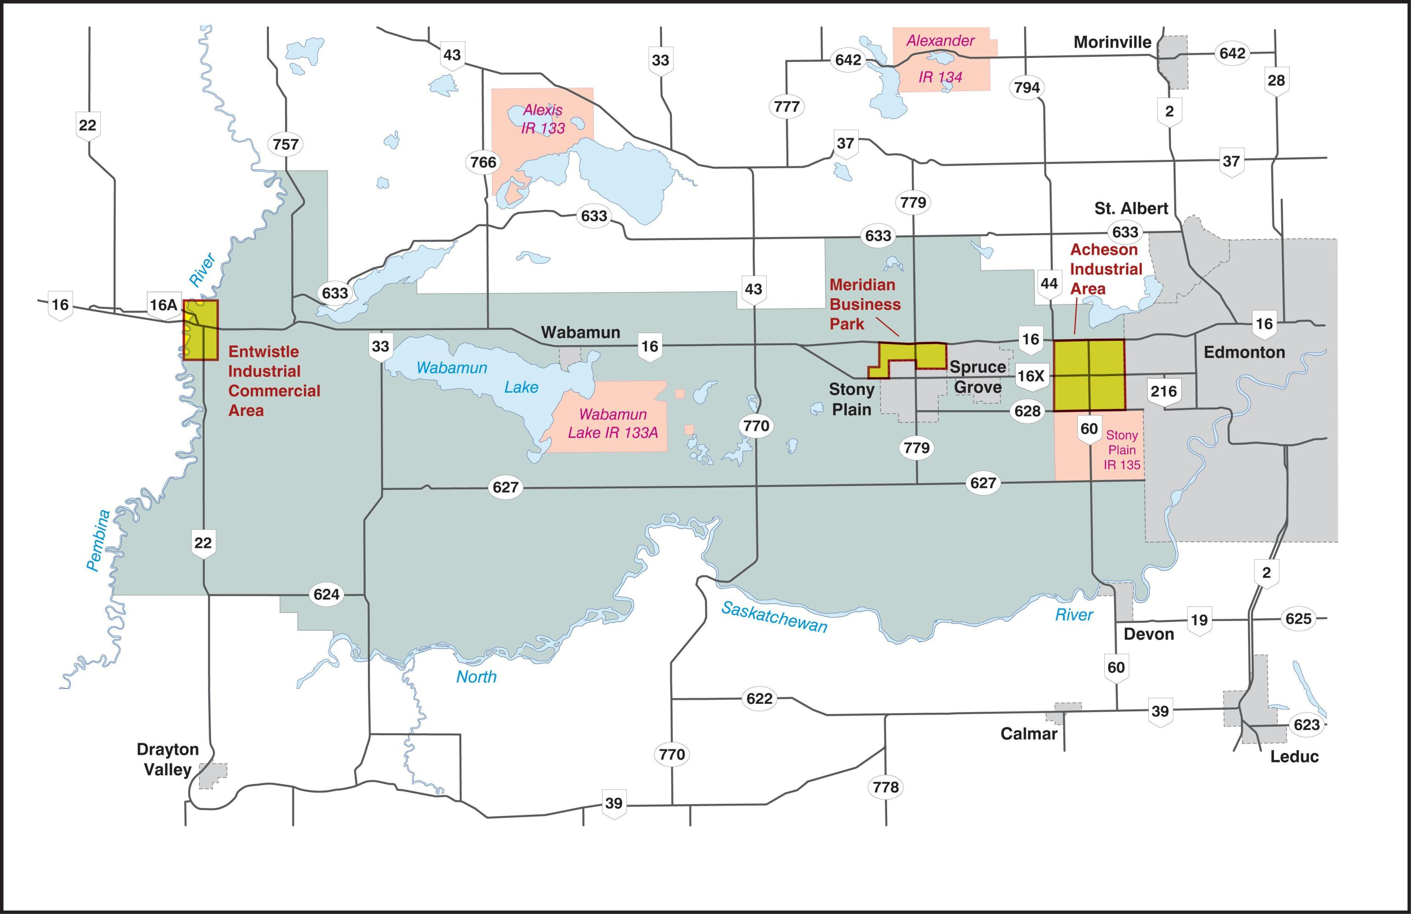
Rotarian Signature:

Give form to Dianne Brown, Chair, ph. 780-963-4605 logcabinpottery@gmail.com

