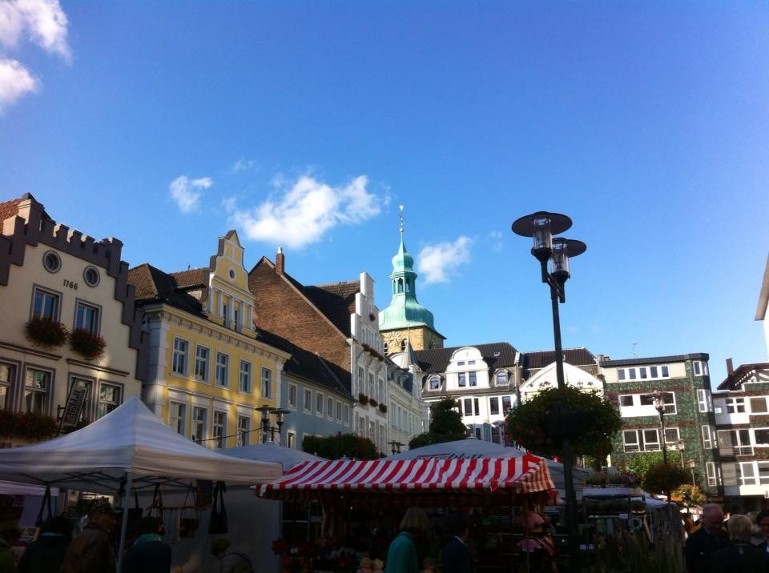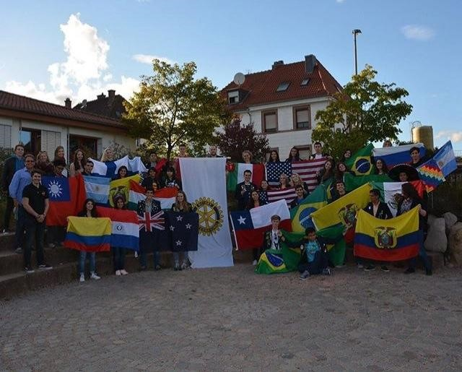
The Youth Exchange Scholarship
Valued at over $20,000:
Room, board, tuition, and monthly stipend for a high school year abroad.
YOUR LOCAL ROTARY CLUB:
Rotary Club of Spruce Grove
Meets: Thursdays from 12:00 – 1:30pm at the Grove Motor Inn.

Have you always dreamed of…

⇒ Traveling the World?
⇒ Living in another Country?
⇒ Being fluent in another language?

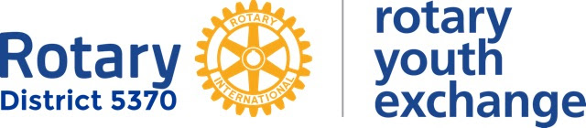

THE YOUTH EXCHANGE SCHOLARSHIPS ARE MADE POSSIBLE BY THE GENEROSITY OF OUR OVERSEAS PARTNERS AND LOCAL ROTARY CLUBS IN ROTARY DISTRICT 5370 QUALIFIED APPLICANTS MUST BE AGES 16-18 Yrs. AT THE TIME OF DEPARTURE. THE SCHOLARSHIPS COVER ROOM, BOARD, TUITION, AND A MONTHLY STIPEND FOR ONE ACADEMIC YEAR.
or Contact your local Rotary club

The Rotary Youth Exchange Scholarship

Rotary District 5370’s Youth Exchange Program, with the help of our local Rotary clubs and our overseas partners, has made a number of Rotary Youth Exchange Scholarships available for the 2018-19 academic year. Valued at over $20,000, each scholarship covers room (homestay), board, tuition, and a monthly stipend while overseas.
The Rotary Scholarship is travel to their host countries in approximately late July to mid-September,
2018, and return in approximately late June of the following year. They’ll attend high school in their host countries and are expected to act as goodwill ambassadors representing Rotary and their home country Canada.
Minimum Requirements to apply:
- Between 16 and 18½ on September 1, 2018 (may currently be in 9th, 10th, or 11th grade
- Good academic standing
- Open-minded individuals who demonstrate leadership qualities
Applicants are not required to be involved with Rotary in any way before applying. Children of Rotarians are welcome to participate but are not given any preference. Home-schooled and private school students, and students with disabilities are encouraged to apply
To learn more:
Fill out the Initial Application form, and submit to:

Michael Klassen – Outbound Coordinator 2018-2019: mdkedm@gmail.com

You will be scheduled for an informational interview to discuss details, and to determine your suitability for the program.

Deadline: Friday, November 10th, 2017

ROTARY YOUTH EXCHANGE
LETTER OF INTENT

(Students Please Note: If your application to your local Rotary Club is successful and you are selected by the club as a prospective Youth Exchange Student, you will receive a link to complete the necessary application forms which you will have to complete and submit to the District Committee for approval and placement. APPROVAL BY THE LOCAL CLUB OF YOUR CANDIDACY IS NOT A GUARANTEE OF APPROVAL OR PLACEMENT BY THE DISTRICT COMMITTEE.)

I, the undersigned, have read and understand the Rules and Guidelines governing the Youth Exchange Program of Rotary International District 5370. I have sought and obtained consent from my parents and would like to submit my application as a prospective Youth Exchange Student sponsored by the Rotary Club of .

Name of Student:

Full Address:

ZIP Code: Telephone Number:

Date of Birth: Citizenship:

Name of School Attending:

Email Address

Grade (year in school): Class Standing (average grade):

Extracurricular activities:

Special interests and hobbies:

Future plans:

Father’s name: Mother’s name:

Address: Address:

Occupation: Occupation:

Phone no. Phone no.

Names and ages of brothers and sisters (list on back if more space is needed):

If you become an Exchange Student, are your parents willing to host an incoming student?

Yes
No
If NO, why not?

For information only: We have exchanged with Italy, France, Belgium, Austria, Switzerland, Denmark, Finland, Netherlands, Swe- den, Germany, Mexico, Brazil, Argentina, Peru, Bolivia, South Africa, India, Japan, and others are possible.
Signature of Student:  Date of signature: | Signature of Parent:  Date of signature:

Email to: Michael Klassen at mdkedm@gmail.com

Next step will be a personal interview with the Rotary Club Youth Exchange Committee, yourself and your parents. You will be notified when your interview will take place via the email listed on the application.

Rules and Conditions of Exchange

As a Youth Exchange student sponsored by a Rotary club or district, you must agree to the following rules and conditions of exchange. Please note that districts may edit this document or insert additional rules if needed to account for local conditions.

- You must obey the laws of the host country. If found guilty of violating any law, you can expect no assistance from your sponsors or native country. You must return home at your own expense as soon as released by authorities.

- You are not allowed to possess or use illegal drugs. Medicine prescribed to you by a physician is allowed.

- The illegal drinking of alcoholic beverages is expressly forbidden. Students who are of legal age should refrain. I f your host family offers you an alcoholic drink, it is permissible to accept it under their supervision in the home.

- You may not operate a motorized vehicle or participate in driver education programs.

- You will be under the host district's authority while you are an exchange student and must abide by the rules and conditions of ex- change provided by the host district. Parents or legal guardians must not authorize any extra activities directly to you. Any relatives you may have in the host country will have no authority over you while you are in the program.

- You must attend school regularly and make an honest attempt to succeed.

- You must have travel insurance that provides medical and dental coverage for accidental injury and illness, death benefits (including repatriation of remains), disability I dismemberment benefits, emergency medical evacuation, emergency visitation expenses, 24- hour emergency assistance services, and legal services, in amounts satisfactory to the host Rotary club or district in consultation with the sponsor Rotary club or district, with coverage from the time of your departure from your home country until your return.

- You should have sufficient financial support to assure your well-being during your exchange. Your host district may require a contingency fund for emergency situations. Unused funds will be returned to your parents or legal guardians at the end of your exchange.

- You must follow the travel rules of your host district. Travel is permitted with host parents or for Rotary club or district function s authorized by the host Rotary club or district with proper adult chaperones. The host district and club, host family, and your parents or legal guardians must approve any other travel in writing, thus exempting Rotary of responsibility and liability.

- You must return home directly by a route mutually agreeable to your host district and your parents or legal guardians.

- Any costs related to an early return home or any other unusual costs (language tutoring, tours, etc.) are the responsibility of you and your parents or legal guardians.

- You should communicate with your first host family prior to leaving your home country. The family's information must be provided to you by your host club or district prior to your departure.

- Visits by your parents or legal guardians, siblings, or friends while you are on exchange are strongly discouraged. Such visits may only take place with the host club's and district's consent and within their guidelines. Typically, visits may be arranged only in the last quarter of the exchange or during school breaks and are not allowed during major holidays.

- Tal k with your host club counselor, host parents, or other trusted adult if you encounter any form of abuse or harassment.

Recommendations for a Successful Exchange

- Smoking is discouraged. If you state in your application that you do not smoke, you will be held to that position throughout your exchange. Your acceptance and host family placement is based on your signed statement. Under no circumstances are you to smoke in your host family's bedrooms.

- Body piercing or obtaining a tattoo while on your exchange is not allowed, for health reasons.

- Respect your host’s wishes. Become an integral part of the host family, assuming duties and responsibilities normal for a student of your age or for children in the family.

- Learn the language of your host country. Teachers, host parents, Rotary club members, and others you meet in the community will appreciate the effort. It will go a long way in your gaining acceptance in the community and with those who will become lifelong friends.

- Attend Rotary -sponsored events and host family events, and show an interest in these activities. Volunteer to be involved; do not wait to be asked. Lack of interest on your part is detrimental to your ex- change and can have a negative impact on future exchanges.

- Avoid serious romantic activity. Abstain from sexual activity.

- Get involved in your school and community activities. Plan your recreation and spare-time activities around your school and community friends. Don't spend all your time with other exchange students. If there is a local Interact club, you are encouraged to join it.

- Choose friends in the community carefully. Ask for and heed the advice of host families, counselors, and school personnel in choosing friends.

- Do not borrow money. Pay any bills promptly. Ask permission to use the family phone or computer, keep track of all calls and time on the Internet, and reimburse your host family each month for the costs you incur.

- Limit your use of the Internet and mobile phones. Excessive or inappropriate use is not acceptable.

- If you are offered an opportunity to go on a trip or attend an event, make sure you understand any costs you must pay and your responsibilities before you go

