Dominica

Project of a Portable Saw Mill
Dear Jan,
Thank you for concern for Dominica and your generous offer of help. The situation here is that most of the high value downed trees are in rather inaccessible mountainous areas. A lot are in the national forest. The wood has to be cut by portable chainsaw and hand carried to the road. There is a need for simple chainsaw guides that the local forestry officers can use to make straighter cuts with the hand chainsaw. …………….
I look forward to hearing from you.
Kindest Regards,
Anne Winn
VP, Rotary Club of Portsmouth

History of the most recent significant hurricanes to strike Dominica. US$ figures are damage costs.

1979 Hurricane David 56 deaths, US$1.54b.
1980 Hurricane Allen - no data found.
1999 Hurricane Lenny US $21.5m.
2015 Tropical Storm Erika 30 deaths, US$482.8m.
2017 Hurricane Maria 31+ deaths, US$1.37b.

Hurricane Maria, 2017,is the worst natural hazard-induced disaster strike the island in recorded history.
- Hurricane David destroyed 80% of the homes, leaving 75% of the population homeless. The impact was most severe on the agriculture industry destroying the 75% of the banana and coconut crops. There was severe damage to the ecosystem which had still not recovered by 2017 when Hurricane Maria struck.

- Asymmetric structure of Tropical Storm Erika combined with mountainous Dominican terrain and moisture aloft brought up to 33 inches of rain, triggering catastrophic floods and mudslides. Hundreds of homes were destroyed, thousands displaced. Entire town of Petite Savanne was evacuated and subsequently abandoned. Rebuilding was halted in Sept 2017 by Hurricane Maria.

- Hurricane Maria damaged the roofs of as much as 98% of the island's buildings, including those serving as shelters, and half of the houses had their frames destroyed. Its ferocious winds defoliated nearly all vegetation, splintering or uprooting thousands of trees and decimating the island's lush rainforests. The agricultural sector, a vital source of income for the country, was completely wiped out: 100% of banana and tuber plantations were lost, as well as vast amounts of livestock and farm equipment.

Estimated budget for the Logosol Portable sawmill for Yellowknife Rotary, landed at the National Airport; $8,000

Local Projects after last Hurricane, by the Portsmouth Rotary Club, this among many projects:

- Secure and cover homes, with local Rotarian and Swiss Rotarians from Zurich
- Produce clean water, by working with California based charity, Waves for Water
- Produce food from local recourses, by produce local Fish pots.

For more information; www.rotaryportsmouth.org

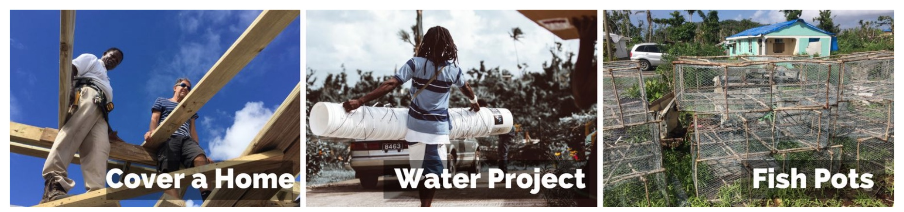

Charity Waves for Water, www.wavesforwater.org/
We encourage people to look at aid-work or humanitarianism as a lifestyle, rather than a component of doing good and giving back

General information from 2017:
www.theguardian.com/global-development/2017/nov/01/it-feels-like-dominica-is-finished-life-amid-the-ruins-left-by-hurricane-maria

Product that will fit the local needs and condition):
http://www.logosol.ca/sawmills/f2-chain-sawmill/

