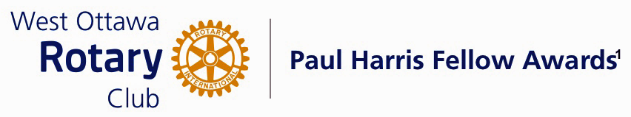

Conferred on Alex Munter June 27, 2023
Turbulent times often bring out the best in people. The medical system that we have all revered for so long has been under incredible pressure for the past few years. Institutions have been stretched well beyond their limits. This statement certainly reflects the realities of the situation at the Children’s Hospital of Eastern Ontario. CHEO has experienced unprecedented pressures on all its services during the pandemic and especially during the last few months of 2022 and early months of 2023.

Our community has been very open in support of the superlative efforts of CHEO to overcome this significant pressure to provide the very best of pediatric care to those in need of its vital services. CHEO, Ottawa and Eastern Ontario, have been very fortunate to have had Mr. Alex Munter as the CEO of this institution. Alex Munter's style has been very open , transparent and honest, involving his staff and the community at large. His leadership has also been felt across the Province of Ontario, rallying other pediatric and health care centers by advocating to the Provincial Government about the needs of children’s physical and mental health.

Alex has gained the respect and admiration of all around him, with his leadership style and strong advocacy and commitment to children’s health. He constantly has paid close attention to the mental health and physical well being of the children who come to CHEO for help; to their parents and loved ones, to his treasured staff and to the public at large with his boundless energy and commitment, both day and night. He has tirelessly kept his fingers on the pulse of all situations that have come into his sphere.

All involved with CHEO have held their spirits and labour high through the efforts and leadership exemplified by Alex Munter. His accomplishments make him an ideal recipient of Rotary’s Paul Harris Fellowship Award.

Alex Munter, please come forward and accept your Paul Harris Fellow Award.

THE PAUL HARRIS FELLOW AWARD
The Paul Harris Fellow Award is named after Paul Harris, a Chicago Attorney who in 1905 founded Rotary, a group of friends that became a service club. Rotary has since evolved to become Rotary International, a service organization of some 34 000 Rotary clubs. The Paul Harris Recognition Program was introduced by the Trustees of The Rotary Foundation in 1957 to encourage donations to the Foundation. The Rotary Club of West Ottawa adopted the program to create the Paul Harris Fellow Award. The Award recognizes individuals who have given distinguished service that exemplifies the ideals and objectives of Rotary. To bestow the Award, the Club contributes US $1000 to The Rotary Foundation in the name of the individual to be honoured; that individual is then named a Paul Harris Fellow by the Foundation.

For individuals who are members of the Rotary Club of West Ottawa, a nominee should meet at least three of the following criteria to become a recipient of the Paul Harris Fellow Award:

- Served a minimum of two (2) years on the Club’s Board of Directors;
- Chaired two (2) or more of the Club’s Standing Committees;
- Performed noteworthy volunteer service in the Club over the years;
- Provided extraordinary support or leadership in Club fundraising;
- Performed a unique role, or provided years of special service for the Club;
- Enhanced the Club’s reputation or public profile;
- Been active on a Rotary District Committee; and
- Performed outstanding volunteer service for the community, external to Rotary.

