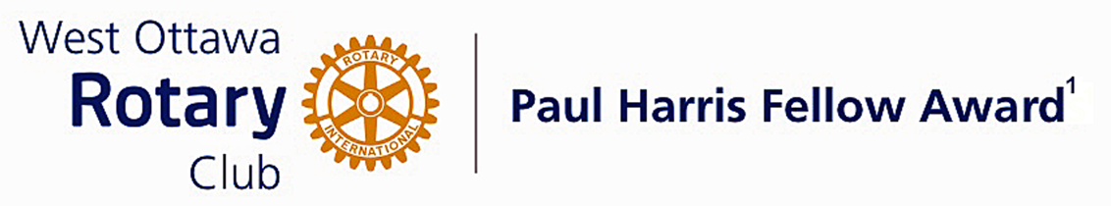

Conferred on Ava Hill June 28, 2022
Ava Hill is a Mohawk, Wolf Clan and until 2019 was the Chief of the 56th and 57th Six Nations Elected Council.
She represented Six Nations on the Aboriginal Partnership for the 2015 Pan Am Games in Toronto.
For many years, Ava Hill has engaged internationally with the United Nations Permanent Forum on Indigenous Issues.
She was recognized for her volunteer work when she was awarded the YMCA's Peacemaker Medal in 2020.
Ava continues her work with the International Commonwealth Games Federation, promoting a Declaration on Reconciliation with Indigenous Peoples Through Sports.
Her words " reconciliation must inspire all of us to transform society so that our children and grandchildren can live together in dignity, peace and prosperity on these lands that we now share."
Ava, thank you for helping us to learn to live together in a peaceful and respectful way.

Congratulations Ava, on your Paul Harris Award.

The Paul Harris Fellow Award

The Paul Harris Fellow Award is named after Paul Harris, a Chicago Attorney who in 1905 founded Rotary, a group of friends that became a service club. Rotary has since evolved to become Rotary International, a service organization of some 34 000 Rotary clubs. The Paul Harris Recognition Program was introduced by the Trustees of The Rotary Foundation in 1957 to encourage donations to the Foundation. The Rotary Club of West Ottawa adopted the program to create the Paul Harris Fellow Award. The Award recognizes individuals who have given distinguished service that exemplifies the ideals and objectives of Rotary. To bestow the Award, the Club makes a contribution of US $1000 to The Rotary Foundation in the name of the individual to be honoured; that individual is then named a Paul Harris Fellow by the Foundation.
For non club members a nominee must meet at least one of the following criteria:
- Has made an outstanding personal or business contribution that has significantly enhanced the welfare of the community at the local, national or international level; or
- Has made an outstanding personal or business contribution that has significantly improved understanding and generated mutual respect between or among people of different races, cultures or countries; or
- Has performed outstanding community service in support of youth, the elderly, the underprivileged, the disabled or the developmentally challenged; or
- Exemplifies the qualities of the good citizen and provides a role model of the ideal community builder.

~ ~ ~

