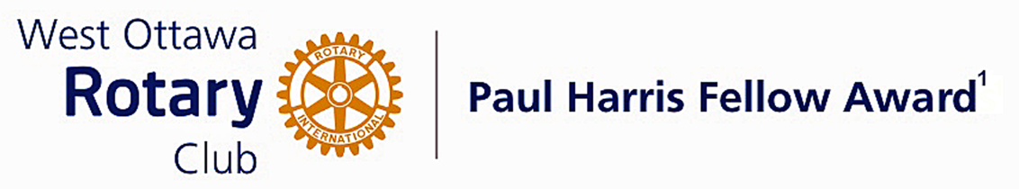
Conferred on Bea Osome June 28, 2022
Bea Osome's extensive work in fundraising for water wells has allowed us to access District funds to expand the benefits of her water wells and potable water systems and hygienic toilets in Kenya.
She has also performed a unique role to our club over a period of years by ensuring that there is onsite management and responsibility for the projects that we have supported over the years.
Her knowledge of local business practices, financial processes, public attitudes and political environment of the area have ensured the success of projects that we support and want to succeed.
Bea has enhanced the reputation of our Club and of Rotary by hosting major public events where the projects are having a positive effect on the people who live there. Those high profile events link our efforts to those who need our help the most.
Bea has also provided outstanding volunteer service to others outside of Rotary. Her dedication and support to newcomers in our area were recognized when she was honoured as a WOW ambassador in 2014 in our community. (Welcoming Ottawa Week)
She was also recognized as a Member Emeritus of the RNAO (Regional Nurses Association of Ontario) for her 40 plus years of dedicated work.

Congratulations Bea, on your Paul Harris Award.

The Paul Harris Fellow Award

The Paul Harris Fellow Award is named after Paul Harris, a Chicago Attorney who in 1905 founded Rotary, a group of friends that became a service club. Rotary has since evolved to become Rotary International, a service organization of some 34 000 Rotary clubs. The Paul Harris Recognition Program was introduced by the Trustees of The Rotary Foundation in 1957 to encourage donations to the Foundation. The Rotary Club of West Ottawa adopted the program to create the Paul Harris Fellow Award. The Award recognizes individuals who have given distinguished service that exemplifies the ideals and objectives of Rotary. To bestow the Award, the Club makes a contribution of US $1000 to The Rotary Foundation in the name of the individual to be honoured; that individual is then named a Paul Harris Fellow by the Foundation.
For individuals who are members of the Rotary Club of West Ottawa, a nominee should meet at least three of the following criteria to become a recipient of the Paul Harris Fellow Award:
- Served a minimum of two (2) years on the Club’s board of Directors;
- Chaired two (2) or more of the Club’s standing committees;
- Performed noteworthy volunteer service in the Club over the years;
- Provided extraordinary support or leadership in Club fundraising;
- Performed a unique role, or provided a special service for the Club over the years;
- Enhanced the Club’s reputation or public profile;
- Been active on a Rotary District committee;
- Performed outstanding volunteer service for the community, external to Rotary.

~ ~ ~

