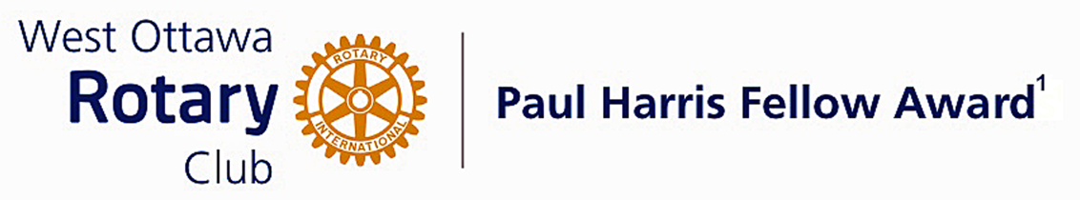

Conferred on Caroline DeWitt June 28, 2022

In our Rotary Year of 2019/2020, as President of our club, Caroline was the first President to be faced with a pandemic and the restrictions and challenges that created. She was able to lead the club through this difficult time and laid the groundwork for our club to continue its work in our community without the normal in person meetings.
She has been an active participant in our major fundraisers: the Mums for Thanksgiving and our Rotary Calendar where she was the chair of that committee for two years.
She led our club to support the Rotary Club in Trinidad and Tobago to provide educational support for children in that area.
Caroline, thank you for your leadership and commitment to maintain the strength and vitality of our Club. It allowed us to continue to give our best to those who needed help the most during a most difficult time.
Congratulations Caroline, on your Paul Harris Award.

The Paul Harris Fellow Award

The Paul Harris Fellow Award is named after Paul Harris, a Chicago Attorney who in 1905 founded Rotary, a group of friends that became a service club. Rotary has since evolved to become Rotary International, a service organization of some 34 000 Rotary clubs. The Paul Harris Recognition Program was introduced by the Trustees of The Rotary Foundation in 1957 to encourage donations to the Foundation. The Rotary Club of West Ottawa adopted the program to create the Paul Harris Fellow Award. The Award recognizes individuals who have given distinguished service that exemplifies the ideals and objectives of Rotary. To bestow the Award, the Club makes a contribution of US $1000 to The Rotary Foundation in the name of the individual to be honoured; that individual is then named a Paul Harris Fellow by the Foundation.
For individuals who are members of the Rotary Club of West Ottawa, a nominee should meet at least three of the following criteria to become a recipient of the Paul Harris Fellow Award:
- Served a minimum of two (2) years on the Club’s board of Directors;
- Chaired two (2) or more of the Club’s standing committees;
- Performed noteworthy volunteer service in the Club over the years;
- Provided extraordinary support or leadership in Club fundraising;
- Performed a unique role, or provided a special service for the Club over the years;
- Enhanced the Club’s reputation or public profile;
- Been active on a Rotary District committee;
- Performed outstanding volunteer service for the community, external to Rotary.

~ ~ ~

