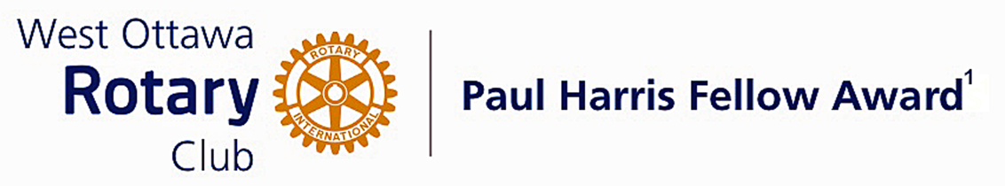

Conferred on David Bettney June 28, 2022
David Bettney and his wife are registered missionaries with the Latin American Missions. That led him to a group called Stove Team International, where he has spent many years installing award winning ecocina stoves.
He made connections with many communities and raised support for the awareness of the need for these life saving stoves. Smoke from indoor cooking stoves is the leading cause of death in Latin America in children under five.
Stove Team's model was awarded the U.S. Environmental Protection Agency Partnership for Clean Indoor Air Award for developing local markets.
David worked with a local company called the ECopan Factory and then delivered the stoves to families in Honduras who were in need. He travelled long distances into remote areas to deliver and install these life changing stoves.
His work with the communities in Honduras continued due to his connection with Water Ambassadors Canada. He organized teams to come to Honduras to help install the water purification systems and repair hand pump wells.
David, you have made a most significant contribution to improving the lives of others.
Congratulations David, on your Paul Harris Award.

The Paul Harris Fellow Award

The Paul Harris Fellow Award is named after Paul Harris, a Chicago Attorney who in 1905 founded Rotary, a group of friends that became a service club. Rotary has since evolved to become Rotary International, a service organization of some 34 000 Rotary clubs. The Paul Harris Recognition Program was introduced by the Trustees of The Rotary Foundation in 1957 to encourage donations to the Foundation. The Rotary Club of West Ottawa adopted the program to create the Paul Harris Fellow Award. The Award recognizes individuals who have given distinguished service that exemplifies the ideals and objectives of Rotary. To bestow the Award, the Club makes a contribution of US $1000 to The Rotary Foundation in the name of the individual to be honoured; that individual is then named a Paul Harris Fellow by the Foundation.
For non club members a nominee must meet at least one of the following criteria:
- Has made an outstanding personal or business contribution that has significantly enhanced the welfare of the community at the local, national or international level; or
- Has made an outstanding personal or business contribution that has significantly improved understanding and generated mutual respect between or among people of different races, cultures or countries; or
- Has performed outstanding community service in support of youth, the elderly, the underprivileged, the disabled or the developmentally challenged; or
- Exemplifies the qualities of the good citizen and provides a role model of the ideal community builder.

~ ~ ~

