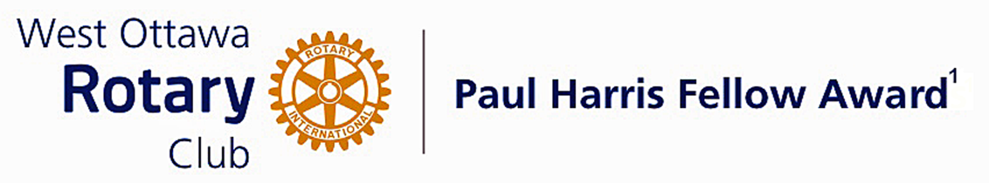
Conferred on Don Butler June 29, 2021
Rotarian Don Butler has performed many services for our Club which are often not appreciated. In 2017 when Rod Holmes ended many successful years as the Club’s Spinoff Editor, we needed a dedicate member to step into those shoes and Don was our man.

He chairs the Bulletin Committee and leads a team of Spinoff writers.
He also takes his turn at writing the Spinoff weekly edition. As such he follows up where statements are in doubt, usually resolving the matter by calling up the writer to clarify.

Don is a stickler for accuracy and good grammar spending countless hours on verifying the facts using the internet as his encyclopedia.

He was Co-chair of the Mums campaign from 2015 until 2018.

Don was the Mums Project Treasurer in 2019 and helped in that area the previous year. As such he collected the payments for Mums plants and deposited them into the Club account at a TD branch. He then provided the information to the Treasurer. This work had to be done in a specific manner using prescribed forms such that the data and reports would fit seamlessly into the Club Treasurer’s accounts. Inevitably, issues arose regarding payments which Don resolved skillfully.

In 2018 and 2019 he was a member of the Mums Committee and one of several members who created routes for delivery of the plants.

Don is a member of the Program Committee and has been for the many years offering suggestions for appropriate speakers.

This Rotarian flies under the radar. He performs duties which are the backbone of the Clubs major activities. He feels it is the duty of every Rotarian to perform club duties before doing something for himself. This Rotarian feels he does not deserve this award but, we: your nominators, the Awards Committee, the RCWO Board of Directors and the Club Membership do!

Don please accept this Paul Harris Fellow award for 2021.

The Paul Harris Fellow Award

The Paul Harris Fellow Award is named after Paul Harris, a Chicago Attorney who in 1905 founded Rotary, a group of friends that became a service club. Rotary has since evolved to become Rotary International, a service organization of some 34 000 Rotary clubs. The Paul Harris Recognition Program was introduced by the Trustees of The Rotary Foundation in 1957 to encourage donations to the Foundation. The Rotary Club of West Ottawa adopted the program to create the Paul Harris Fellow Award. The Award recognizes individuals who have given distinguished service that exemplifies the ideals and objectives of Rotary. To bestow the Award, the Club makes a contribution of US $1000 to The Rotary Foundation in the name of the individual to be honoured; that individual is then named a Paul Harris Fellow by the Foundation.
For individuals who are members of the Rotary Club of West Ottawa, a nominee should meet at least three of the following criteria to become a recipient of the Paul Harris Fellow Award:
- Served a minimum of two (2) years on the Club’s board of Directors;
- Chaired two (2) or more of the Club’s standing committees;
- Performed noteworthy volunteer service in the Club over the years;
- Provided extraordinary support or leadership in Club fundraising;
- Performed a unique role, or provided a special service for the Club over the years;
- Enhanced the Club’s reputation or public profile;
- Been active on a Rotary District committee;
- Performed outstanding volunteer service for the community, external to Rotary.

~ ~ ~

