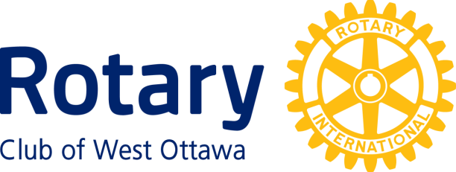

***Family and Community Service Award***

***Conferred upon Ottawa Riverkeeper June 27th, 2023***

The Ottawa Riverkeeper has demonstrated an unwavering commitment to preserving and protecting the ecosystem and the natural environment by adopting a river in our local community. Through their tireless efforts they have made a significant impact on the health of the river and the surrounding ecosystem.

Their work includes regular cleanup efforts, testing the quality of the water, protecting the native American eels, removal of invasive species and implementation of measures to prevent pollution and habitat degradation.

Their dedication to the environment is reflected in their numerous achievements: for instance in 2019, organized 17 shoreline cleanups, collected 2,000 lbs. of trash, tested 493 water samples. Currently they have established a Riverwatch network, developed 14 indicators to measure the health of the water and encouraged volunteers to post images to demonstrate that the river’s improved water quality is drinkable.

Their work serves as an inspiration to us all and we hope their efforts will inspire others to take action in protecting our natural environment.

Over the years our Rotary Club has established a relationship with the Ottawa Riverkeeper. In 2019 we had Ms. Chloe Hillier of the Ottawa Riverkeeper to be our guest speaker. In 2020 the Ottawa Riverkeeper’s CEO Ms. Logue was our guest speaker at our weekly meeting. We then collaborated with them on a service project to clean up the river as part of Rotary’s Adopt A River Initiative.

We acknowledge the Ottawa Riverkeeper with our Family and Community Service Award in recognition of their exceptional work in adopting a River (Ottawa River), which is consistent with Rotary’s Adopt a River Initiative- Great Lakes Watershed cleaning the rivers of the world. Please accept this award and our thanks.

Family and Community Service Award

Rotary clubs may confer the Family and Community Service Award on individuals and organizations for outstanding service to families and communities, or in recognition of the positive contributions to individual Rotary clubs made by spouses or family members of Rotarians.

For organizations as well as individuals not related to a member of the Rotary Club of West Ottawa: The awardee must have provided outstanding service to families, neighbourhoods or local communities in the National Capital Region.

For members of families of West Ottawa Rotarians, the awardee must either:

* Have provided outstanding service to families, neighbourhoods or local communities in the National Capital Region, or
* Have made a significant contribution to the work of the Rotary Club of West Ottawa.

The following persons and organizations have received this Award:

2009 Trudi Kersley; Ottawa Police Service.

2010 City of Ottawa, Parks & Recreation

2011 Bushtukah; Dorothy Young

2013 St. Luke’s Lunch Club & Drop-In Centre

2014 Parkdale Food Centre

2015 Twice Upon A Time

2018 Cat Weaver; Jennifer Wyatt & Deborah Wyatt; Ryan Armitage

2019 West Carleton Warriors; Results Canada – Ottawa Chapter; Hospice Care Ottawa

2021 The Ottawa Tool Library

2022 Nathalie Maione

2022 Shelter Movers Ottawa