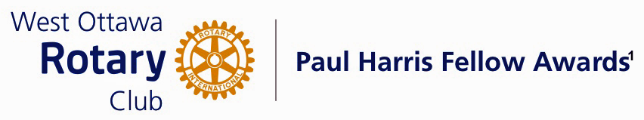
Conferred on Jennifer Ahde June 27, 2023
This Rotarian, joined our club in 2012. She immediately became very active an involved in building our club and supporting our projects. Her initial passion was helping us to attract new members. She took on leadership of a group called "New Generations" and initiating fireside chats, answering any questions and explaining some of our club's history to the newer members of our club.

Her interest in building our club continues. She has taken the lead on another initiative called Future Directions. This committee examines the fundamental direction our Club will embark on over the coming years. This required identifying and valuing where our Club has been, and evaluating where we are going. It involves a high knowledge and sense of just what makes our Club tick; thoughts of what our membership needs are; and what will make the RCWO a leader into the future. She has dedicated a considerable amount of her time and skills, to thoughtfully analyze our future.

She was on our club's Board of directors from 2015 - 2018. Her leadership skills and dedication has also taken another direction in Rotary, having taken on a position with the Board of Rotel, a Rotary sponsored project. Rotel is a 50-room, non-profit motel facility serving patients and families using Ottawa area hospitals. Rotel has been designed to keep patients and their loved ones in close touch and to ease the stress on the lives of outpatients. Although new to this Board, the use of her legal training and positive personality has contributed to the workings and direction of this important institution in our Community. Throughout our Region, volunteer Boards are desperately searching for good people for their institutions. She is one of those people.

Throughout her Rotary membership, she has also served as Chair of at least three committees. One of the most memorable and hard working committee was the Music for Humanity in 2017- 18. She organized and arranged the venue, the musicians and the ticket sales which culminated in a substantial donation to Polio Plus, one of Rotary International’s most ambitious and important world programs.

Put quite simply, this Rotarian has earned and fulfilled all the qualifications to becoming a Paul Harris recipient.

Jen Ahde, please come forward and accept your Paul Harris Fellow Award.

THE PAUL HARRIS FELLOW AWARD

The Paul Harris Fellow Award is named after Paul Harris, a Chicago Attorney who in 1905 founded Rotary, a group of friends that became a service club. Rotary has since evolved to become Rotary International, a service organization of some 34 000 Rotary clubs. The Paul Harris Recognition Program was introduced by the Trustees of The Rotary Foundation in 1957 to encourage donations to the Foundation. The Rotary Club of West Ottawa adopted the program to create the Paul Harris Fellow Award. The Award recognizes individuals who have given distinguished service that exemplifies the ideals and objectives of Rotary. To bestow the Award, the Club contributes US $1000 to The Rotary Foundation in the name of the individual to be honoured; that individual is then named a Paul Harris Fellow by the Foundation.

For individuals who are members of the Rotary Club of West Ottawa, a nominee should meet at least three of the following criteria to become a recipient of the Paul Harris Fellow Award:

- Served a minimum of two (2) years on the Club’s Board of Directors;
- Chaired two (2) or more of the Club’s Standing Committees;
- Performed noteworthy volunteer service in the Club over the years;
- Provided extraordinary support or leadership in Club fundraising;
- Performed a unique role, or provided years of special service for the Club;
- Enhanced the Club’s reputation or public profile;
- Been active on a Rotary District Committee; and
- Performed outstanding volunteer service for the community, external to Rotary.

