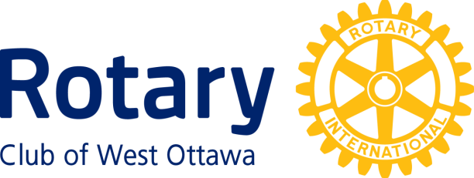

Ruth Martin Award for Community Service
Conferred upon Jenn Hayward , June 29th, 2021

Jenn Hayward is a Metis originating from Saskatoon. She began service when she was a Human Justice Major with the University of Regina.
Jenn moved to Ottawa in 2007 for a new position with Correctional Service Canada focussing on Indigenous Justice.
When Jenn arrived in Ottawa she began producing comedy shows that benefitted the Elizabeth Fry Society. She won a Femmy Award which is given annually by a collective of women and is given to women who identify as feminist who do community service.
In 2016 Jenn attended Coady Institute's Global Change Leaders Program. She joined 24 women from around the world learning about International Development. She traveled to Kenya in 2018 and immediately invested in African Grassroots, a microfinance social enterprise.
As the owner of her own courier company, she works with local charities and women's groups offering free pickups for charitable events and food hamper programs. This includes Shepherd’s of Good Hope, Harmony House, Harvest Dinner, Wabano and other ad hoc requests.
She has written for the CBC for several years, and has a syndicated column educating with humour on Indigenous issues.
Jenn’s future goals include more community service focusing on social enterprises and empowering communities. Doing it all with her husband and three foster children, Jenn is doing it all.
Jenn Hayward, a most worthy candidate for the Ruth Martin award.

The Ruth Martin Award for Community Service

Ruth Martin, after whom this Award is named, dedicated much of her life to the betterment of the community at large. Ruth’s husband, John Martin, established this Award with the Rotary Club of West Ottawa after her death in tribute to her ideals and life of service to the community.

The Awardee must have performed noteworthy service over a period of years for the well-being of the community that encompasses the National Capital Region. Any organization or individual is eligible Except the Rotary Club of West Ottawa or members of that Club.

The following members of the Rotary Club of West Ottawa to date have received this award:

1996 Patricia Henry 1997 Elsie Gertrude Scott
1998 Elizabeth I. Davies 1999 Margaret Pranschke
2000 Dian Craig 2001 Moe Atallah
2002 Eva Lamb 2003 Marion Gullock
2004 Jim McNeill 2005 Barry Bregman
2006 Charles Austin 2008 Elaine Garfinkel
2009 Kevin Frost 2010 Mark Emery
2011 Don Flynn 2012 Margaret Knight
2013 Hazel Bowen 2014 Kent & Mary Brown
2016 Rev. Anthony Bailey 2018 Isabelle Nicol & Sandra Garland
2019 Shehla Kerim

~ ~ ~

