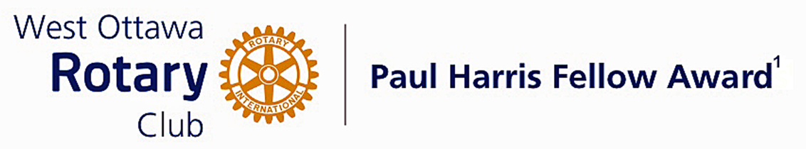

Conferred on Larry Chop June 28, 2022
Larry has been on the Board of Directors for two years and has been Director of Club Service and Fellowship for the past two years.
He supports our club in many venues, including being the chair of the Photography committee since 2018.
He has been co-chair of the Program committee for the last four years. In this group he is also the secretary and spends many hours keeping the group updated on the latest speaker changes to ensure that every club meeting runs smoothly.
Larry has been valuable in our club fundraising, and has been a member of the Mums Committee for several years and is now Co-chair of that group. His supportive role with Rocco has helped ensure the success of our Mums fundraiser this past year.
His expertise on the computer and the club's electronic use of Clubrunner has made him a "go to" guy for questions and helping others to learn how to make the best use of this program.
Congratulations Larry, on your Paul Harris Award.

The Paul Harris Fellow Award

The Paul Harris Fellow Award is named after Paul Harris, a Chicago Attorney who in 1905 founded Rotary, a group of friends that became a service club. Rotary has since evolved to become Rotary International, a service organization of some 34 000 Rotary clubs. The Paul Harris Recognition Program was introduced by the Trustees of The Rotary Foundation in 1957 to encourage donations to the Foundation. The Rotary Club of West Ottawa adopted the program to create the Paul Harris Fellow Award. The Award recognizes individuals who have given distinguished service that exemplifies the ideals and objectives of Rotary. To bestow the Award, the Club makes a contribution of US $1000 to The Rotary Foundation in the name of the individual to be honoured; that individual is then named a Paul Harris Fellow by the Foundation.
For individuals who are members of the Rotary Club of West Ottawa, a nominee should meet at least three of the following criteria to become a recipient of the Paul Harris Fellow Award:
- Served a minimum of two (2) years on the Club’s board of Directors;
- Chaired two (2) or more of the Club’s standing committees;
- Performed noteworthy volunteer service in the Club over the years;
- Provided extraordinary support or leadership in Club fundraising;
- Performed a unique role, or provided a special service for the Club over the years;
- Enhanced the Club’s reputation or public profile;
- Been active on a Rotary District committee;
- Performed outstanding volunteer service for the community, external to Rotary.

~ ~ ~

