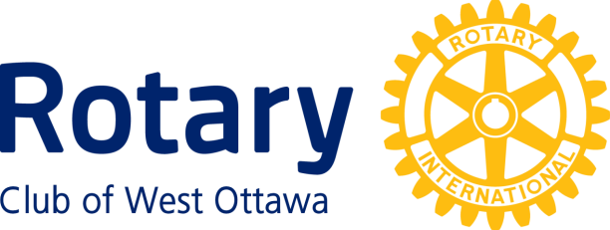

In recognition of outstanding dedication to the principles of Rotary International, and in grateful appreciation of exceptional contributions to the formation and evolution of the distinctive spirit of the Rotary Club of West Ottawa, the Board of Directors is
most pleased to name
Len Baird

an Honoured Life Member of
the Rotary Club of West Ottawa.

__________________________ ________________________
Caroline DeWitt Dave Morton President Secretary
June 29, 2021

Honoured Life Membership
in
the Rotary Club of West Ottawa

The Award of Honoured Life Membership is given for outstanding service to the Club and to Rotary over an extended period of time. The Club’s Policy on Awards states that Honoured Life Membership is to be considered the highest Club award bestowed by the Club on any member. Few members have shown the extent of service that merits consideration for such an award.

