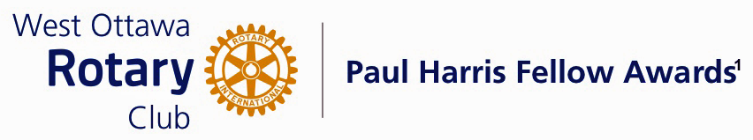
Conferred on Linda Flynn June 29, 2021
Linda first joined our Rotary Club in 1996. After an absence of a few years, she rejoined in 2005. Linda has been a continually active and enthusiastic member since then in many leadership roles. It is hard to imagine how we would have prospered without her.
Linda made a discovery while at the Rotary International Conference in Montreal in June of 2010. She saw a display of dictionaries for children known as the Dictionary for Life. Linda thought this would be an excellent project in which to be involved during her year as President of our Club in 2010-11.
The Club’s involvement began in three schools with 256 books ordered and delivered to their students in Grade 3. Due to Linda’s encouragement and promotion, this program is now delivered by 11 clubs in District 7040, one club in B.C. and one Rotaract Club in Nova Scotia. This has even happened during COVID-19, working with the cooperation of the School Boards and the Principals of those schools.
Linda has had a committee each Rotary year to assist her, particularly with the organizing and distributing of books personally to the students, while writing of grants to support the program has fallen to her. We celebrate 10 years of success for Dictionaries Four Life Project.
In addition, Linda has served diligently as Treasurer for our Rotary Club of West Ottawa for 5 years. This task required much attention to detail, such as setting up budgets for the year, collecting dues from members, tracking spending by various club committees. reporting to the Club on the state of our various accounts,
receiving donations to the Club and issuing receipts or sending money to the various groups and individuals that our committees support. Linda has served superbly in this role.
So let us say thank you to a very deserving Paul Harris Fellow winner, Linda Flynn. And a happy 10th anniversary of the Dictionary4Life Project.

THE PAUL HARRIS FELLOW AWARD
The Paul Harris Fellow Award is named after Paul Harris, a Chicago Attorney who in 1905 founded Rotary, a group of friends that became a service club. Rotary has since evolved to become Rotary International, a service organization of some 34 000 Rotary clubs. The Paul Harris Recognition Program was introduced by the Trustees of The Rotary Foundation in 1957 to encourage donations to the Foundation. The Rotary Club of West Ottawa adopted the program to create the Paul Harris Fellow Award. The Award recognizes individuals who have given distinguished service that exemplifies the ideals and objectives of Rotary. To bestow the Award, the Club contributes US $1000 to The Rotary Foundation in the name of the individual to be honoured; that individual is then named a Paul Harris Fellow by the Foundation.

For individuals who are members of the Rotary Club of West Ottawa, a nominee should meet at least three of the following criteria to become a recipient of the Paul Harris Fellow Award:

- Served a minimum of two (2) years on the Club’s Board of Directors;
- Chaired two (2) or more of the Club’s Standing Committees;
- Performed noteworthy volunteer service in the Club over the years;
- Provided extraordinary support or leadership in Club fundraising;
- Performed a unique role, or provided years of special service for the Club;
- Enhanced the Club’s reputation or public profile;
- Been active on a Rotary District Committee; and
- Performed outstanding volunteer service for the community, external to Rotary.

