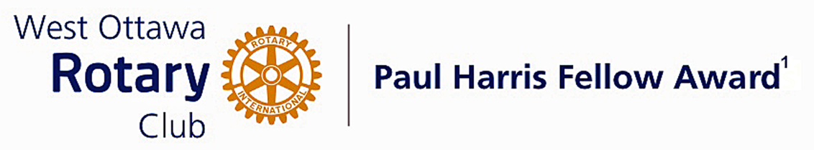

Conferred on Mark Barnes June 28, 2022
Mark Barnes is a pharmacist and owner of Respect Rx pharmacies. He is a member of the National Advisory Council on prescription Drug misuse and serves on the Overdose Task Force with Ottawa Public Health.
He was the lead with his partner pharmacists to advocate for the respectful approach to addiction and mental health treatment. This led them to develop Respect Rx pharmacies that pride themselves on providing dignified, stigma-free pharmacy service to those with complex mental health and addiction issues.
Mark's work on the opioid crisis led to the development and implementation of a return fentanyl patch program to help curb diversion of this deadly drug to the streets. In 2015 this fentanyl patch-for-patch return program became Ontario law, and is now a practice standard for the College of Physicians and Surgeons of Ontario and the Ontario College of Pharmacists.
Respect Rx has trained over 50,000 people and conducted over 450 community based seminars on the proper use of naloxone and the signs and symptoms of opioid overdose. Among his many awards he was recognized by the City of Ottawa in 2019 as a Healthy Communities Champion for his dedication to promoting overdose protection.
Mark, your dedicated time and expertise has certainly made our community a better place to live.
Congratulations Mark, on your Paul Harris Award.

The Paul Harris Fellow Award

The Paul Harris Fellow Award is named after Paul Harris, a Chicago Attorney who in 1905 founded Rotary, a group of friends that became a service club. Rotary has since evolved to become Rotary International, a service organization of some 34 000 Rotary clubs. The Paul Harris Recognition Program was introduced by the Trustees of The Rotary Foundation in 1957 to encourage donations to the Foundation. The Rotary Club of West Ottawa adopted the program to create the Paul Harris Fellow Award. The Award recognizes individuals who have given distinguished service that exemplifies the ideals and objectives of Rotary. To bestow the Award, the Club makes a contribution of US $1000 to The Rotary Foundation in the name of the individual to be honoured; that individual is then named a Paul Harris Fellow by the Foundation.
For non club members a nominee must meet at least one of the following criteria:
- Has made an outstanding personal or business contribution that has significantly enhanced the welfare of the community at the local, national or international level; or
- Has made an outstanding personal or business contribution that has significantly improved understanding and generated mutual respect between or among people of different races, cultures or countries; or
- Has performed outstanding community service in support of youth, the elderly, the underprivileged, the disabled or the developmentally challenged; or
- Exemplifies the qualities of the good citizen and provides a role model of the ideal community builder.

~ ~ ~

