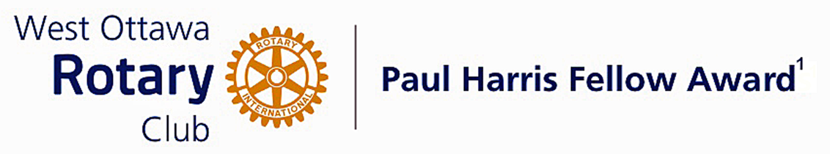

Conferred on Mike Traub June 28, 2022

Mike Traub has taken a lead role in our Music for Humanities Concert for many years since he was last recognized in 2015. He chaired that committee for several years and ensured its success with the contribution of very high quality food services from his place of business, at the end of those evenings.
Mike has been a major support to our Fundraisers for the last many years. He has purchased ads in our Calendar and made many contributions of his photography skills to the Calendar.
Mike has supported our club by offering the ability to store our club's archives in a safe and secure environment in a facility he manages.
He has enhanced the profile of our Club and Rotary to the residents of the facilities he manages by permitting on site sales of our Calendars and Mums.

Congratulations Mike, on your Paul Harris Award.

The Paul Harris Fellow Award

The Paul Harris Fellow Award is named after Paul Harris, a Chicago Attorney who in 1905 founded Rotary, a group of friends that became a service club. Rotary has since evolved to become Rotary International, a service organization of some 34,000 Rotary clubs. The Paul Harris Recognition Program was introduced by the Trustees of The Rotary Foundation in 1957 to encourage donations to the Foundation. The Rotary Club of West Ottawa adopted the program to create the Paul Harris Fellow Award. The Award recognizes individuals who have given distinguished service that exemplifies the ideals and objectives of Rotary. To bestow the Award, the Club makes a contribution of US $1000 to The Rotary Foundation in the name of the individual to be honoured; that individual is then named a Paul Harris Fellow by the Foundation.
For individuals who are members of the Rotary Club of West Ottawa, a nominee should meet at least three of the following criteria to become a recipient of the Paul Harris Fellow Award:
- Served a minimum of two (2) years on the Club’s board of Directors;
- Chaired two (2) or more of the Club’s standing committees;
- Performed noteworthy volunteer service in the Club over the years;
- Provided extraordinary support or leadership in Club fundraising;
- Performed a unique role, or provided a special service for the Club over the years;
- Enhanced the Club’s reputation or public profile;
- Been active on a Rotary District committee;
- Performed outstanding volunteer service for the community, external to Rotary.

~ ~ ~

