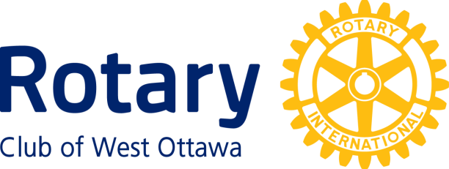

Ruth Martin Award for Community Service
Conferred upon Myrna Hay , June 29th, 2021
Myrna Hay is a senior who volunteers at Manordale Public School. She watched the school being built in 1960 (Principal Hanif Jamal says she “supervised” the construction crew) and has been there ever since----that’s over 60 years of volunteer service. She has been the community representative at Manordale Public School for many years. Myrna is everyone's grandparent at school. Many students, staff and parents regularly ask Myrna for advice.
Myrna now is the breakfast and lunch monitor, helping nourish students and families who can't afford breakfast and lunch for their kids. She has run the school's milk, Subway sandwiches and pizza programs for many years.
She is always tidying up and having fun with kids. She learned the newest dance moves and let us play them virtually for when students were learning online, to give them a reminder of their other home at school.
Myrna regularly speaks at Manordale’s Remembrance Day ceremonies about the importance of honouring those who have fought to preserve peace, democracy and freedom.
The advice Myrna gives others helps make Manordale Public School a better place to learn, teach, work and grow as a family.
Myrna lectures and tells the Principal that he is working too late and that he is not eating enough. She gives sage advice, and the Principal is happy and he listens to it.
Having had a pacemaker inserted in the Fall of 2019, she was advised by her Doctor not to go back to the school during COVID--- she is however anxious to return.
We are pleased to have Ruth Cull receive her Ruth Martin Award

The Ruth Martin Award for Community Service
Ruth Martin, after whom this Award is named, dedicated much of her life to the betterment of the community at large. Ruth’s husband, John Martin, established this Award with the Rotary Club of West Ottawa after her death in tribute to her ideals and life of service to the community.

The Awardee must have performed noteworthy service over a period of years for the well-being of the community that encompasses the National Capital Region. Any organization or individual is eligible Except the Rotary Club of West Ottawa or members of that Club.

The following members of the Rotary Club of West Ottawa to date have received this award:

1996 Patricia Henry 1997 Elsie Gertrude Scott
1998 Elizabeth I. Davies 1999 Margaret Pranschke
2000 Dian Craig 2001 Moe Atallah
2002 Eva Lamb 2003 Marion Gullock
2004 Jim McNeill 2005 Barry Bregman
2006 Charles Austin 2008 Elaine Garfinkel
2009 Kevin Frost 2010 Mark Emery
2011 Don Flynn 2012 Margaret Knight
2013 Hazel Bowen 2014 Kent & Mary Brown
2016 Rev. Anthony Bailey 2018 Isabelle Nicol & Sandra Garland
2019 Shehla Kerim 2020 Jenn Hayward

~ ~ ~

