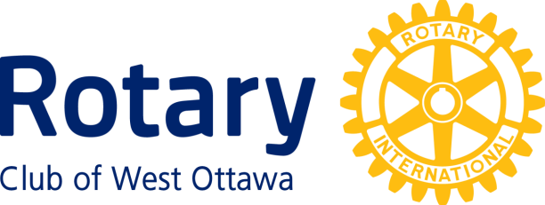

Family and Community Service Award
Conferred upon The Ottawa Tool Library June 29th, 2021
The Ottawa Tool Library (OTL), founded in 2014, is a place where you can borrow tools instead of books, a place to learn, share and empower each other. This functions on a membership fee system.
It is a non-profit founded by Bettina Vollmerhausen and Frederick Sune. Their mission is to engage and empower the community to participate in sharing resources by providing access to tools and skills for everybody.
They provide expertise and access to tools for all, while safeguarding the environment and promoting community.
The OTL also provides a dedicated space where members can work on personal projects.
If you need help, they offer weekly courses at Workshop Space 101.
This course is for anyone who wants to use the following tools in the WorkSpace: router, jointer, planer and table saw. The users receive training on the safe handling of these tools and also learn how to set them up for their own usage and work project.
If you use tools, they can break down. So the OTL has a Monthly Repair Café. It is staffed by dozens of volunteers and it provides free repairs to the public.
Even more important is that the Tool Library offers events for children or youth like : Tinkering School (a building project) and Zero Waste Living.
The OTL met the challenge of the pandemic by providing curb-side pickup of tools. Some children's tinkering school workshops, Robot Kit and DIY toolbox are now offered virtually. When the pandemic regulations allow the in-person workshops are limited to 5-6 children..They have relocated to an improved space of 2400 square feet, which opened on April 1, 2021 at 877A Boyd Ave. They keep finding a way to support people in our community.
Congratulations to the Ottawa Tool Library.

Family and Community Service Award

Rotary clubs may confer the Family and Community Service Award on individuals and organizations for outstanding service to families and communities, or in recognition of the positive contributions to individual Rotary clubs made by spouses or family members of Rotarians.

For organizations as well as individuals not related to a member of the Rotary Club of West Ottawa: The awardee must have provided outstanding service to families, neighbourhoods or local communities in the National Capital Region.

For members of families of West Ottawa Rotarians, the awardee must either:
- Have provided outstanding service to families, neighbourhoods or local communities in the National Capital Region, or
- Have made a significant contribution to the work of the Rotary Club of West Ottawa.

The following persons and organizations have received this Award:

2009 Trudi Kersley; Ottawa Police Service.
2010 City of Ottawa, Parks & Recreation
2011 Bushtukah; Dorothy Young
2013 St. Luke’s Lunch Club & Drop-In Centre
2014 Parkdale Food Centre
2015 Twice Upon A Time
2018 Cat Weaver; Jennifer Wyatt & Deborah Wyatt; Ryan Armitage
2019 West Carleton Warriors; Results Canada – Ottawa Chapter; Hospice Care Ottawa

