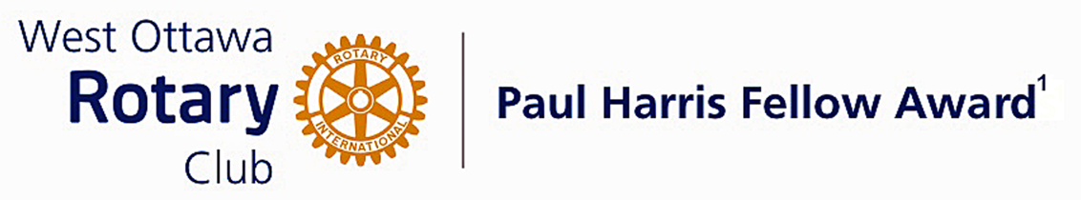

Conferred on Pardeep Ahluwalia June 29, 2021
The Rotary Foundation’s Paul Harris Fellow is bestowed on individuals to recognize distinguished service that exemplifies the ideals and objectives of Rotary.
For persons who are members of the Rotary Club of West Ottawa, a nominee must meet at least three of eight criteria to be awarded the Paul Harris Fellow.
Pardeep has accomplished this and much more.
He joined our Club in 2016 and immediately got involved.
Initially he participated in the International Service Committee and Cash Calendar taking over as Chair of the Cash Calendar Committee in June 2017 and remained Co-Chair until June 2018.
He then joined the Board of Directors as Director of ISC and the Rotary International Foundation in 2017. That year, in November, when our then President Elect found it necessary to step back because of work commitments and our President Nominee was as yet unable to move forward, he graciously agreed to become President Elect and made the choice to serve a two year term, 2018-19 and 2019-20.
Not resting on his laurels, he is now Chair of D7040 Strategic Planning and he has developed such a plan for our Club. He is a member of D7040 Diversity, Equity and Inclusion Committee and a Member of D7040 Legislative Committee.
He and his wife Simmy hosted Russian delegates pre-RI convention 2019 as part of the Friendship Exchange. He is a Member and Connoisseur of Ottawa Whiskey Guild which has supported some of our fundraising projects.
Last but certainly not least, Pardeep is District Governor Designate D7040 for 2023-24
Pardeep has exemplified the qualities of a good Rotarian through his work in the club, community, internationally and the District.
We congratulate Pardeep Ahluwalia on his well deserved Paul Harris Fellow award.

The Paul Harris Fellow Award

The Paul Harris Fellow Award is named after Paul Harris, a Chicago Attorney who in 1905 founded Rotary, a group of friends that became a service club. Rotary has since evolved to become Rotary International, a service organization of some 34 000 Rotary clubs. The Paul Harris Recognition Program was introduced by the Trustees of The Rotary Foundation in 1957 to encourage donations to the Foundation. The Rotary Club of West Ottawa adopted the program to create the Paul Harris Fellow Award. The Award recognizes individuals who have given distinguished service that exemplifies the ideals and objectives of Rotary. To bestow the Award, the Club makes a contribution of US $1,000 to The Rotary Foundation in the name of the individual to be honoured; that individual is then named a Paul Harris Fellow by the Foundation.
For individuals who are members of the Rotary Club of West Ottawa, a nominee should meet at least three of the following criteria to become a recipient of the Paul Harris Fellow Award:
- Served a minimum of two (2) years on the Club’s board of Directors;
- Chaired two (2) or more of the Club’s standing committees;
- Performed noteworthy volunteer service in the Club over the years;
- Provided extraordinary support or leadership in Club fundraising;
- Performed a unique role, or provided a special service for the Club over the years;
- Enhanced the Club’s reputation or public profile;
- Been active on a Rotary District committee;
- Performed outstanding volunteer service for the community, external to Rotary.

~ ~ ~

