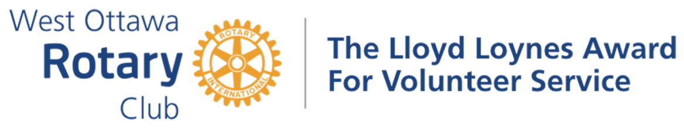

***Awarded to Ron Doll***

Over the years, this Rotarian’s outstanding contributions to our Club’s committees have produced many benefits for our fellow Rotarians. Sharing his talent and time has always shown effective leadership, with detailed planning either as an active member in the committees or as a chair. His hands on approach, has distinguished himself as a recipient of this Award.

Let us focus on his fine work as a chair of the Social and Recreational Committee. It was during the latter part of the Pandemic up to the present; he stepped up and took over the leadership of this committee. During the Rotary years of 2021 – 2023, nearly every month, he and his committee have provided monthly “get-togethers” for our members so that they could meet outside of the regular Tuesday’s meetings. Every member knew that the venue, whether it was local or beyond our city limits, was going to be a safe and hearty experience. Weeks before the event, they were well informed and encouraged to sign up through his soft but persuasive voice, not only at every hybrid meeting but also through Club Runner. For example, in the winter months, events were arranged for those who could strap on “snow-shoes” or just walk along the beautiful Kanata Trails or to go to a “pub” to enjoy a mug or two of a “green beer” on St. Patrick’s Day. During the warmer months, arrangements were made to Bike to Brunch along the Ottawa River with the focus of ending the trip at the Mill Street Pub. For a bit of history, arrangements were made to tour the Billings Bridge Estate with its steeped tea or to sign up for a tour of Almonte with its freshly roasted coffee. The list goes on!

His volunteer activity was extended to other committees as well. As a team person, he gave his time and talent to support our successful literacy program, Dictionary4Life. There you could see him at night moving books and labelling them before handing them over to other Rotary Clubs for distribution the next day. It did not stop there, because he then delivered the colourful dictionaries to a specified school with the rewarding duty of being part of a team to hand them over to the excited grade three students.

Finally, he had some free time to join two other significant committees. Looking to the Club’s future, he was a member of not only the Future Directions Committee but also the Strategic Planning Committee for three years. The results of their work are being observed today with the influx of new members, maintenance and retention of our members.

His contributions to the welfare of our Rotary Club make him a worthy recipient of our Lloyd Loynes Award. Please, Ron Doll, come forward to receive your Award.

***THE LLOYD LOYNES AWARD FOR VOLUNTEER SERVICE***

***Lloyd Loynes, a member of the Rotary Club of West Ottawa after whom this Award is named, promoted many ways of increasing volunteerism in the Club and in the community. Ted Ferrier, also a Club member, established this Award with the Rotary Club of West Ottawa after Lloyd’s death in tribute to his ideals and life of volunteerism.***

***The Award itself is a trophy, to be returned to the Club in time for the following year’s winner to receive it. Winners are given a small replica as a keepsake.***

***The Awardee must be a member in good standing of the Rotary Club of West Ottawa. In addition, the Awardee must meet one or both of the following two criteria:***

* ***Have provided outstanding “hands-on” volunteer service (time and talent) in support of the Club’s projects;***
* ***Have provided outstanding volunteer service to the community, external to Rotary. The following members of the Rotary Club of West Ottawa have received this Award:***

***1987 Ray Horning  
1990 Ed Quipp  
1993 Patricia Troughton 1996 Warren Creighton 1999 Ted Ferrier  
2002 A.J. (Bud) McGinnis 2006 Phil Bronsther 2010 Hadi Mortada 2012 Art Saper  
2014 Jake Maarse  
2018 Mary Wattie  
2020  
2023 Dave Morton***

***1988 Al Gregory  
1991 Orm Tye  
1994 Keith Fraser  
1997 Carol Waters  
2000 Carolyn Correia  
2004 Peter Gilman  
2007 George Grande  
2011 Bea Osome & Suan Cross  
2013 Brian Hartley & Sarvesh Upadhyaya***

***2016 Navin Parekh & Rocco Disipio***

***2019 Joan Heyland & Robert Shaw-Wood***

***2021 Dave Morton***

***2022 Susan Diening***