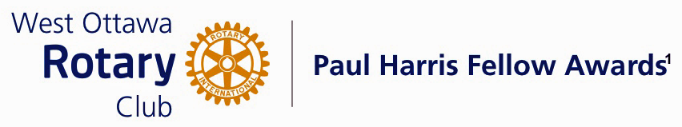

Conferred on Ruth Cull June 29, 2021
This award if for her nursing expertise, her compassion for children and for the introduction of Mollypenny; the therapeutic clown, who brings joy, laughter and a bit of magic to children receiving care at CHEO.
Ruth started as an Operating Room Nurse in 1974 but saw the need for a team member that could bridge the gap between a worried child and the treatment team! After 28 years as a nurse, she began combining volunteer hours as a therapeutic clown, Mollypenny the Clown.
Ruth was the perfect volunteer.
The concept became so successful that Ruth was gradually convinced to become a full time therapeutic clown to allay the children's anxiety to surgery and procedures
Ruth has been an integral part of the CHEO Treatment Team contributing to the care of children, assisting with problem solving and reducing emotional stress through the medium of a gentle, kind and understanding clown.
Ruth also participates in many extracurricular events such as: the CHEO Telethon, The Teddy Bear Picnic, candlelight events and many other fundraiser and charity events.
We salute Ruth Cull and Mollypenny . Please accept your Paul Harris Fellow Award.

The Paul Harris Fellow Award
The Paul Harris Fellow Award is named after Paul Harris, a Chicago Attorney who in 1905 founded Rotary, a group of friends that became a service club. Rotary has since evolved to become Rotary International, a service organization of some 34,000 Rotary clubs. The Paul Harris Recognition Program was introduced by the Trustees of The Rotary Foundation in 1957 to encourage donations to the Foundation.
The Rotary Club of West Ottawa adopted the program to create the Paul Harris Fellow Award. The Award recognizes individuals who have given distinguished service that exemplifies the ideals and objectives of Rotary.
To bestow the Award, the Club makes a contribution of US $1,000 to The Rotary Foundation in the name of the individual to be honoured; that individual is then named a Paul Harris Fellow by the Foundation.
For individuals who are not members of the Rotary Club of West Ottawa, a nominee must meet at least one (1) of the following criteria to become a recipient of the Paul Harris Fellow Award:
- Has made an outstanding personal or business contribution that has significantly enhanced the welfare of the community at the local, national or international level; or
- Has made an outstanding personal or business contribution that has significantly improved understanding and generated mutual respect between and among people of different races, cultures or countries; or
- Has performed outstanding community service in support of youth, the elderly, the underprivileged, the disabled or the developmentally challenged; or
- Exemplifies the qualities of the good citizen and provides a role model of the ideal community builder.
~ ~

