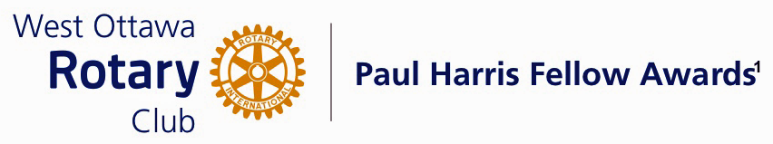
Conferred on Suan Cross June 27, 2023
This honoree has performed volunteer service to the club over the years since joining in 2008. She has served on the International Service Committee and worked tirelessly with the Mums for Thanksgiving team during the years of all “hands-on sorting and routing”, then always delivering the lovely mums to the happy recipients at the end.

Her volunteer service outside of Rotary has been none other than astounding. Having been a Social Worker in her previous life and during visits to Nairobi Kenya, Suan Cross discovered that the Mathare Slum area needed help. She felt it was important to give aid to the children and women especially; so home she came and then started the fund raising, which she continues today. Funding through the Club’s International Service Committee provides only a small portion of what is needed.

During the last 25 plus years she has managed to accomplish so much including: opening a school to educate the children and starting a feeding program because we all know that learning is much easier on a full stomach.

Next was funding for the first Medical Clinic in that area of the slum, with the assistance of staff from St Gertrude’s Hospital. Families now receive the medical care they so desperately need. Some of the women have learned to sew, making dresses, cloth diapers and reusable sanity napkins for the girls, so they might attend school on a regular basis. Suan then began other focus on the children in that area. Ten years ago was the first and now yearly excursion for the school children . Most of the them had never been out of the slum, or had never seen a tree or any of the native animals. Now the Nairobi Game Park organizes an excursion each year for the children.
In 2022 a water supply was developed and now supplies clean water to the school children and their families.

This year for her visit, she had in hand 47 pair of used glasses. The staff at the Lion’s Hospital located on the other side of Nairobi, agreed to come to the school to examine the children’s eyes and perform needed surgeries and regrind the glass lenses for those needing glasses, all free of charge. 67 children were examined. Suan arranges transportation for the 8 children needing surgery to and from the hospital for all the necessary appointments. She has continued with that venture since arriving back home.

Suan, please come up to accept your Paul Harris Award.

THE PAUL HARRIS FELLOW AWARD
The Paul Harris Fellow Award is named after Paul Harris, a Chicago Attorney who in 1905 founded Rotary, a group of friends that became a service club. Rotary has since evolved to become Rotary International, a service organization of some 34 000 Rotary clubs. The Paul Harris Recognition Program was introduced by the Trustees of The Rotary Foundation in 1957 to encourage donations to the Foundation. The Rotary Club of West Ottawa adopted the program to create the Paul Harris Fellow Award. The Award recognizes individuals who have given distinguished service that exemplifies the ideals and objectives of Rotary. To bestow the Award, the Club contributes US $1000 to The Rotary Foundation in the name of the individual to be honoured; that individual is then named a Paul Harris Fellow by the Foundation.

For individuals who are members of the Rotary Club of West Ottawa, a nominee should meet at least three of the following criteria to become a recipient of the Paul Harris Fellow Award:

- Served a minimum of two (2) years on the Club’s Board of Directors;
- Chaired two (2) or more of the Club’s Standing Committees;
- Performed noteworthy volunteer service in the Club over the years;
- Provided extraordinary support or leadership in Club fundraising;
- Performed a unique role, or provided years of special service for the Club;
- Enhanced the Club’s reputation or public profile;
- Been active on a Rotary District Committee; and
- Performed outstanding volunteer service for the community, external to Rotary.

