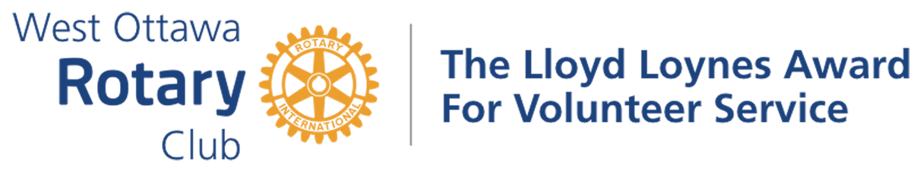

Awarded to Susan Diening on June 28, 2022

Susan joined the Rotary Club of Montreal -Lakeshore in 1995 and came to the Rotary Club of West Ottawa in 2010.
She has always been an advocate for the Rotary Foundation promoting it when and wherever she can.

Having received her first PHF in 1999, she is now a Major Donor level 1, a Sustaining Member, a Member of the Paul Harris Society, a Rotary Foundation Benefactor and a Member of the Bequest Society level 2.
This may not sound like “hands on” but Susan really does walk the walk, participating in The Foundation Walk every year no matter the location in the District. During the pandemic Susan walked close to home with her Grandson. She always encourages others to participate and/or donate.

This year just to spice things up a bit Susan encouraged us to set up an account with rotary.org. There you can see your contributions and add to them. If you did make a donation Susan would give you 100 points from her own account toward a PHF for you. Mighty generous.

Apart from Rotary, Susan also walks and raises funds for two other organizations—“Light the Night” (blood disorders) and supporting people with “Down Syndrome”, which includes her lovely Granddaughter.
Susan , please accept the Lloyd Loynes Award with our gratitude for all that you do.

The Lloyd Loynes Award for Volunteer Service

Lloyd Loynes, a member of the Rotary Club of West Ottawa after whom this Award is named, promoted many ways of increasing volunteerism in the Club and in the community. Ted Ferrier, also a Club member, established this Award with the Rotary Club of West Ottawa after Lloyd’s death in tribute to his ideals and life of volunteerism.

The Award itself is a trophy, to be returned to the Club in time for the following year’s winner to receive it. Winners are given a small replica as a keepsake.

The Awardees must be a member in good standing of the Rotary Club of West Ottawa. In addition, the Awardees must meet one or both of the following two criteria:
- Have provided outstanding “hands-on” volunteer service (time and talent) in support of the Club’s projects;
- Have provided outstanding volunteer service to the community, external to Rotary.

The following members of the Rotary Club of West Ottawa have received this Award:

1987 Ray Horning 1988 Al Gregory 1989 Malcolm Thomson
1990 Ed Quipp 1991 Orm Tye 1992 Abol Ziai
1993 Patricia Troughton 1994 Keith Fraser 1995 Bill Morris
1996 Warren Creighton 1997 Carol Waters 1998 Jack Sawyer
1999 Ted Ferrier 2000 Carolyn Correia 2001 Russell Hicks
2002 A.J. (Bud) McGinnis 2004 Peter Gilman 2005 Sue Goddard
2006 Phil Bronsther 2007 George Grande 2009 Tom Belton
2010 Hadi Mortada 2011 Bea Osome & Suan Cross
2012 Art Saper 2013 Brian Hartley & Sarvesh Upadhyaya
2014 Jake Maarse 2016 Navin Parekh & Rocco Disipio
2018 Mary Wattie 2019 Joan Heyland & Robert Shaw-Wood
2021 David Morton 2022 Susan Diening

~ ~ ~

