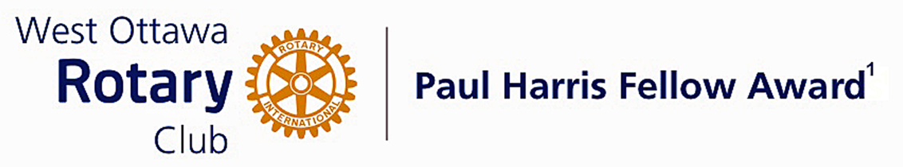
Conferred on Susan MacLatchy June 29, 2021

For 20 years, Susan MacLatchy combined her love of curling with her love for her community.

Susan launched the first annual bonspiel for Breast Cancer in 1998 at the Carleton Heights Curling Club and, at this time, personally raised $6,000 for the Canadian Breast Cancer Foundation.

Her dedication to this bonspiel over the years earned her the Ottawa Mayor’s City Builder Award in recognition of her outstanding contribution to public health. Susan and her organizing committee worked tirelessly to grow this bonspiel.

During the weekend of March 30, 2018, the last bonspiel of the 20-year annual competition was held. Some 100 women curlers from the Ottawa area competed. In total, over the years, the Carleton Heights Curling Club raised over $600,000 for the Breast Cancer Foundation while also helping build awareness of breast cancer and its treatment.

Susan continues serving her community. Recently, Susan prepared some 350 masks for use during the COVID-19 pandemic.

She also raised over $5,000 for the Ottawa Network for Education School Breakfast Program.

Susan is currently employed by Scotia Macleod as an Executive Assistant. She takes a highly conscientious approach to her various marketing, administrative and other responsibilities. When it comes to helping her clients, Sue believes that “no detail is too small”.

She is a most deserving recipient of our Paul Harris Fellow Award.
Congratulations Susan.

________________________
¹Named after the founder of Rotary International, the Paul Harris Fellow Recognition program was introduced by the trustees of the Rotary Foundation in 1957 to encourage donations to the Foundation. The Rotary Club of West Ottawa adopted the program to create the Club’s Paul Harris Fellow Award. The award recognizes individuals who have given distinguished service that exemplifies the ideals and objectives of Rotary. To bestow the award, the Club makes a contribution of $1,000 US to the Rotary Foundation in the name of the individual to be honoured; that individual is then named a Paul Harris Fellow by the Foundation.
A nominee for the award who is not a member of the Rotary Club of West Ottawa must meet at least one of four criteria to be named a Paul Harris Fellow. The nominee must: 1) have made an outstanding personal or business contribution that has significantly enhanced the welfare of the community at the local, national or international level; 2) have made an outstanding personal or business contribution that has significantly improved understanding and generated mutual respect between or among people of different races, cultures or countries; 3) have performed outstanding community service in support of youth, the elderly, the underprivileged, the disabled or the developmentally challenged; or 4) exemplify the qualities of the good citizen and provide a role model of the ideal community builder.

The Paul Harris Fellow Award

The Paul Harris Fellow Award is named after Paul Harris, a Chicago Attorney who in 1905 founded Rotary, a group of friends that became a service club. Rotary has since evolved to become Rotary International, a service organization of some 34,000 Rotary clubs.

The Paul Harris Recognition Program was introduced by the Trustees of The Rotary Foundation in 1957 to encourage donations to the Foundation.

The Rotary Club of West Ottawa adopted the program to create the Paul Harris Fellow Award. The Award recognizes individuals who have given distinguished service that exemplifies the ideals and objectives of Rotary. To bestow the Award, the Club makes a contribution of US $1,000 to The Rotary Foundation in the name of the individual to be honoured; that individual is then named a Paul Harris Fellow by the Foundation.

For individuals who are not members of the Rotary Club of West Ottawa, a nominee must meet at least one of the following criteria to become a recipient of the Paul Harris Fellow Award:

- Has made an outstanding personal or business contribution that has significantly enhanced the welfare of the community at the local, national or international level; or
- Has made an outstanding personal or business contribution that has significantly improved understanding and generated mutual respect between and among people of different races, cultures or countries; or
- Has performed outstanding community service in support of youth, the elderly, the underprivileged, the disabled or the developmentally challenged; or
- Exemplifies the qualities of the good citizen and provides a role model of the ideal community builder.
~ ~ ~

