4th Annual
Delta Rotary Business Ethics Award
Nomination Form

The three Rotary clubs of Delta seek companies in our community which are role models of ethical business practice. We want to recognize them throughout the community and learn from their example. Finalists will demonstrate the 4-way Test of Rotary International in action.

Please nominate a business which demonstrates ethical business practices. Finalists and the ultimate winner of this Delta Rotary Business Ethics Award, now in its fourth year, will be selected based on their nominations, not as the most ethical organizations, but as good, current role models. The award will be presented at a gala dinner on Friday, January 30, 2015.

Please use this form to nominate, or send to, a Delta-based company or organization worthy of recognition through this program. Scan and send your completed forms to marketing@enactuskpu.ca or by mail to:
Rotary Club of Ladner
PO Box 77
Delta BC V4K 3N5

Submissions Deadline:
January 9th, 2015


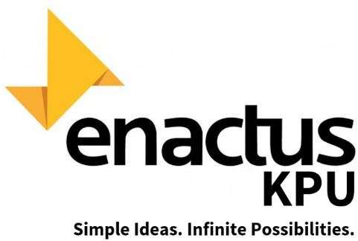

Administered by:
Kwantlen Polytechnic University chapter of the international business school network, Enactus
Sponsored by Rotary Clubs of Ladner
North Delta
Tsawwassen

Rotary International’s
4-Way Test

Rotary’s 4-Way Test is the framework for assessing ethical business practice.

1) Is it the truth?

Truth is an objective measure whereas honesty is a subjective representation of what one believes the truth to be.

Examples:
- Business is truthful in advertising, communications with clients, staff
- Honest practices – is honest about practices and policies with clients/staff
- Operations – making efforts to be transparent about operations (treatment of clients and customers)
- Public – truth in advertising
- Customers – truth in service (communication/actions between employer/employees and customer – do as you say and say as you do) Customer survey
- Employees – truth in communication regarding employee rights and benefits and their role in the company Employee survey
- Vendors – truth in communication, adherence to contracts/agreements
- Legal – adheres to applicable laws including but not limited to Human Rights Act, Employment Standards Act, Worksafe BC’s OHS Regulations, Employment Equity Act, CRA

2) Is it fair to all concerned?

Fairness is the act of weighing options and then making a choice that optimizes utility for the greatest number of people: the needs of the many outweigh the needs of the few.

Examples:
- May include, but is not limited to, any number of – clients, customers, environmental behaviours, community, special interests, sustainability, overseas efforts, domestic efforts, national efforts, specific partnerships, work share, outreach
- Public – public health and safety, clean environment in and around location
- Customers – fair treatment, fair pricing, process/mechanism for employees to express concerns Customer survey
- Employees – health and safety, fair wages Employee survey
- Vendors – responsible A/P cycle, fair trade, ethical sources of supply (are your suppliers ethical?)

3) Will it build goodwill and better friendships?

Goodwill comes from a reputation for acts that are considered to be helpful, cooperative, friendly and linked to honesty and fairness. Friendships come from partnerships between others businesses, and organizations including charities and community groups and steady, long term relationships with clients, staff, and vendors – give and take, informal and personable.

Examples:
- May include but not limited to: clients, staff, community organizations, charities, special interests through:
- Long-time partnerships
- Build-up of mutual trust between parties
- Acting consistently in accordance with an organization’s mission and goals
- Treating clients, customers, vendors, community consistently and fairly –
- this does not mean treating everyone the same
- Acting with empathy
- Community involvement, outreach (ie. Contributions to community, employs at-risk youth/developmentally disabled, etc.)
- Customer service focus/ encourages customer loyalty; customer survey
- Employee engagement/retention Employee survey

4) Will it be beneficial to all concerned?

Beneficial can be assessed in various ways, such as amount of product donated, time donated, money raised/donated, number of events held, consistent partnerships, organized and meaningful contribution for all the people affected by the businesses’ practices.

Examples:
- Economic sustainability – long-term employment for employees, employ locally, continuing service to customers & public, profitable for employer
- Environmental sustainability – waste management, recycling, environmental protection of business premises (eg. Chemical storage/disposal, etc.)
- People/profit balance
- Quality product(s) and/or service(s)

4th Annual
Delta Rotary Business Ethics Award

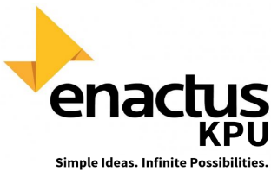
Nomination Form

Nomination submitted by:
Address: City:
Email: Phone:

Company Nominated
Company Contact
Address
Phone
Website
Operating since

1. Is it the truth? How does the company nominated demonstrate truthfulness in its business practices?

Any examples the company can share of third party validation? e.g. Worksafebc Clearance;
Human Rights Tribunal ruling; Employment Standards Act; customer survey results; employee survey results, etc.

2. Fairness (please respond to some, if not all, questions)
To what extent does the candidate consider public health and safety in its business operations?
How is worker safety dealt with in the workplace?
What role does the customer play in product pricing?
What mechanisms do customers have to express concerns?
How do you determine employee wages? (Upon what criteria are the wages based?)
What mechanisms do employees have for expressing their concerns?
What are your criteria for selecting your suppliers?
Additional Comments:

3. Fairness: candidate’s relationships (please respond to some, if not all, questions)
Customers?
How does the candidate encourage customer loyalty?
Employees?
How does the candidate encourage employee loyalty?
Other businesses?
Community Organizations?
Additional Comments?

4. Beneficial to all: Who benefits from the business and how do they benefit from it?
Customers | Quality | Consistency | Service | Long-term | Other
Employees | Fair Wages | Work-life  balance | Employ locally | Long-term | Other
Other  businesses | Buy local | Goodwill | Partnerships | Long-term | Other
Delta  Community | Charitable  support | Reside in | Outreach | Long-term | Other
Environment | Waste- Management | Recycling | Protection | Long-term | Other
Additional Comments:

