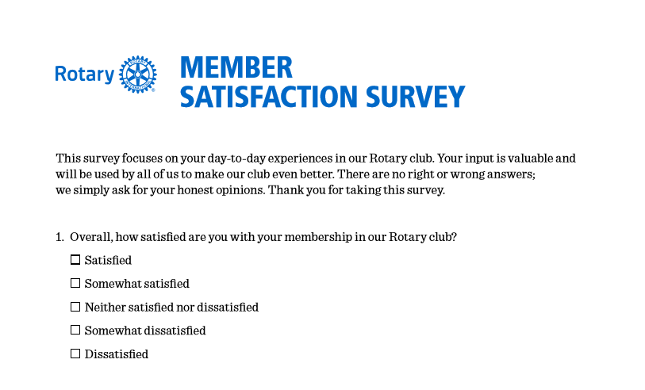
2023

8
11
1
2
0
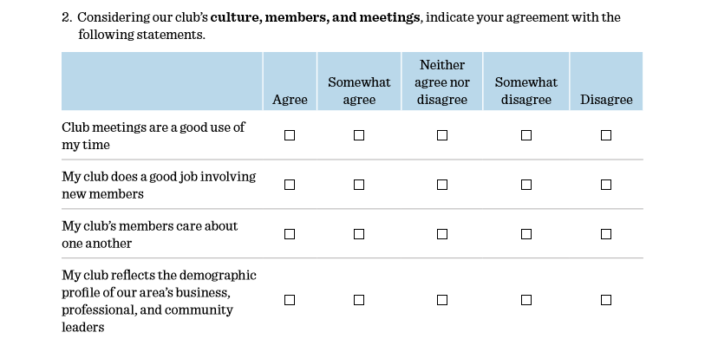

1
1
10
11
0
0
3
2
8
10

11
7
1
3
0
2
3
0
8
9

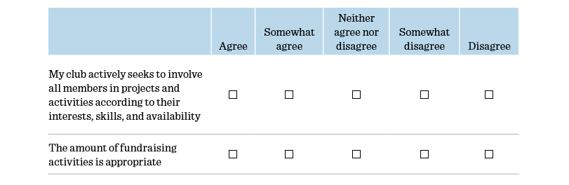

13
7
1
2
0

0
2
2
16
11
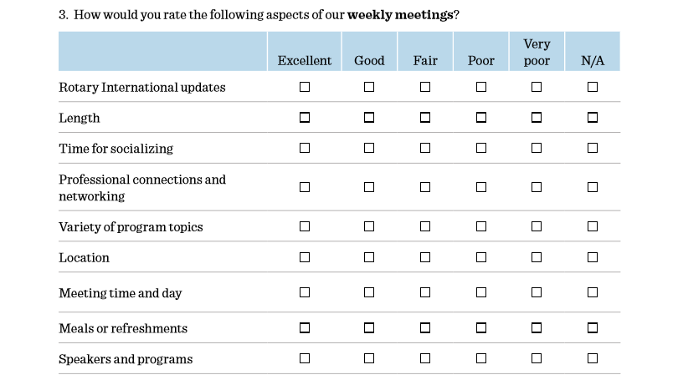

0
0
0
0
16
8
1
6
10
0
1
3
0
6
14
3
0
0
1
0
6
12
4
1
1
8
8
0
0
6
3
4
8
4
1
0
10
0
0
1
13
1
0
4
13
5
0
0
7
2
9
0
1
1
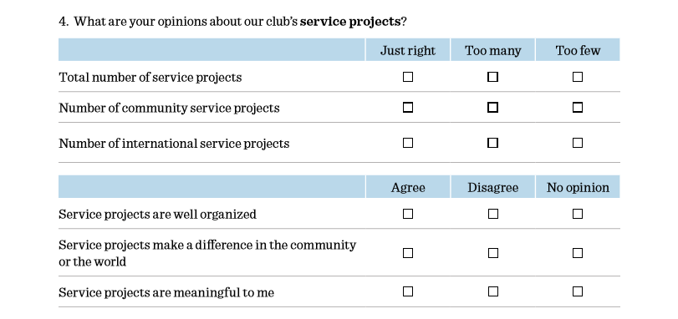
0
6
16
18
1
4
11
1
10

3
2
18
3
1
17
17
1
2
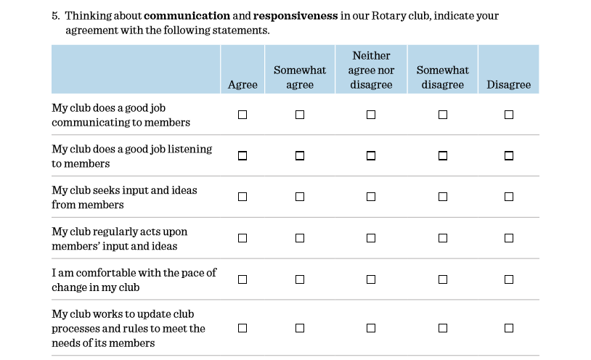

0
2
0
9
12
3
9
8
1
1
1
0
11
8
3

5
8
9
0
2
6
4
1
9
3

0
1
11
8
2
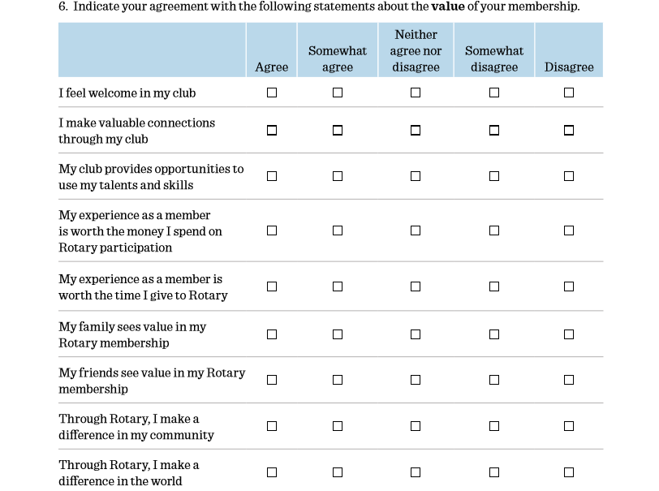

13
19
16
16
15
10
11
14
15
1
0
0
2

2
0
8
0
0
3
0
1
0
1
2
2

0
7
0
1
1
0
6
4
1
0
7
4
5
2
1
1
1
8
0
0
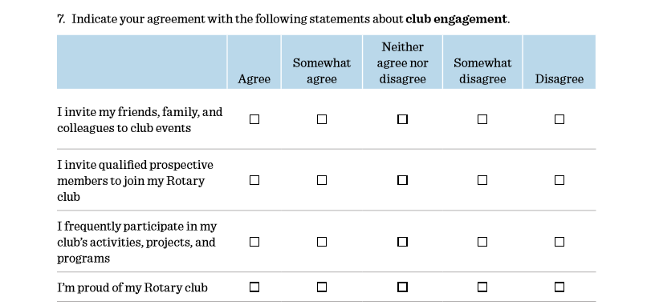

9
3
10
0
0

8
5
10
0
0

12
13
7
0
1

14
2
7
0
0
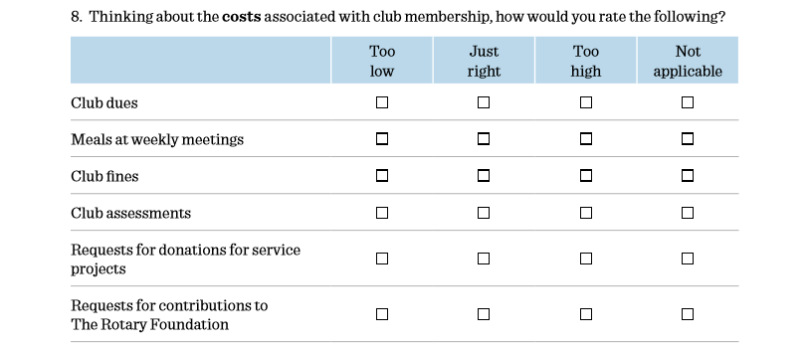

0
11
2
0
12
0
1
11
20
0
0
0
16
1
5
0
18
2
1
1

0
0
4
17

9. Have you ever served on a club committee within the past 5 years? YES 8 NO 11
10. Is there something you would like to be involved in as a member of the club? YES 3 NO 10
Comments written on the April 2023 Satisfaction Surveys
- Back to Red Lobster.
- Go back to Red Lobster – permanently.
- Red Lobster was good site for the weekly meetings.
- Move back to Red Lobster for lunch.
- New to the group so far it has been very welcome and a good use of my time.
- Very new member. Very much enjoying so far. Location – Food better at Red Lobster. Privacy better at The Hills. Access to AV equipment better at The Hills.
- Move lunch to Red Lobster.
- We need to work hard to rebuild unity in the club. I do feel things have been improving lately but we need to reach out to missing club members. Not happy with our current meals. Frankly, not supportive of the changes away from Christian Family Center. While Red Lobster meals were good, the meeting space was not great and both issues suffer at The Hills.
- I think we should explore other options for location of our noon meetings.
- I have not enjoyed the way that the members have acted this past year and have been embarrassed how they have acted in front of guests. I don’t feel our current location is a good location seeing they are closed for 2-3 months per year and keep rotated us around and neither are handicapped accessible.
- Has been a tough year with speakers double-booked to accommodate the president for his Republican politicians. Thank God for our board who worked to avoid at least politicians being favored moving forward.
- This Rotary group is perfect for my goals for serving others as a Christian. My sometime busy schedule and my health issues keep me from being as active as my heart and mind and body wants to be. It’s a Catch 22.
- Meeting locations are not good. The Hills has overpriced meals and frequently has other events making it hard to hear. Red Lobster meals were good but it’s a terrible meeting space without WiFi and presentation space and equipment. Awkward to have meetings when others are paying to dine out. We need a space that can host our business lunch separately and with a screen and WiFi and decently priced meals.

